# Time Series

**Time Series** is defined as a stochastic process with continuous state space and discrete time domain.

## Basic

### Univariate Time Series

A sequence of observations of a single process taken at a sequence of different times, given by

{Xt: t=1, 2, 3…, n} E.g., AR, MA, ARMA, ARIMA

### Multivariate Time Series

An ‘m’ dimensional multivariate time series Xt is defined as a column vector with values of ‘m’ different processes at time t. E.g., VAR

### Purely In-Deterministic process

A process is called purely In-deterministic if knowledge of values of X1, X2 …Xn is progressively less useful at predicting the value of XN as N → $∞$

When we talk of stationary time series process, we shall mean a weakly stationary purely in-deterministic process.

### Stationary Time Series

* Atime series is described as “stationary” if its statistical properties do not vary over time.
* For practical purposes, it is sufficient for a series to be weakly stationary, which requires its first two moments to be constant values & the covariance depends only on the lag, not on time t.
* Stationarity is an issue relating only to the autoregressive terms, and is not affected by adding or subtracting constants.

### Ergodicity

This is consistency property of dependent variable. It is an assumption because it cannot be tested. It states that Sample Moments will converge to population moments as sample size tends to infinity.

#### **Mean Ergodicity**

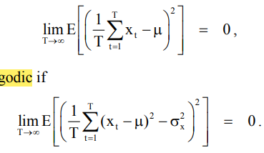

#### **Variance Ergodicity**



A stochastic process has to be in statistical equilibrium in order to be ergodic i.e., it has to be stationary.

***Types of Stationarity***

* **Strict Stationarity** = the common distributional function of stochastic process does not change by a shift in time.
* ***Mean Stationarity*** = E(Xt) = μ constant for all ‘t’
* ***Variance Stationarity*** = V(Xt) = σ2 constant and finite for all ‘t’
* ***Covariance Stationarity*** = Cov (Xt, Xs) = γt-s is a function of lag not time

For t = s, covariance stationary implies variance stationary

***Weak Stationarity aka Stationary in 2nd moment*** = mean stationary + covariance stationary.

### Non-Stationary Time Series

Non-stationary means presence of trend either in –

* Mean → only deterministic
* Variance → only stochastic
* Mean and variance → both

**3 Possible Causes for Non-Stationarity -**

1. Deterministic Trend (linear or exponential growth)
2. Deterministic Cycle (Seasonal Cycle)
3. Integrated Time Series

### Invertibility

A time series Xt is said to be invertible if we can express the white noise terms et as a convergent sum of the Xt terms.

### Integrated Process I (d)

An ‘I(d)’is a process which is not originally stationary but becomes stationary after differencing ‘d’ times.

**Comment on Appropriate value of ‘d’**

* The correct value of ‘d’ should result in differences that appear to be stationary.
* A time series is likely to be non-stationary if the sample autocorrelation decays slowly from 1.
* The sample ACF of original series Xt appears to decay slowly from 1 so it should be differenced.
* The sample ACF of first-order differences ∆Xt appears to decay slowly from 1 so it should be differenced.
* The sample ACF of second-order differences ∆2Xt does not decay slowly from 1. We don’t need to difference the series any more.
* Another way of choosing appropriate value of ‘d’ is by finding the differenced series with the minimum sample Variance. Here, the second-order differenced series has the lowest standard deviation/variance.
* Thus, appropriate value of d is 2.

### Co-Integrated Time Series

Two time series processes X and Y are co-integrated if:

1. X and Y are I (1) processes.
2. There exists a non-zero vector α, β such that α*X+ β*Y is stationary.

***Why CPI and NAEI (National Average Earnings Index) might be cointegrated?***

CPI is price inflation, which drives wage inflation (NAEI). So we expect them to ‘move together’. Neither process is stationary – they both have a trend (as prices and wages increase over time), so they may both be I(1) process.

**When it is reasonable to expect that 2 time series processes are co-integrated:**

1. If one of the processes is driving the other
2. If both are being driven by the same underlying process

**Correlograms -** Plot of the Autocorrelation Function

### Partial Autocorrelation Function

Due to the stability conditions, autocorrelation functions of stationary finite order autoregressive processes are always sequences that converge to zero but do not break off. This makes it difficult to distinguish between processes of different orders when using the autocorrelation function. To cope with this problem, we introduce the concept of Partial autocorrelation function.

The partial correlation between two 2 random variables is that correlation that remains if the possible impact of all other random variables has been eliminated. The PACF measures the correlation between Xt and Xt-k which remains when the influences of Xt-1, Xt-2, … Xt-k+1 on Xt and Xt-k have been eliminated.

$$X_{t}=ϕ_{1}X_{t-1}+ϕ_{2}X_{t-2}+…+ ϕ_{k}X_{t-k}+u_{t}$$

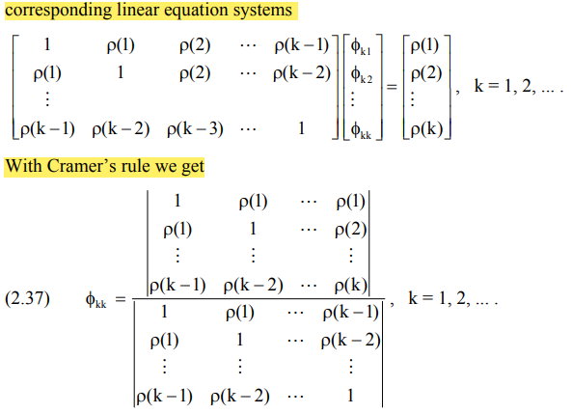

Values of PACF is zero for k > p, so we get asymptotically that they are normally distributed with

$E\left(ϕ_{k}\right)=0 and V\left(ϕ_{k}\right)=\frac{1}{T} for k>p$.

### Identification of white noise

A test for whether a particular sequence of observations forms a standard white noise process may seem of doubtful usefulness, but one of the techniques of residual analysis suggests that the verification of goodness of fit of any model should include a test as to whether the residuals form a white noise process. A suitable test, or portfolio of tests, is therefore a valuable asset.

Clearly the SACF and SPACF of a white noise process are random, being simple functions of the observations. In particular, even if the original process was a perfectly standard white noise the SACF and SPACF would not be identically zero. The question is what scale of deviation from zero is to be expected.

**AIC -** The question of when to stop adding new parameters is addressed by Akaike’s information criterion (AIC), which states that we should only consider adding an extra parameter if this results in a reduction of the residual sum of squares by a factor of at least -2 n e , or alternatively, one can evaluate for each possible model the value of: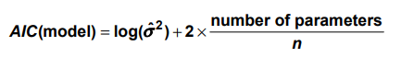And then choose as the most appropriate the one corresponding to the lowest such value.

### Transformation

#### Variance-Stabilising Transformation

Transformations are most commonly used when dependence is suspected between the variance of the residuals and the size of the fitted values.

#### Transformation To Increase Normality

In certain applications it may be found that most residuals are small and negative, with a few large positive values to offset them. This may be taken to indicate that the distribution of the error terms is non-normal.

**Note** - A further caution when using transformed data involves the final step of turning forecasts for the transformed process into forecasts for the original process, as some transformations introduce a systematic bias.

## AR(p) -vs- MA(q) process

|  |  |  |
| --- | --- | --- |
|  | **AR (p) Process** | **MA (q) Process** |
| **General Form** | Xt = μ + α1(Xt-1 –μ) + …+ αp*(Xt-p - μ) + et | Xt = μ + β1*et-1 + … +βp*Xt-q + et |
|  | Weighted Average of the past p observed values | weighted average of the past q white noise terms |
| **Number of parameters** | p +2 | q +2 |
| **Yule Walker Equation** | γk = α1γk-1 + α2*γk-2 +…+ αp*γk-p  for k ≥ p | - |
| **Distinguishing property** | ACF decays  PACF cuts off  beyond lag ‘p’ | ACF cuts off  PACF decays  beyond lag ‘q’ |
| **Stationarity / Invertibility** | we check for stationarity  always invertible | we check for Invertibility  always stationary  (Linear combination of white noise process i.e. a sequence of uncorrelated random variables with constant mean, thus weakly stationary) |
| **Markov Property** | only AR (1) is Markov | Never Markov |

## AR(p) process

***Variance of Xt under AR (1) process***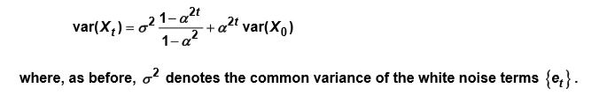

$Y_{t}=ϕ_{0}+ ϕ_{1}Y_{t-1}+e_{t}$

$\left(1-ϕ_{1}L\right)Y_{t}=ϕ_{0}+e_{t}$

* Inverse Characteristic equation → $\left(1-ϕ_{1}L\right)= 0$
* Characteristic equation, we put Z = 1/L, $Z-ϕ_{1}= 0$
* Characteristic root is $z= ϕ_{1}$
* If root = 1, we have a ***unit root*** and in the presence of unit root, Yt exhibits stochastic behaviour.

### For |φ1| < 1 and t →

* is time independent
* $V\left(Y_{t}\right)=\frac{σ^{2}}{1-ϕ_{1}^{2}}$ is time independent
* Thus, there is no trend in mean and variance i.e. the series is stationary

### For |φ1| = 1 and t → $∞$

* $Y_{t}= ϕ_{0}+Y_{t-1}+e_{t}$ is a ***Random Walk With Drift***
$Y_{t}= Y_{0}+ ϕ_{0}t+ \sum_{i=0}^{t-1}{e_{t-i}}$

$E\left(Y_{t}\right)=Y_{0}+ϕ_{0}t$

$V\left(Y_{t}\right)=σ^{2}t$

* There is trend in both mean and variance i.e. the series is non-stationary.

### For |φ1| = 1 and φ0 = 0 and t → $∞$

* $Y_{t}= Y_{t-1}+e_{t}$ is a ***Random Walk Without Drift***
$Y_{t}= Y_{0}+ \sum_{i=0}^{t-1}{e_{t-i}}$

* $E\left(Y_{t}\right)=Y_{0}$ → no trend in mean
* $V\left(Y_{t}\right)=σ^{2}t$ → trend in variance
* There is trend in both mean and variance i.e. the series is non-stationary.
* $∇Y_{t}=e_{t}$ is stationary

For this reason, the Random Walk model is called DSP (Difference Stationary Process) i.e. a series which becomes stationary after differencing.

### What is stochastic trend? How is it generated?

‘Stochastic’ indicates that the behaviour of the trend is random. ‘Trend’ is the change in value of Yt with time. Stochastic trend is un-observed but it is revealed in trend in variance of the series. Only deterministic trend can be observed.

$Y_{t}=Y_{0}+ \sum_{i=0}^{t-1}{e_{t-i}}$ i.e. initial value + accumulation of random shocks over time which we call stochastic trend.

### AR(2) process

$Y_{t}= ϕ_{0}+ ϕ_{1}Y_{t-1}+ϕ_{2}Y_{t-2}+e_{t}$

$\left(1-ϕ_{1}L- ϕ_{2}L^{2}\right)Y_{t}= ϕ_{0}+e_{t}$

* Inverse characteristic equation → $\left(1-ϕ_{1}L- ϕ_{2}L^{2}\right)= 0$
* Characteristic equation → $z^{2} - ϕ_{1}z- ϕ_{2}=0$
* 2 Characteristic root →
  + For z1=1, z2=1 (2 unit roots), Yt is non-stationary exhibiting stochastic trend

This is possible only for φ1 = 2 and φ2 = -1

* + For z1=1, z2<1 or z1<1, z2=1 (1 unit roots), Yt is non-stationary exhibiting stochastic trend

Nature of stochastic trend is different for both non-stationary series.

* + For z1 < 1, z2 < 1, Yt is stationary.

### AR(p) process

$Y_{t}= ϕ_{0}+ϕ_{1}Y_{t-1}+…+ ϕ_{p}Y_{t-p}+e_{t}$

$\left(1-ϕ_{1}L-… ϕ_{p}L^{p}\right)Y_{t}=e_{t}$

* Inverse characteristic equation → $\left(1-ϕ_{1}L-… ϕ_{p}L^{p}\right)=0$
* Characteristic equation → $z^{p}-ϕ_{1}z^{p-1}-ϕ_{2}z^{p-2}… -ϕ_{p}z^{0}=0= ϕ\left(z\right)$
* Now if we can factorise and express $ϕ\left(z\right)={\left(z-1\right)}^{d}*remaining$

Then, the process is Integrated order ‘d’ i.e. I(d) series.

### Non-stationary without Unit Root

Series where is there only deterministic trend and no stochastic trend i.e. the change in Yt with time is constant/ by a fixed amount.

* $Y_{t}=α+βt+e_{t}$ where, et ~ N(0, σ2) Cov(et, et-k) = 0
* Population regression function → E(Yt) = α + β*t
* And V(Yt) = σ2 i.e. constant thus, no stochastic trend. And Cov(Yt, Yt-k) = 0

After de-trending the series,

* $∇Y_{t}=e_{t}$– stationary.

Thus, Yt is called **TSP** (**Trend Stationary Process**).

|  |  |
| --- | --- |
| ***Trend Stationary Process TSP*** | ***Difference Stationary Process DSP*** |
| 1. Non-stationary 2. Stationary by de-trending 3. Trend in mean – deterministic trend 4. No trend in variance or covariance – no stochastic trend 5. Effect of shock is transitory – it dies out shortly | 1. Non-stationary 2. Stationary by taking difference 3. Trend in mean – deterministic trend, or no trend in mean 4. Trend in Variance or covariance – stochastic trend. The stochastic trend incorporates all the random shocks that have permanent effects on the level of Yt. 5. Effect of shock is permanent, it persists for long period. |

### Estimating AR(p) Process

#### For known order ‘p’

**Conditional Distribution of Yt on Yt-1 for AR(1) Process (2019 Sept)**

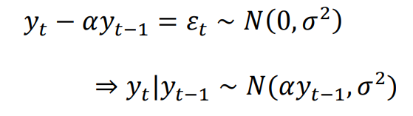

1. **Likelihood function of AR(1) model (2019 Sept)**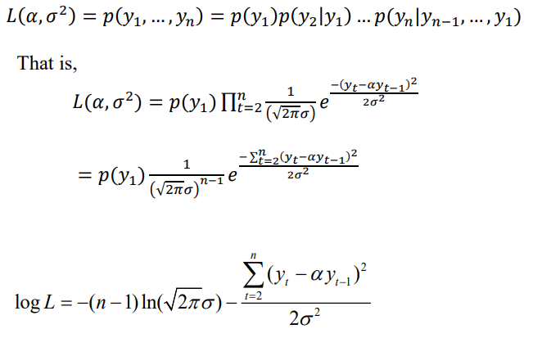
2. **MLE of α and σ2**

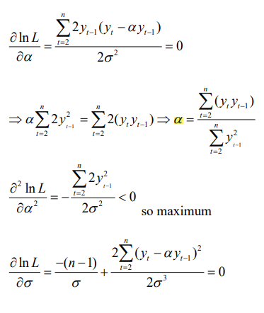

(i) (ii)

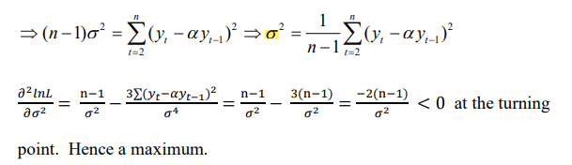(iii)

1. **Expression for α and σ2 using Yule-Walker Equation**

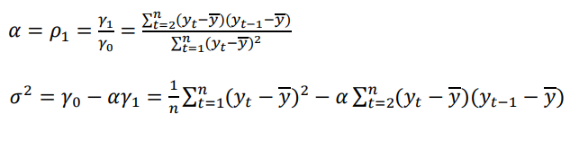

**Comment on difference between MLE and Yule-Walker estimates** - The main difference is that using Yule-Walker, we include the sample mean. This may not have a big effect when average y is small.

#### For unknown order ‘p’

Appropriate value of ‘p’ is estimated with help of information criteria.



$Final Prediction Error FPE=\frac{T+m}{T-m}\frac{1}{T}\sum_{t=1}^{T}{{\left({\hat{u}}_{t}^{(p)}\right)}^{2}}$

$AIC=\ln\left(\frac{1}{T}\right)\sum_{t=1}^{T}{{\left({\hat{u_{t}}}^{(p)}\right)}^{2}}+m\frac{2}{T}$

$Bayesian criterion SC= \ln\left(\frac{1}{T}\right)\sum_{t=1}^{T}{{\left({\hat{u_{t}}}^{(p)}\right)}^{2}}+m\frac{\ln\left(T\right)}{T}$

$Hannan Quinn HQ= \ln\left(\frac{1}{T}\right)\sum_{t=1}^{T}{{\left({\hat{u_{t}}}^{(p)}\right)}^{2}}+m\frac{2ln⁡(lnT)}{T}$

Where, ${\hat{u}}_{t}^{(p)}$ is estimated residuals of AR(p) process, ‘m’ is the number of estimated parameters.

Idea of information criteria → residual term (sum of squared residuals which decreases when the number of parameters estimated increases) and penalty term (which increases when the number of estimated parameter increases).

FPE and AIC overestimate the true order asymptotically while SC and HQ estimate the true order of the process consistently

For T ≥ 16, the penalty term of SC is larger than HQ which itself is larger than the one of AIC. This leads to the following order of estimated AR orders : SC ≤ HQ ≤ AIC.

## Non-linear MA Model (NMA)

$$y_{t}=e_{t}+αe_{t-1}^{2}.$$

This model is non-linear in mean but not in variance. s

## ARMA (p, q) process

* Combination of AR (p) and MA (q)
* General form **→** Xt = μ + α1(Xt-1 – μ) + … + αp*(Xt-p – μ) + β1*et-1 +…+ βp*et-q + et
* Need to check for stationarity and Invertibility both
* ACF and PACF behaviour **–**
  + Neither ACF nor PACF will cut off, both decay
  + Presence of β1*et-1 means that PACF will decay exponentially to zero, but will never cut off i.e. remain non-zero. (Sept 2013)
  + Only ARMA (1,0) is Markov

**Method of Moment estimation for ARMA (1,1) process (Q6 Assignment)**

* + In ARMA (1, 1) there are p + q parameters to be estimated.
  + We can calculate the theoretical ACF {ρk} of an ARMA (p, q) process, which will be a function of α’s and β’s.
  + Then the method of moments estimates are those values of α, β such that the theoretical ACF r1 …rp +q coincides with the observed sample ACF ρ1 …ρp +q.
  + This method is easily available for AR (p) models since the corresponding Yule-Walker equations are linear, therefore moment estimation requires solving them with respect to the unknown parameters αi.

## Box-Jekin’s Methodology

* **Prepare the data**
  + **Removing linear trend**
    - Differencing Yt = Xt – Xt-1
    - Least Square Trend Removal Yt = Xt – (a +bt)
  + **Removing exponential trend -** Can be removed by taking logs i.e. set Yt = ln (Xt)
  + **Removing seasonal effect**
    - Seasonal Differencing - We difference the data by a lag equal to the period. E.g. Yt = Xt – Xt-12 if period is 12.
    - Method of Seasonal Means - First, we calculate estimates of the seasonal means from the data by finding the average number of people claiming unemployment benefit (as per question) for each month less the overall mean of all months. Overall mean = sum(Xt)/N. Then, we subtract the appropriate seasonal mean from the observed values (or from the de-trended values). For e.g. for each January value, we would subtract January’s seasonal mean.
    - Method of Moving Averages - The moving average model explains the relationship between the Xt as an indirect effect, arising from the fact that the current value of the process results from the recently passed random error terms as well as the current one. In this sense, Xt is ‘smoothed noise’.
* **Tentative identification of ARIMA Model**
* **Estimation of parameters in identified model**
* **Diagnostic checks**
  + Inspection of Graph of Residuals
  + Counting Turning Points
  + Ljung- Box Test / Portmanteau Test - A portmanteau test is a type of statistical hypothesis test in which the null hypothesis is well specified, but the alternative hypothesis is more loosely specified.
* **Forecasting** 
  + Box-Jekins Approach to forecasting time series

Reason for difference between estimated and actual values: The estimated values set the future residuals to be zero. There is some external reason (e.g. change in economic outlook, change in the way figures are recorded and so on).

* + Exponential Smoothing

**Relative Merit of using a large/small number of lags ‘m’ by considering how sample size ‘n’ would vary with ‘m’ and if sample acf is not equal to theoretical values. (April 2021)**

* Sample ACF = Theoretical ACF

As ‘m’ increases, the absolute value of test statistic increases. As acf values (ρ_k) generally decreases with increasing ‘k’ thus, the test statistic increases more slowly than the corresponding chi-square critical value.

There are two potential concerns (1) to make the test powerful, we prefer small values of ‘m’ (2)to ensure meaningful ACF values are included, we prefer large values of ‘m’. thus, we need to strike a balance between the two.

* Sample ACF != Theoretical ACF

If first few values of sample acf > theoretical acf then, small number of lags means small value of TS. Thus, to maximise the power of the test, value of ‘n’ should be higher.

If first few values of sample acf > theoretical acf then, small number of lags means high value of TS. Thus, to maximise the power of test, value of ‘n’ should be small. Here, is ‘n’ is also large, then there could a bias towards rejecting H0.

## Unit Root Tests

### Dickey Fuller Test

This test only considers AR(1).

H0 : |φ1| = 1 i.e. presence of unit root/ Random Walk process ***-vs-*** H1 : |φ1| < 1 i.e. stationary

H0 : |φ1| = 1, β = 0 i.e. DSP process ***-vs-*** H1 : |φ1| < 1, β 0 i.e. TSP process

To perform Dickey-Fuller Test, we need to estimate (OLS) the model. **ρ = φ1 - 1**

H0 : |ρ| = 0 ***-vs-*** H1 : |ρ| < 0

$∇Y_{t}=ϕ_{0}+βt+ρY_{t-1}+e_{t}$

H0 : |ρ| < 0 β = 0 ***-vs-*** H1 : |ρ| < 0, β $≠$ 0.

$$t-statistic =\frac{\hat{ϕ}-1}{Se(\hat{ϕ})}=\frac{\hat{ρ}}{Se\left(\hat{ρ}\right)}$$

Where, $\hat{ϕ}=\frac{\sum_{\left(t=1\right)}^{T}{Y_{t-1}Y_{t}}}{\sum_{t=1}^{T}{Y_{t-1}^{2}}}$ → $\hat{ϕ}=ϕ+\frac{\sum_{t=1}^{T}{e_{t} Y_{t-1}}}{\sum_{t=1}^{T}{Y_{t-1}^{2}}}$

Thus, $E\left(\hat{ϕ}\right)=ϕ$ i.e. unbiased estimator.

$V\left(\hat{ϕ}\right)=\frac{σ^{2}}{\sum_{t=1}^{T}{Y_{t-1}^{2}}}=\frac{σ^{2}}{T\left(\frac{\sum_{t=1}^{T}{Y_{t-1}^{2}}}{T}\right)}= \frac{σ^{2}}{T\left(\frac{σ^{2}}{1-ϕ^{2}}\right)}=\frac{1-ϕ^{2}}{T}$ where, V(Yt) = .

* Asymptotic Distribution with T → $∞$, $\hat{ϕ}\sim N\left(ϕ,\frac{1-ϕ^{2}}{T}\right)$ provided et ~N(0, σ2).

Under Null Hypothesis, φ = 1, so the mean = 1 and variance = 0. So, $\hat{ϕ}\sim N(1,0)$. A distribution with 0 Variance does not make sense. Thus, we cannot use conventional t-statistic.

### Augmented Dickey Fuller Test

Here, we convert higher order AR → AR(1) series.

* **For AR(2)**

$Y_{t}= ϕ_{0}+ ϕ_{1}Y_{t-1}+ϕ_{2}Y_{t-2}+e_{t}$

$Y_{t}= ϕ_{0}+\left(ϕ_{1}+ϕ_{2}\right)Y_{t-1}-ϕ_{2}\left(Y_{t-1}-Y_{t-2}\right)+e_{t}$

$∇Y_{t}= ϕ_{0}+ρY_{t-1}-β∇Y_{t-1}+e_{t}$

* Here, β = -φ2, ρ = φ1+φ2 -1,
* **For AR(3)**
$Y_{t}= ϕ_{0}+ ϕ_{1}Y_{t-1}+ϕ_{2}Y_{t-2}+ϕ_{3}Y_{t-3}+e_{t}$

$Y_{t}= ϕ_{0}+\left(ϕ_{1}+ϕ_{2}+ϕ_{3}\right)Y_{t-1}-{(ϕ}_{2}+ϕ_{3})\left(Y_{t-1}-Y_{t-2}\right)-ϕ_{3}(Y_{t-2}- Y_{t-3})+e_{t}$

$∇Y_{t}= ϕ_{0}+ρY_{t-1}+β_{1}∇Y_{t-1}+β_{2}∇Y_{t-2}+e_{t}$

* **For AR(p)**
$∇Y_{t}= ϕ_{0}+ρY_{t-1}+\sum_{j=1}^{p-1}{β_{j}∇Y_{t-j}}+e_{t}$

* **For ARMA(p, q)**
$ϕ\left(L\right)Y_{t}= θ\left(L\right)e_{t}$

$ϕ\left(L\right)θ^{-1}(L)Y_{t}= e_{t}$

$∇Y_{t}= ρY_{t-1}+\sum_{j=1}^{∞}{β_{j}∇Y_{t-j}}+e_{t}$

* This is ARMA(p, q) expressed as AR($∞$) i.e. with $∞$ augmented terms.

### Lag Selection

Inference of ADF is very sensitive to Lag Selection. It is done the basis of some information criteria which considers a trade off between size distortions because of the inclusion of too few lags and the power loss because of inclusion of too many lags.

In this approach suggested by Ng and Perron (1995), the optimum lag P* is obtained as –

* IC(p) = $\ln{{\hat{σ}}_{p}^{2}}+p\frac{C_{T}}{T }$ and P* is minimum of IC(p)
* Minimum IC(p) ensures lower Variance and lower penalty CT.
* **For AIC**, CT = 2 → $T ln{\hat{σ}}_{p}^{2}+2p$
* **For BIC**, CT = *ln* T → $T ln{\hat{σ}}_{p}^{2}+p lnT$
* **For HQIC**, CT = *ln(ln* T) → $T ln{\hat{σ}}_{p}^{2}+p ln(ln T)$
* Starting value (rule of thumb given by Schwert 1989) **PMAX = 12(T/100)0.25,** then reduce next value by lag 1.

### ADF & PP Test - Augmented Dickey Fuller Test & Phillips Perron Test

H0: there is an unit root (equal to 1) i.e. non-stationary

H1: process if stationary (greater than 1) or explosive (less than 1)

### KPSS - Kwiatkowski Phillips Schmidt Shin Test

H0: process is stationary

H1: there is an unit root

## Testing Autocorrelation of Errors

### Durbin Watson Test

* H0 : No autocorrelation
* H1: Autocorrelation of order 1
* Steps
  + Estimate the basic linear regression model Yt = βxt + et.
  + Predict residuals et-hat.
  + Calculate DW test statistic given by

* + The distribution of DW test statistic is not constant and depends upon ‘x’.

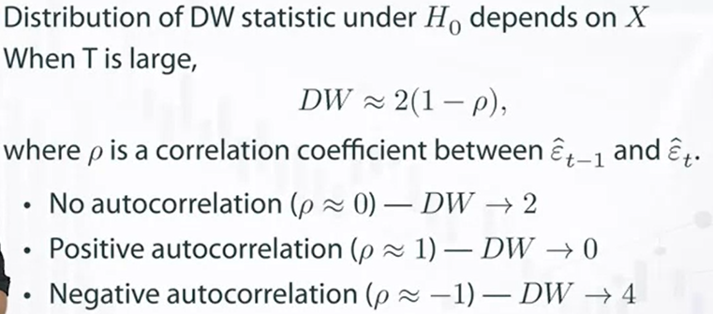

* R code: **durbinWatsonTest()** in ***car*** package

where, ‘p’ = max.lag with default value =1. Here, p-value is calculated using bootstrap.

* R code: **dwtest()** in ***lmtest*** package, but only with p=1

where, p-value is calculated using normal approximation or an exact algorithm.

* Limitations of Durbin-Watson test : test is not applicable if
  + There is no constant in the regression model
  + Lagged dependent variable Yt-1 is included.
  + Autocorrelation of higher order exist

### H Durbin Statistic

* Here we allow lagged dependent variable Yt-1.
* Steps: 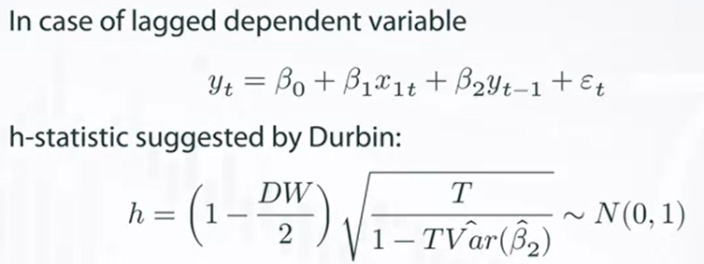
* Limitation
  + Only 1 lagged variable is allowed i.e. Yt-1
  + Autocorrelation of higher exists, then test is not applicable

### Breusch Godfrey Test (LM Test)

* This is also called the ***Lagrange Multiplier Test***. This is an asymptotic test i.e. used when we have large samples.
* H0: no autocorrelation
* H1: autocorrelation of order ‘p’

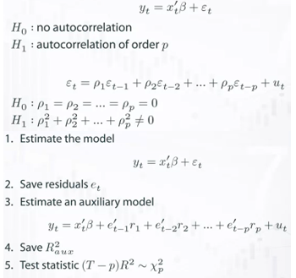

LM Test -vs- Durbin-Watson Test:

* LM Test checks for autocorrelation of any order.
* The results are correct if there are lagged endogenous variables in the regression equation, whereas the DW gives biased results in favour of Null hypothesis.

### Ljung-Box Test

* H0: no autocorrelation
* H1: autocorrelation of order ‘p’
$Test Statistic=n\left(n+2\right)\sum_{k=1}^{m}{\frac{γ_{k}^{2}}{n-k}} \sim χ_{m-\left(p+q\right)}^{2}$

* This is a right-tailed test where, ‘n’ is sample size, ‘m’ is lag, ‘p’ is AR(p) and ‘q’ is MA(q)

### Choice of number of ACFs in conducting Ljung Box Test

* Under Ljung Box test, H0: residuals are independent and TS ~ Chi-square with df = m - (p + q)
* If value of ‘m’ i.e. number of ACFs is large, the degree of freedom is large number. This weakens the test.
* As a result, the TS is more likely to follow Chi Square
* Thus, we need to strike a compromise between these two effects.

### Turning Point Test

* H0: No autocorrelation/ errors are white noise/ model is good fit
$Test Statistic=\frac{\left(T ±0.5\right)-E(T)}{√V\left(T\right)} \sim N(0,1)$

* This is a two-tailed test where, T is the number of turning points, $E\left(T\right)=\frac{2}{3}\left(N-2\right)$ and

$V\left(T\right)=\frac{16N-29}{90}$, we add 0.5 if E(T) > T and vice-versa.

## Testing Normality of Errors

### Jarque-Bera Test

* For a symmetrical distribution (like Normal), the Skewness = 0 and Kurtosis = 3. If K>3, it implies that the distribution has fatter tails. (‘tails’ meaning outside +/- 2σ and ‘fatter’ meaning higher density of distribution in the centre and tails than Normal).
* JB test compares sample skewness and kurtosis with population values.
$JB=\frac{n}{6}\left[S^{2}+\frac{{\left(K-3\right)}^{2}}{4}\right] \sim χ_{2}^{2}$

* 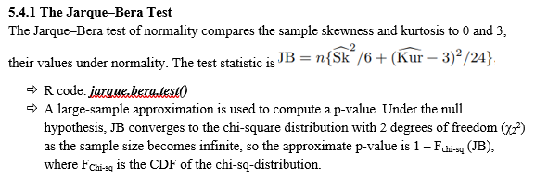

### Shapiro Wilk Test

* H0: sample (X1, X2, … Xn) is drawn from normal distribution
* H1: otherwise
* 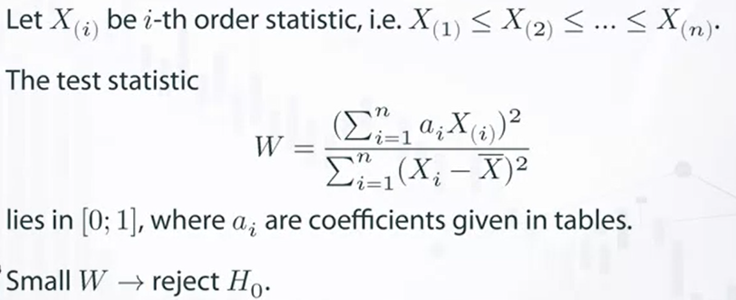

### Kolmogrov Smirnov Test

* H0: sample (X1, X2, …, Xn) is drawn from the distribution with CDF F*(x) i.e. normal distribution
* H1: otherwise
* 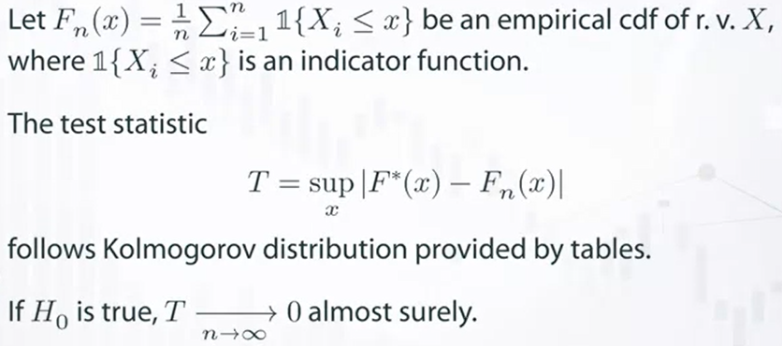with the help of indicator function, we compare the empirical CDF of X with the normal distribution (theoretical).
* The Kolmogrov-Smirnov statistic is the maximum absolute difference between the two CDFs.

## Forecasting Techniques

### Naive, SNaive Model

Naive Models are very simple where,

* Forecast_tomorrow = Observed_today

SNaive or Seasonal Naive models extends the Naive Model by including seasonality components.

* Forecast_Jan 2019 = Observed_Jan 2020
* Forecast_Feb 2019 = Observed_ Feb 2020

The Naive and SNaive models are vital because they act as a good basis to compare other models. If a model is performing poorer than the Naive Model, it is best to re-evaluate or discard it.

### Seasonal Decomposition + Random Walk with drift

Here, we will decompose the series into trend, seasonal and random components to analyse them. Then, we fit using forecast() command with method = “rwdrift” on the decomposed series.

Here, ‘drift’ implies that there is an ability to pick up the trend and seasonality.

### Simple Exponential Smoothing

* Yt+1 = α Yt + (1 – α)Ŷt.

i.e. forecast_tomorrow = actual_today + forecast_today

* Yt+1 = Yt + α (Yt - Ŷt).

i.e. forecast_tomorrow = forecast_today + “modified by how wrong I was today”

If we replace Ŷt = α Yt-1 + (1 – α)Ŷt-1 in the first equation, we can show that Ŷt is a combination of previous values. If alpha = 0.5, we end up with an equation which looks like –

* Yt+1 = 0.5Yt + 0.25Ŷt-1 +0.125Ŷt-2 +0.625Ŷt-2.

i.e. forecast_tomorrow = half of today + fourth of yesterday + eighth of day before yesterday

It is like a weighted average of past, with weightage more towards recent ones. Thus, we can call this “Exponentially Weighted Moving Average” or “Simple Exponential Smoothing” as there weights are exponentially smoothing weights.

What does R do?

* It gives the same result for all months because it did not have a “forecast_today” value to begin with. So R assumed that Yt = Ŷt ,thus Yt+1 = Yt.

### Holt Winter Double Exponential

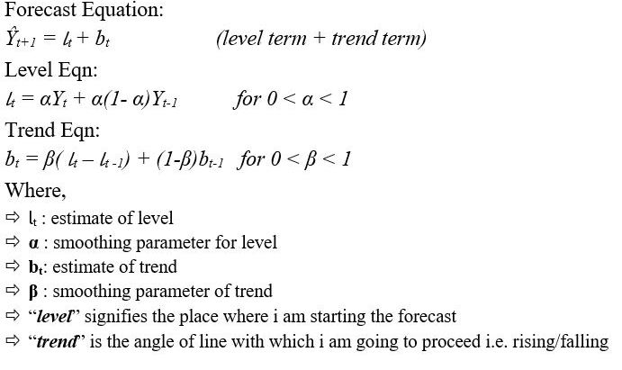

### Holt Winter Triple Exponential

The optimum values for the smoothing parameters are based on minimising one-step ahead forecast errors.

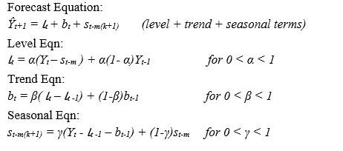

## Accuracy Measures

### MFE - Mean Forecast Error

$MFE=\frac{1}{n}\sum_{t=1}^{n}{e_{t}}$

* It is measure of average deviation of forecasted values from actual ones
* It shows the direction of error and thus also termed as the Forecast Bias
* The MFE, the effects of positive and negative errors cancel out and there is no way to know their exact amount.
* A zero MFE does not mean that forecasts are perfect, i.e. contain no error; rather it only indicates that forecasts are on proper target.
* MFE does not penalise extreme errors.
* It depends on the scale of measurement and also affected by data transformations.
* For a good forecast, i.e. to have a minimum bias, it is desirable that the MFE is as close to zero as possible.

### MAE - Mean Absolute Error

$MAE=\frac{1}{n}\sum_{t=1}^{n}{\left|e_{t}\right|}$

* It measures the average absolute deviation of forecasted values from original ones.
* It is also termed as the Mean Absolute Deviation (MAD).
* It shows the magnitude of overall error, occurred due to forecasting.
* In MAE, the effects of positive and negative errors do not cancel out.
* Unlike MFE, MAE does not provide any idea about the direction of errors.
* For a good forecast, the obtained MAE should be as small as possible.
* Like MFE, MAE also depends on the scale of measurement and data transformations.
* Extreme forecast errors are not penalized by MAE.

### MAPE - Mean Absolute Percentage Error

$MAPE=\frac{1}{n}\sum_{t=1}^{n}{\left|\frac{e_{t}}{y_{t}}\right|*100}$

* This measure represents the percentage of average absolute error occurred.
* It is independent of the scale of measurement, but affected by data transformation.
* It does not show the direction of error.
* MAPE does not penalize extreme deviations.
* In this measure, opposite signed errors do not offset each other.

### MPE - Mean Percentage Error

$\frac{1}{n}\sum_{t=1}^{n}{\left(\frac{e_{t}}{y_{t}}\right)100}$

* MPE represents the percentage of average error occurred, while forecasting.
* It has similar properties as MAPE, except.
* It shows the direction of error occurred. • Opposite signed errors affect each other and cancel out.
* Thus like MFE, by obtaining a value of MPE close to zero, we cannot conclude that the corresponding model performed very well.
* It is desirable that for a good forecast the obtained MPE should be small.

### MSE - Mean Squared Error

$MSE=\frac{1}{n}\sum_{t=1}^{n}{e_{t}^{2}}$

* It is a measure of average squared deviation of forecasted values.
* As here the opposite signed errors do not offset one another, MSE gives an overall idea of the error occurred during forecasting.
* It penalizes extreme errors occurred while forecasting.
* MSE emphasizes the fact that the total forecast error is in fact much affected by large individual errors, i.e. large errors are much expensive than small errors.
* MSE does not provide any idea about the direction of overall error.
* MSE is sensitive to the change of scale and data transformations.
* Although MSE is a good measure of overall forecast error, but it is not as intuitive and easily interpretable as the other measures discussed before.

### SSE - Sum of Squared Error

$SSE= \sum_{t=1}^{n}{e_{t}^{2}}$

* It measures the total squared deviation of forecasted observations, from the actual values.
* The properties of SSE are same as those of MSE

### SMSE - Signed Mean Square Error

$SMSE=\frac{1}{n}\sum_{t=1}^{n}{{\left(\frac{e_{t}}{\left|e_{t}\right|}\right)}^{2}e_{t}^{2}}$

* It is same as MSE, except that here the original sign is kept for each individual squared error.
* SMSE penalizes extreme errors, occurred while forecasting.
* Unlike MSE, SMSE also shows the direction of the overall error.
* In calculation of SMSE, positive and negative errors offset each other.
* Like MSE, SMSE is also sensitive to the change of scale and data transformations.

### RMSE - Root Mean Squared Error

$RMSE=\sqrt{MSE}$

* RMSE is nothing but the square root of calculated MSE.
* All the properties of MSE hold for RMSE as well.

### NMSE - Normalized Mean Squared Error

$NMSE=\frac{MSE}{σ^{2}}=\frac{1}{nσ^{2}}\sum_{t=1}^{n}{e_{t}^{2}}$

* NMSE normalizes the obtained MSE after dividing it by the test variance.
* It is a balanced error measure and is very effective in judging forecast accuracy of a model.
* The smaller the NMSE value, the better forecast.
* Other properties of NMSE are same as those of MSE.

### Theil’s U-statistics

$U=\frac{\sqrt{\frac{1}{n}\sum_{t=1}^{n}{e_{t}^{2}}}}{\sqrt{\frac{1}{n}\sum_{t=1}^{n}{f_{t}^{2}}}\sqrt{\frac{1}{n}\sum_{t=1}^{n}{y_{t}^{2}}}}$

* It is a normalized measure of total forecast error.
* 0 ≤ U ≤ 1; U = 0 means a perfect fit.
* This measure is affected by change of scale and data transformations.
* For assessing good forecast accuracy, it is desirable that the U-statistic is close to zero.

## Granger Causality

Underlying assumption → weak stationarity holds.

Causality means ‘y as the effect of x’. In traditional econometrics, when distinguishing endogenous and exogeneous (predetermined) variables, one assumes that such information is a priori available. Problems arise, however, if there are simultaneities between the variables, i.e. if it is possible that ‘x’ is causal to ‘y’ and ‘y’ is causal to ‘x’.

It is impossible to determine the direction of causality of instantaneous relations between different variables if there is no such information. In this case, the only possibility is to estimate a reduced form of the system.

The idea of causality is closely related to the idea of succession in time, at the latest since David Hume who said that cause always precedes effect.

However, if ‘x’ is causal to ‘y’, current and lagged values of ‘x’ should contain information that can be used to improve the forecast to ‘y’. Accordingly, the definition of causality proposed in 1969 by Clive Granger looks at the incremental predictability i.e. it examines whether the forecast of the future values of y can be improved if – besides all other available information – the current and lagged values of x are also taken into account.

Let ***It*** be the total information set at time ‘t’ and ***x̅t*** and ***y̅t*** be set of all current and past values of series.

* ***Granger Causality*** → x is simply/ Granger causal to ‘y’ if and only if the future value of Y can be better predicted (smaller forecast error variance) by using current and past values of x via an optimal linear prediction function i.e. $σ^{2}\left(Y_{t+1} | I_{t}\right)<σ^{2}\left(Y_{t+1} | I_{t}-{\overline{X}}_{t}\right)$.
* ***Instantaneous Granger Causality*** → x is instantaneously Granger causal to ‘y’ if and only if the future value of Y can be better predicted by using future value Xt+1 current and past values of x. i.e. $σ^{2}\left(Y_{t+1} | {\{I}_{t}, x_{t+1}\}\right)<σ^{2}\left(Y_{t+1} | I_{t}\right)$.
* ***Feedback*** → there is feedback between x and y if x is causal to y and y is causal to x.

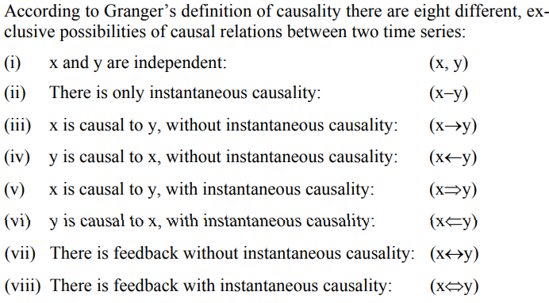

### Haugh Pierce Test

The power of this test is smaller than the power of Granger test, thus it is the first step to analyse causal relations between 2 time series. This test is based on Cross-correlation between residuals of Xt (residual of Xt is a) and Yt (residual of Yt is b).

H0: ρ ab(k) = 0 for all k where, k1≤ k ≤ k2.

* Step 1: Check if estimated residuals ‘a’ and ‘b’ are White Noise
* Step 2:
* For k1 < 0 & k2 > 0 → any causal relation?
* For k1 = 1 & k2 ≥ 1 → simple causal relation from X to Y?
* For k1 ≤ -1 & k2 = -1 → simple causal relation from Y to X?
* ρ ab(0) → instantaneous relationship?

### Granger Causality Test

* Say we have an AR(2) process → $Y_{t}=α+β_{1}Y_{t-1}+β_{2}Y_{t-2}$ we estimate the value of R21 for this regression model.
* Then we perform another regression → $Y_{t}=α+β_{1}Y_{t-1}+β_{2}Y_{t-2}+ γ_{1}X_{t-1}+ γ_{2}X_{t-2}$ we estimate the value of R22 for this regression model.
* Then, we check if the increase in R2 given by R22 -R21 is significant or not. But the problem is that the degree of freedoms are different for both, so we need to adjust –

$test statistic F=\frac{{(R}_{2}^{2}-R_{1}^{2})/k}{(1-R_{2}^{2})/n-k}$. If p-value < 0.05, then there is significant Granger Causality.

* ***R code:***

library(lmtest)

# H0 : x does not cause y

grangertest(y ~ x, order = 2)

# H0 : y does not cause x

grangertest(x ~ y, order = 2)

# If both H0 are rejected, then there is bi-directional causality.

* Drawbacks

1. Allows to test only 2 variables
2. Test is very significant to Lag Selection
3. Indirect Causality cannot be tested

## Co-Integrated Series

Clive Granger developed the concept of Cointegration in 1981 and was awarded the Nobel Prize for the same.

Co-integration implies co-movement of integrated series i.e. the stochastic behaviour of the two non-stationary series are similar. Co-integration relates to the problem of estimation between non-stationary variables.

One of the properties of non-stationary series is that they are highly-correlated although there is no causal explanation for this relation. This is called ***Spurious Regression***. E.g. consumption and income are highly correlated and there is explanation. But consumption and number of car accidents may be highly correlated without any causal explanation.

Impact of spurious regression –

* Inflated R2 and low DW statistic.
* Appears when *et* is not white noise – classical assumption is violated.

Correlation coefficient does not imply causal relationship. Non-stationary series *x1t* and *x2t* both follow a trend i.e. change over time because of which there may be some statistical association but no causal relation.

### Why do we need Error to be White Noise?

$$X_{1t}= β_{1}+β_{2}X_{2t}+e_{t}$$

* et shows the deviation of Actual data from assumed linear behaviour. Now if et is white noise, the deviation is purely temporary, it will revert back immediately or over short period of time.
* If et shows unit-root behaviour then the deviation will never converge towards the theoretical line i.e. the OLS estimate will be inconsistent.
$$e_{t}= X_{1t}- β_{1}-β_{2}X_{2t}$$

* If X1t and X2t are stationary. Then et will be stationary and the OLS estimates will be consistent. Thus, there is no spurious regression.
* If X1t and X2t have single-unit root each. Then their linear combination ‘et’ will be stationary (because both exhibit similar stochastic trend). Thus, there is no spurious regression. Such variables are called Co-integrated.

### Definition

If X1t and X2t, in a regression model, are integrated of order 1 i.e. I(1) process, containing a single unit root, and their linear combination $X_{1t}= β_{1}+β_{2}X_{2t}+e_{t}$ is stationary, then X1t and X2t, will be co-integrated.

Two non-stationary time series Xt and Yt are cointegrated if some linear combination a*Xt + b*Yt with ‘a’ and ‘b’ constant, is a stationary series.

Co-Integration provides long-run equilibrium relationship between the variables. This is because the stationary error produces disequilibrium a temporary phenomenon. Therefore, the integrates series providing equilibrium relationship are co-integrated.

### Phillips-Ouliaris Test

In R, two series can be tested for cointegration using PO Test implemented via ***po.test()*** from ***tseries*** library. The function requires series in matrix form and produces results for a test with H0: no cointegration.

### Engle Granger 2 Step Method

Before performing the test, we need to ensure –

1. X1t and X2t are I(1) processes each. Perform ADF test.
2. Estimate parameters of X1t and X2t and Test whether estimated residuals ${\hat{e}}_{t}$ are I(0)
   * Estimated residuals are expressed as AR process → $∇\hat{e_{t}}=ρ\hat{e_{t-1}}+ν_{t}$
   * H0: ρ = 0 and H1: ρ < 0. If we reject H0, then there is Co-integration of order 1.
   * For higher order AR → $∇\hat{e_{t}}=ρ\hat{e_{t-1}}+\sum_{j=1}^{p}{γ_{j}∇{\hat{e}}_{t-j}}+ν_{t}$

## Vector Autoregressive Process (VAR)

Christopher A Sims developed the approach of VAR as an alternative to traditional simultaneous equations system approach.

Underlying assumptions → weakly stationary, all included variables are jointly endogenous i.e. each component of X depends linearly on its own lagged values up to ‘p’ periods as well as on the lagged values of all other variables up to order ‘p’.

VAR allows us to identify and interpret economic shocks and to assess their influence on macroeconomic variables.

### General Form

$$X_{t}=μ+A_{1}\left(X_{t-1}-μ\right)+…+ A_{p}\left(X_{t-p}-μ\right)+e_{t}$$

Where, $X_{t}=\left[\begin{matrix}X_{t}\left(1\right) \\ … \\ X_{t}\left(m\right)\end{matrix}\right], μ=\left[\begin{matrix}μ\left(1\right) \\ … \\ μ\left(m\right)\end{matrix}\right], A_{j} m x m matrix, e_{t}=\left[\begin{matrix}e_{t}\left(1\right) \\ … \\ e_{t}\left(m\right)\end{matrix}\right]$

### Compact Form

It can be written in a compact form $A\left(L\right)X_{t}=μ+U_{t}$ where, $A\left(L\right)=I_{K}-A_{1}L- A_{2}L^{2}-…- A_{p}L^{p}$

$E\left(U_{t}\right)=0, E\left(U_{t}U_{s}^{'}\right)=\left\{\begin{aligned}Σ_{uu} for t=s \\ 0 for t≠s\end{aligned}\right.$

The residuals U might be contemporaneously correlated which indicates instantaneous relations between the endogenous variables X.

### Stationary condition

For stationarity, $\left|A-λI\right|=0 gives values of λ.$ If |λ|<1 for all values of λ then process is stationary.

### MA representation

$X_{t}=A^{-1}\left(L\right)μ+A^{-1}\left(L\right)U_{t}$

$X_{t}=μ+U_{t}-BU_{t-1}-B_{2}U_{t-2}-B_{3}U_{t-3}…$

* $X_{t}=μ+B\left(L\right)U_{t}$ where, B0 = Im

### Auto Covariance Matrix

$Γ_{X}\left(s\right)=E\left[\left(X_{t}-μ\right){\left(X_{t-s}-μ\right)}^{'}\right]$

Without loss of generality, we set $μ=0.$

$Γ_{X}\left(s\right)=E\left[X_{t}X_{t-s}^{'}\right]=A_{1}E\left[X_{t-1}X_{t-s}^{'}\right]+A_{2}E\left[X_{t-2}X_{t-s}^{'}\right]+…A_{p}E\left[X_{t-p}X_{t-s}^{'}\right]+E\left[U_{t}X_{t-s}^{'}\right]$

This leads to equations determining the autocovariance matrices for s ≥ 0:



$Γ_{X}\left(s\right)=A_{1}Γ_{x}\left(s-1\right)+A_{2}Γ_{x}\left(s-2\right)+… A_{p}Γ_{x}\left(s-p\right)$

$Γ_{X}\left(0\right)=A_{1}Γ_{x}\left(-1\right)+A_{2}Γ_{x}\left(-2\right)+… A_{p}Γ_{x}\left(-p\right)$

$= A_{1}Γ_{x}{\left(1\right)}^{'}+A_{2}Γ_{x}\left(2\right)'+… A_{p}Γ_{x}\left(p\right)'$

### Auto Correlation Matrix

$R_{X}\left(s\right)=D^{-1}Γ_{X}\left(s\right)D^{-1}$

$with D^{-1}= \left[\begin{matrix}1/√γ_{11}(0) & ⋯ & 0 \\ ⋮ & ⋱ & ⋮ \\ 0 & ⋯ & 1/√γ_{kk}(0)\end{matrix}\right]$

### Error Correction Representation

An alternative to AR and MA representations there is an error correction representation for every stationary VAR(p) model.

$A_{p-1}^{*}\left(L\right) △X_{t}=μ-A\left(1\right)X_{t-1 }+U_{t}$

Where, $A_{P-1}^{*}\left(L\right)=I_{m}-A_{1}^{*}L-A_{2}^{*}L^{2}…-A_{p-1}^{*}L^{p-1}$ and $A_{i}^{*}= \sum_{j=i+1}^{p}{A_{j}} where, i=1,2…p-1$

The advantage of the this representation is that A(1), the matrix of long run equilibrium relations, can be estimated directly in the framework of a linear model.

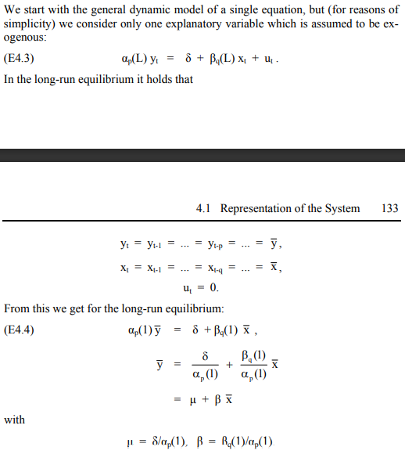

Contrary to the parsimony principle applied in the univariate analysis, the VAR(p) models are over-parameterized systems. The individual parameters can hardly be interpreted meaningfully. For this reason, other methods, like Granger Causality tests, impulse response analysis ad variance decompositions are employed.

**Tests**

Once a VAR model is estimated, it is important to see whether residuals obey model’s assumptions. For testing whether residuals are uncorrelated we use Portmanteau test and Breusch Godfrey LM test.

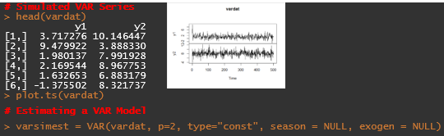 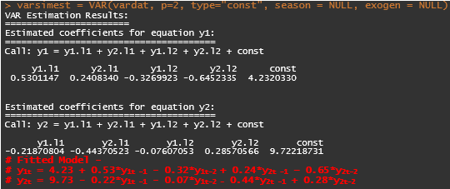

$Y_{1t} = 4.23 + 0.53Y_{1t -1} - 0.32Y_{1t-2} + 0.24Y_{\left(2t -1\right)} – 0.65Y_{2t-2}$

$Y_{2t} = 9.73 - 0.22Y_{1t -1} - 0.07Y_{1t-2} - 0.44Y_{2t -1} + 0.28Y_{2t-2}$

### Portmanteau Test

$Q_{h}=T \sum_{j=1}^{h}{tr\left({\hat{C}}_{j}^{'}{\hat{C}}_{0}^{'}{\hat{C}}_{j}{\hat{C}}_{0}^{-1}\right)} \sim χ_{K^{2}h-n^{*}}^{2} with {\hat{C}}_{j}=\frac{1}{T}\sum_{t=i+1}^{T}{\hat{u_{t}} {\hat{u}}_{t-i}^{'}} where, n^{*}$ is number of deterministic terms.

For small sample, $Q_{h}=T^{2}\sum_{j=1}^{h}{\frac{1}{T-j}tr\left({\hat{C}}_{j}^{'}{\hat{C}}_{0}^{'}{\hat{C}}_{j}{\hat{C}}_{0}^{-1}\right)}$.

**# (1)Portmanteau Test**

> var2c.serial = serial.test(varsimest, lags.pt = 16, type = "PT.asymptotic")

Portmanteau Test (asymptotic)

data: Residuals of VAR object varsimest

Chi-squared = 64.956, df = 56, p-value = 0.1929 **> 0.05**

**# Insufficient to reject H0 at 5% LS, thus residuals are uncorrelated**

### Breusch Godfrey Test

The test is based on an auxiliary regression equation given by –

$$\hat{u_{t}}=A_{1}Y_{t-1}+… A_{p}Y_{t-p}+CD_{t}+B_{1}{\hat{u}}_{t-1}+… B_{h}{\hat{u}}_{t-h}+e_{t}$$

Where, H0 : B1 = … = Bh = 0.

where Σ is residual covariance matrix of restricted and unrestricted models respectively.

**# (2)Breusch Godfrey Test**

> serial.test(varsimest, lags.pt = 16, type = "BG")

Breusch-Godfrey LM test

data: Residuals of VAR object varsimest

Chi-squared = 34.746, df = 20, p-value = 0.0215 **< 0.05**

**# Sufficient to reject H0 at 5% LS, thus residuals are uncorrelated**

### Edgerton & Shukur

They proposed a small-sample correlation defined as –

$LMF_{h}=\frac{1-{\left(1-R_{r}^{2}\right)}^{\frac{1}{r}}}{{\left(1-R_{r}^{2}\right)}^{\frac{1}{r}}}\frac{Nr-q}{Km} with, R_{r}^{2}=1-\frac{\left|\tilde{Σ_{e}}\right|}{\left|\tilde{Σ_{R}}\right|} , q=\frac{1}{2}Km-1, r=\sqrt{\frac{k^{2}m^{2}-4}{k^{2}+m^{2}-5}},$

$N=T-k-m-\frac{1}{2}\left(k-m+1\right)$

* $m=Kh$ and
* n is number of regressors of original system
* $LMF_{h} \sim F_{nK^{2}, INT(Nr-q)}$.

**# (3)Edgerton Shukur Test**

> serial.test(varsimest, lags.pt = 16, type = "ES")

Edgerton-Shukur F test

data: Residuals of VAR object varsimest

F statistic = 1.7468, df1 = 20, df2 = 964, p-value = 0.02213 **< 0.05**

**# Sufficient to reject H0 at 5% LS, thus residuals are uncorrelated**

### ARCH-LM Test

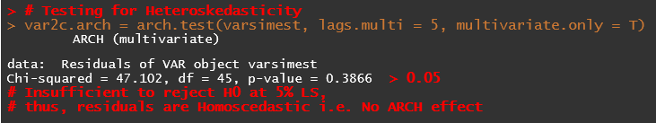

Under univariate series,

${\hat{u}}_{t}^{2}=b_{0}+b_{1}{\hat{u}}_{t-1}+…+ {b_{q}\hat{u}}_{t-q}+e_{t}$

* For ARCH(1), ${\hat{u}}_{t}^{2}=b_{0}+b_{1}{\hat{u}}_{t-1}+e_{t}$ → H0: b1=0 i.e. Homoskedasticity -vs- H1: b1 $≠$ 0 i.e. heteroskedasticity,
* LM = (T – q)R2 ~ χq2

Under VAR,

$vech\left({\hat{u}}_{t}{\hat{u}}_{t}^{'}\right)= β_{0}+B_{1}vech\left({\hat{u}}_{t-1}{\hat{u}}_{t-1}^{'}\right)+…+B_{q}vech\left({\hat{u}}_{t-q}{\hat{u}}_{t-q}^{'}\right)+v_{t}$

* Where, ‘vech’ is column stacking operator for symmetric matrix, which stacks the columns from main diagonal downwards.
* ‘β0’ is K(K+1)/2 dimensional
* ‘Bi’ is coefficient matrix of order K(K+1)/2 x K(K+1)/2
* ‘vt’ is spherical error process
* Here, H0 : B1 = … = Bq = 0 i.e. no arch effect
* Vs H1 : $B_{1}≠0 ∩B_{2}≠0 ∩… B_{q}≠0$
$VARCH_{LM}\left(q\right)=\frac{1}{2}TK\left(K+1\right)R_{m}^{2}\sim χ_{qK^{2}{\left(K+1\right)}^{2}/4}^{2} and R_{m}^{2}=1-\frac{2}{K\left(K+1\right)}tr\left(\hat{Ω}{\hat{Ω}}_{0}^{-1}\right)$

* $where, \hat{Ω}$ is covariance matric of regression matrix.

### Jarque Bera Normality Test

JB normality test applied on univariate and multivariate series are applied to residuals VAR series as well as separate tests for multivariate skewness and kurtosis.

The multivariate version uses residuals that are standardized by a Choleski Decomposition of the variance-covariance matrix for the centered residuals.

$JB_{multi}=s_{3}^{2}+s_{m}^{4}$

* Where, $s_{3}^{2}=T\frac{b_{1}^{'}b_{1}}{6} and s_{4}^{2}=T\frac{{\left(b_{2}-3_{K}\right)}^{'}\left(b_{2}-3_{k}\right)}{24}$
* And $b_{1}, b_{2}$ are 3rd and 4th non-central moment vectors of the standardized residuals given by
* ${\hat{u}}_{t}^{s}={\tilde{P}}^{-}\left({\hat{u}}_{t}-{\overline{\hat{u}}}_{t}\right) and \tilde{P}$ is a lower triangular matrix with positive diagonal such that $\tilde{P}{\tilde{P}}^{'}={\tilde{Σ}}_{u}$ i.e. Choleski decomposition of residual covariance matrix.

|  |  |
| --- | --- |
| |  | | --- | | **> # Testing for Normality**  > var2c.norm = normality.test(varsimest, multivariate.only = T)  $JB  JB-Test (multivariate)  data: Residuals of VAR object varsimest  Chi-squared = 7.4019, df = 4, p-value = 0.1161  $Skewness  Skewness only (multivariate)  data: Residuals of VAR object varsimest  Chi-squared = 5.4419, df = 2, p-value = 0.06581  $Kurtosis  Kurtosis only (multivariate)  data: Residuals of VAR object varsimest  Chi-squared = 1.9601, df = 2, p-value = 0.3753  > plot(var2c.norm) | |

### OLS-CUSUM Test

CUSUM stands for Cumulative Sum of Standardised Residuals.

Here, the aim is to check whether parameters are time-invariant i.e. stable. Thus, this test is called stability test.

# Empirical Fluctuation processes

# Note - un-check 'dse' package first

# library(strucchange)

# library(vars)

> reccusum = stability(varsimest, type="OLS-CUSUM")

> fluctuation = stability(varsimest, type="fluctuation")

> plot(reccusum); plot(fluctuation)

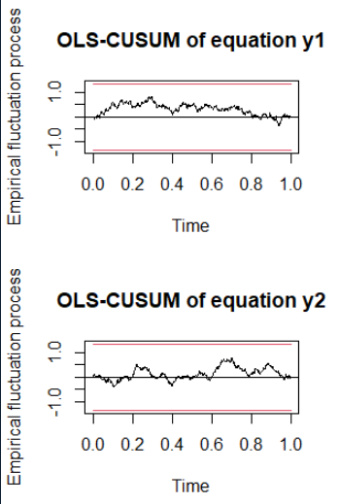 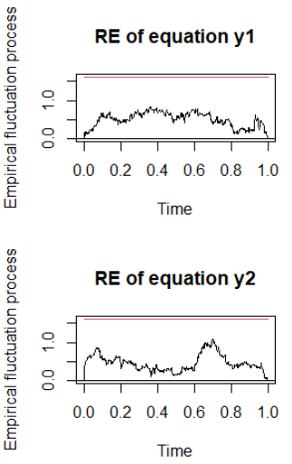

### Causality Tests

* Yt (dim K) is split into 2 subsets Y1t and Y2t (dim K1 x 1 and K2 x 1, K1+K2 = K).
$\left[\begin{matrix}Y_{1t} \\ Y_{2t}\end{matrix}\right]=\sum_{i=1}^{p}{\left[\begin{matrix}α_{11,i} & α_{12,i} \\ α_{21,i} & α_{22,i}\end{matrix}\right]} \left[\begin{matrix}Y_{1,t-i} \\ Y_{2,t-i}\end{matrix}\right]+CD_{t}+\left[\begin{matrix}u_{1t} \\ u_{2t}\end{matrix}\right]$

* ***For Granger Causality***, H0: Y1t does not Granger Cause Y2t i.e. α21,i = 0
* H1: α21,i 0 for i = 1, 2 … p
* Test statistic ~ $F_{pk_{1}k_{2}, kT-n^{*}}$ where, n* is total number of VAR parameters including deterministic regressors.
* ***For Instantaneous Causality***, H0: C σ = 0 (where, C is N x K(K+1)/2 matrix of rank N selecting the relevant covariances of u1t and u2t). σ̃ = vech ($\tilde{Σ_{u}}$).
$Wald Statistic=λ_{w}=T{\tilde{σ}}^{'}C^{'}{\left[2CD_{K}^{+}\left(\tilde{Σ_{u}}⊗\tilde{Σ_{u}}\right){D_{K}^{+}}^{'}C^{'}\right]}^{-1}C \tilde{σ} \sim χ_{N}^{2}$

* Where, $D_{K}^{+}$ Moore Penrose inverse of DK
* DK is duplication matrix (dim K2 x K(K+1)/2 ) [Definition of Duplication matrix → For any symmetric (K x K) matrix A, *vec*(A) = DK *vech*(A) holds].

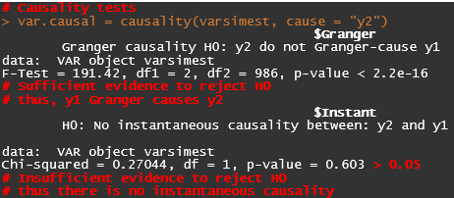

### Impulse response analysis

Aim is to understand how, at a specific point in time t0, an impulse that originates from one variable proceeds through the system. How does a change in the residuals Ui, t0 or in the innovations wi, t0 (i-1,2, …k) influence the components of the vector X?

The impulse response function measures the effect of a unit impulse i.e. of a shock with size of one standard deviation of error term of variable ‘i' at time t0 on variable ‘j’. The cumulative impulse response function describes the effects of a permanent shock on the system.

Granger Causality and Instantaneous causality tests do not quantify impact of impulse variable on response variable over time. Impulse response analysis is used to investigate dynamic interactions between the endogenous variables and is based on Wald Moving Average Representation of VAR(p) process.

$Y_{t}=Φ_{0}u_{t}+Φ_{1}u_{t-1}+Φ_{2}u_{t-2}+…$ with $Φ_{0}=I_{K}$ and $Φ_{s}= \sum_{j=1}^{s}{Φ_{s-j}A_{j}}$ for s = 1,2, …

Note: Aj = 0 for j > p.

The (i, j)th coefficient of Φs matrix are interpreted as expected response of variable Yi, t +s to a unit change in Yi,t.

Orthogonal Response Function → here underlying shocks are less likely to occur in isolation but rather contemporaneous correlation between the components of error process ut exists i.e. off-diagonal elements of Σu are non-zero.

Using Choleski Decomposition of error variance-covariance matrix Σu = PP’ with P being lower triangular.

MA representation → $Y_{t}= Ψ_{0}e_{t}+Ψ_{1}e_{t-1}+... where, e_{t}=P^{-1}u_{t} and Ψ_{i}=Φ_{i}P, Ψ_{0}=P$ for i = 0, 1, 2…

Note - Incidentally, because the matrix P is lower triangular, it follows that only a shock in the first variable of a VAR(p)-process exerts an influence on all the remaining ones and that the second and following variables cannot have a direct impact on Y1t. Please note further that a different ordering of the variables might produce different outcomes with respect to the impulse responses.

> irf.y1 = irf(varsimest, impulse = "y1", response = "y2",

n.ahead = 10, ortho = F, cumulative = F, boot = F, seed = 12345)

> plot(irf.y1)

> irf.y2 = irf(varsimest, impulse = "y2", response = "y1",

n.ahead = 10, ortho = F, cumulative = F, boot = F, seed = 12345)

> plot(irf.y2)

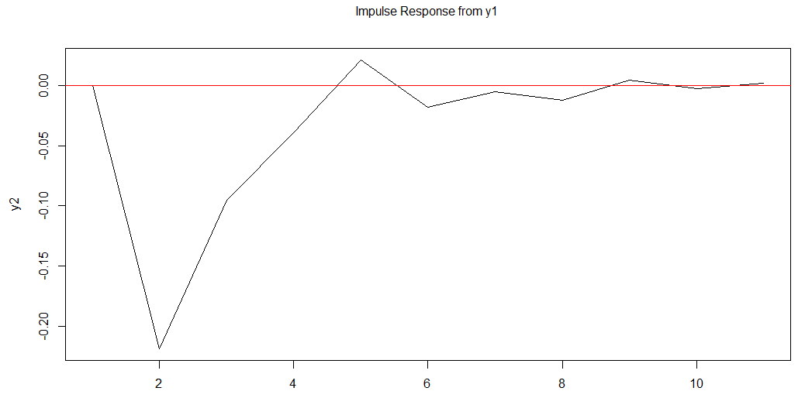 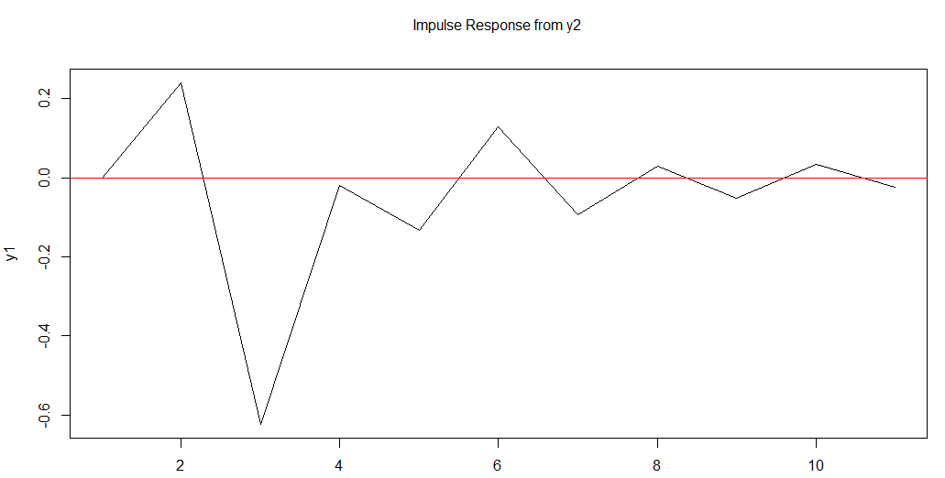

### Forecast Error Variance Decomposition (FEVD)

The aim of the analysis is to decompose the forecast error variance of a variable into those parts which are generated by the innovations of the different variables in the system.

It is based on Orthogonal impulse response coefficient matrices $Ψ_{n}$. The FEVD allows the user to analyze the contribution of variable ‘j’ to the h-step forecast error variance of variable ‘k’. if the element-wise squared orthogonal impulse response are divided by the variance of the forecast error variance σ2k(h), the result is a percentage figure.

**# Forecast Error Variance Decomposition**

> fevd.var2 = fevd(varsimest, n.ahead = 10)

> plot(fevd.var2, addbars = 2)

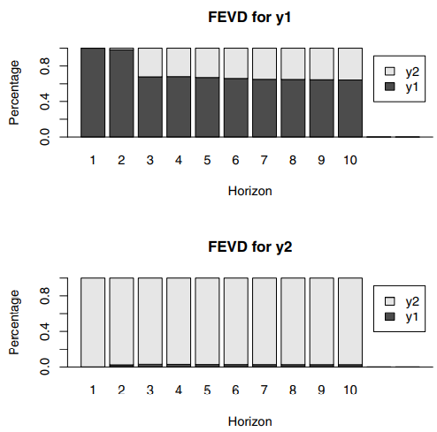

## Bivariate Multivariate White Noise

### Bivariate White Noise

Two series Wx,t and Wy,t are bivariate white noise if they are (1) individually white noise and (2)cross-correlation is zero i.e. $γ_{XY}\left(k\right)=0 ∀k≠0$. Cross correlation at lag 0 can be 0 or non-zero.

### Multivariate White Noise

Series W1,t , W2,t , … Wn,t are multivariate white noise if they are (1) individually white noise and (2)cross-correlation for any pairs of series is zero i.e. $γ_{ij}\left(k\right)=0 ∀i≠j and k≠0$.

* Multivariate Gaussian white noise can be simulated with ***rmvnorm() from mvtnorm library***.
* ***ccf() function*** verifies that cross-correlations are approx. zero for all non-zero lags.

### Pre-Whitening

One simple use of bivariate or multivariate white noise is in the method of pre-whitening. This method works well if multiple series do not have common stochastic trends and cross-correlation is restricted to error process.

* Step 1 → build separate SARIMA models for the multiple time series.
* Step 2 → fitted residuals are saved – they appear to be realisation of multivariate white noise.
* Step 3 → forecast using the separate models and then add multivariate white noise to the forecasts.

## ARFIMA - Fractional Integration/ Differencing

When Yt ~ I(1) series, the ACF declines linearly while Yt~ I(0) series, the ACF declines exponentially. However, there are some time series which share neither of these characteristics. They occur in many disciplines as finance, geophysical sciences, hydrology and macroeconomics. To cope with such time series, our current model has to be enlarged by so-called fractionally integrated process (i.e. long-memory processes).

Definition of Long Memory Process → A process is said to possess a long memory if is non-finite. $\lim_{T→∞}{\sum_{j=-T}^{T}{|ρ_{j}|}}$.

Fractional differencing implies that the value of ‘d’ is no longer restricted to be an integer number. It can be any real number.

Definition of ARFIMA process → the series Yt is an invertible and stationary ARFIMA(p, d, q) process if it can written as $∆^{d}y_{t}=z_{t}$ where, zt is ARMA(p, q) process and both lag polynomials have their roots outside the unit circle (i.e. $∆^{d}y_{t} and z_{t}$ are stationary) and $d ∈(-0.5, 0.5]$.

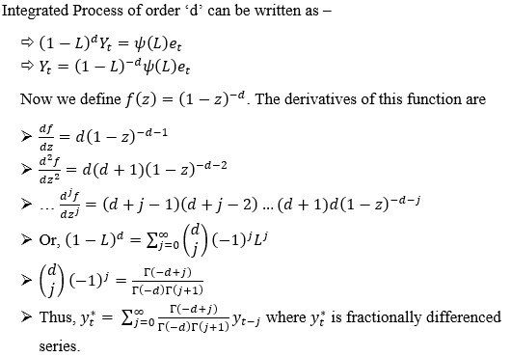

* If **0 < d < 0.5** → **long-memory stationary process**
* If **– 0.5 < d < 0** → anti-persistent or intermediate memory process

(in this case, the process exhibits negative dependency between distant observations)

* As long as **d > -0.5**, it has an invertible MA(∞) representation
* For **d > 0.5**, the series must be integer differenced first.

How is long-memory behaviour incorporated in such a process?

* ACF of long-memory processes declines hyperbolically instead of exponentially as would be the case for stable ARMA model.
* The speed of decay depends on parameter value ‘d’.
* **simARIMA0**() is used to simulate the stationary series from the ***longmemo package***
* **fracdiff.sim**() can be used to simulate long-memory process.
* **fracdiff**() command in ***fracdiff package*** will fit a FARIMA process
* we perform fractional differencing using **diffseries**() command

**#Draft 1 - FARIMA Process**

**#Simulation**

#no. of observations = 2500 #d =(-0.35, 0.35)

#simARIMA0() is used to simulate the stationary series

D = c(0.35, -0.35)

par(mfrow=c(3, 2))

set.seed(09201948)

for (i in 1:2){

H = D[i] + 1/2

x = simARMA0(2500, H)

plot(x, main=toString(paste("d =", D[i])))

acf(x, main=toString(paste("d =", D[i])), lag.max = 48)

}

plot(diff(x), main="d=1")

acf(diff(x), main="d=1", lag.max = 48)

par(mfrow=c(1,1))

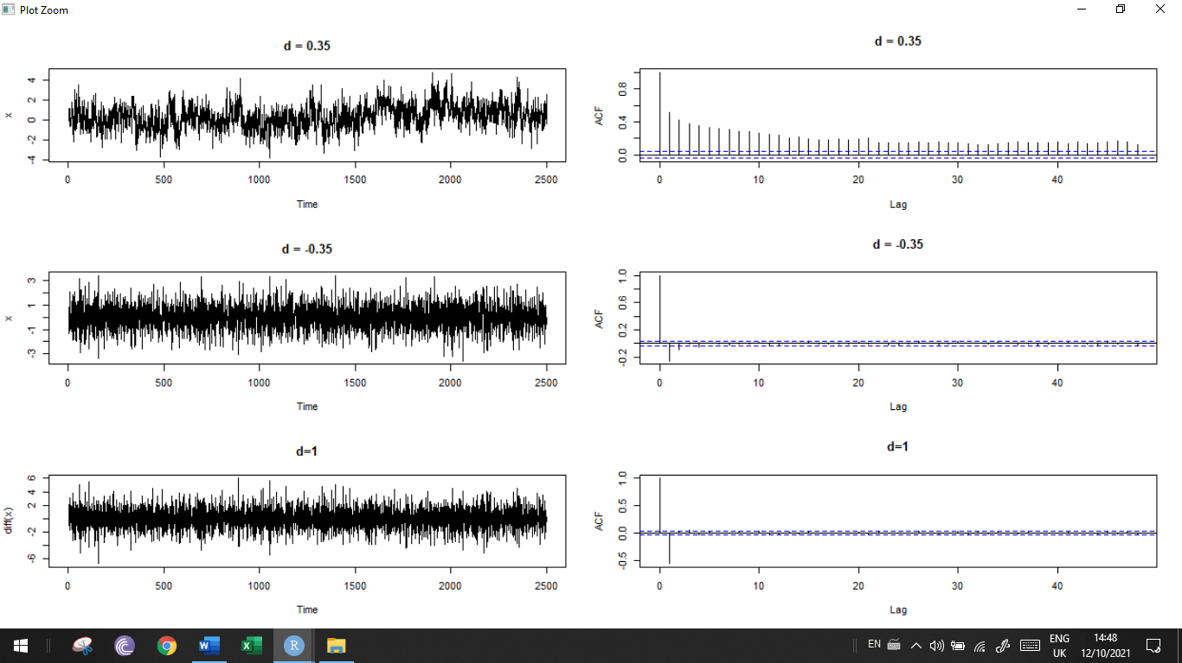

**FARIMA(0,0.35,0) process -**

#sample ACF which drops below 0.5 almost immediately

#but then persists well beyond 30 lags

#this behaviour is typical of stationary processes with long memory

#a short memory stationary process would not have autocorrelations persisting so long

#non-stationary process would not have a sample ACF that dropped below 0.5 so quickly

**FARIMA(0, -0.35,0) process and I(1) process -**

#sample ACF with negative lag1 autocorrelation

#this occurs when the series is differenced once - in such cases, we require a MA term to accommodate the negative autocorrelation

#Thus, we can use a more parsimonious model by fractional differencing.

**#Inflation Rates Example**

**Aim: Compare Fit Of I(1) And Fractional Differencing**

data(Mishkin,package="Ecdat")

y = as.vector(Mishkin[,1])

par(mfrow=c(3,2))

**# Original Series**

plot(ts(y, start=1950, frequency=12), ylab = "y", main="d = 0")

acf(y,main="d = 0")

#slow decaying ACF - typical of a long-memory process

**# Fitting a FARIMA process**

fit.frac = fracdiff(y)

summary(fit.frac) #d-hat = 0.378 (approx..)

fdiffy = diffseries(y, 0.378) #Fractional differencing

plot(ts(fdiffy, start=1950, frequency=12), ylab = "fdiffy", main="d = 0.378")

abline(h=0, col="red")

acf(fdiffy,main="d = 0.378") #looks like a white noise

**# First order differenced series**

plot(ts(diff(y), start=1950, frequency=12), ylab = "diffy", main="d = 1")

abline(h=0, col="red")

acf(diff(y),main="d = 1")

**#Has a negative autocorrelation at lag1 - indicating over differencing**

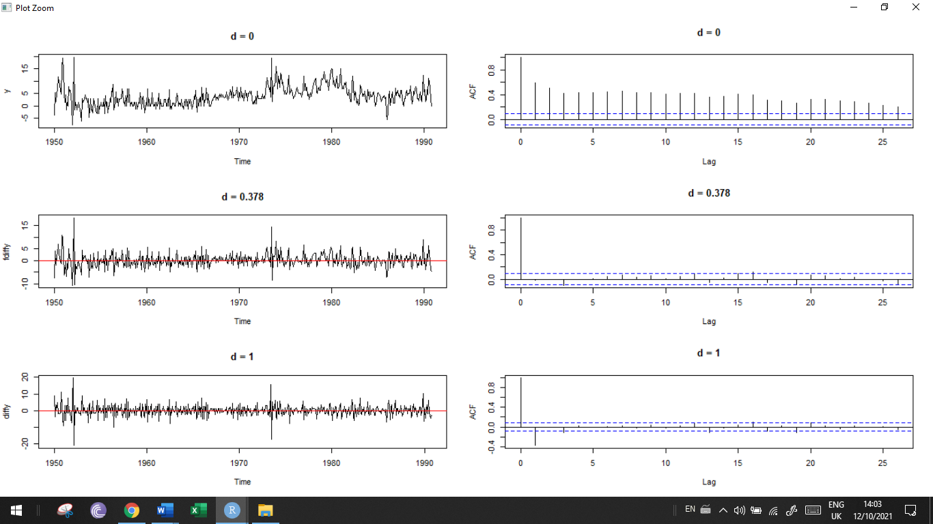

**#Checking Final Fit**

options(digits=5)

auto.arima(diffseries(y, 0.378),ic="bic", trace=TRUE)

Series: diffseries(y, 0.378)

ARIMA(0,0,0) with zero mean

sigma^2 estimated as 8.61 #log likelihood=-1225.3 #AIC=2452.6 #AICc=2452.6 #BIC=2456.8

**#Conclusion: white noise process seems to be a suitable model for the fractionally diff series**

**#original series can be modelled as FARIMA(0, 0.378, 0)**

### RS statistic

For detecting presence of long-memory we can use Hurst test i.e. calculating R/S statistic.

* H0: no long-run dependence

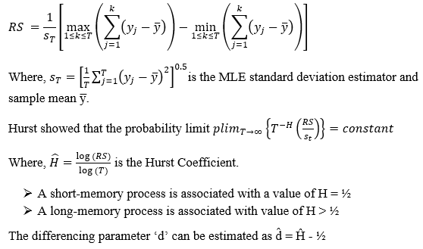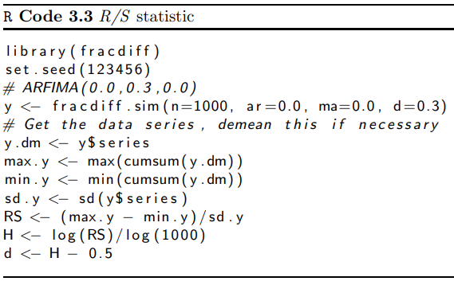

Because the default mean in the function fracdiff is zero, no demeaning has to be done. The estimated Hurst coefficient is 0.7821, which implies an estimated value for d of 0.2821 that is close to its simulated value of 0.3.

Drawback → RS statistic is sensitive to short-range dependence and heteroskedasticity. Hence, any incompatibility between the data and predicted behaviour of RS statistic under H0 of no long-run dependence need not come from long-term memory but may merely be a symptom of short-term autocorrelation.

### Modified RS statistic

To cope with the drawback, Lo [1991] proposed a modified rescaled range statistic.

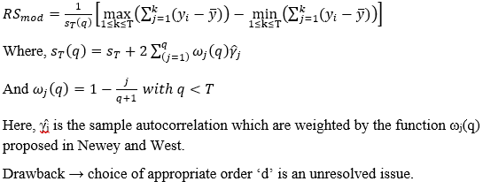

### GPH Method

**Geweke and Porter-Hudak Method**

They suggested a semi-parametric estimator of ‘d’ in the frequency domain.

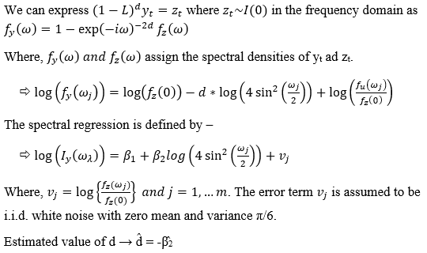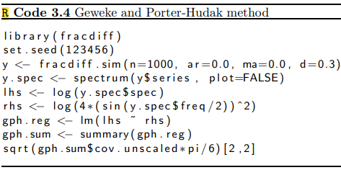

Here, β̂ is approximated as -0.2968 i.e. d = 0.2968 (very close to true value 0.3). In the above code, we have taken all frequencies.

Drawback → selection of range of frequencies to include in regression.

Solution? There are 3 possible ways –

1. Diebold and Rudebusch (1989) set ‘m’ = √T
2. Sowell (1992) set ‘m’ = shortest cycle associated with long-run behaviour.
3. A third possibility would be to chose ‘m’ such that the estimated standard error of the regression is approximately equal to √(π/6).

## SARIMA - Seasonal Time Series

If unit root exists i.e. root equal to 1, then the series exhibits stochastic trend i.e. it follows a ***Random Walk Process (AR(1) with φ =1)***. $Y_{t}=Y_{t-1}+e_{t}=Y_{0}+ϕ_{0}t+ \sum_{i=0}^{t-1}{e_{t-i}}$ i.e. series = initial value + deterministic trend + random component

Our aim is to analyse the stochastic trend which can be done with the help of Unit roots.

Generally, with seasonal data it is best not to remove the seasonal component because it contains useful information for further analysis. The seasonal process is defined as intra-year movements due to changing seasonal factors. It can either be deterministic (clear frequency of 1, 4, 12, 52) or stochastic.

### Seasonality -vs- Cyclic

* **Seasonality -** A seasonal pattern occurs when a time series is affected by seasonal factors such as the time of the year or the day of the week. Seasonality is always of a fixed and known period.
* **Cyclic -** A cycle occurs when the data exhibit rises and falls that are not of a fixed frequency. These fluctuations are usually due to economic conditions, and are often related to the “business cycle.” The duration of these fluctuations is usually at least 2 years.
* 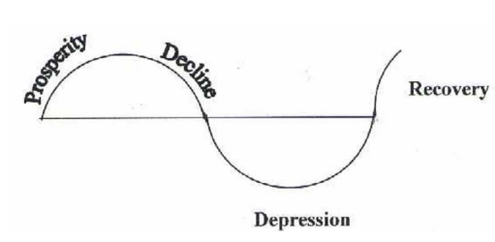 It is easy to confuse cyclic behaviour with seasonal behaviour, but they are really quite different. If the fluctuations are not of a fixed frequency then they are cyclic; if the frequency is unchanging and associated with some aspect of the calendar, then the pattern is seasonal. In general, the average length of cycles is longer than the length of a seasonal pattern, and the magnitudes of cycles tend to be more variable than the magnitudes of seasonal patterns.
* 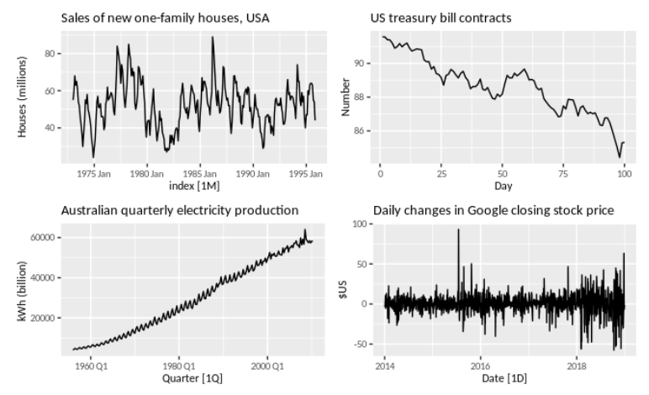The monthly housing sales (top left) show strong seasonality within each year, as well as some strong cyclic behaviour with a period of about 6–10 years. There is no apparent trend in the data over this period.
*  The Australian quarterly electricity production (bottom left) shows a strong increasing trend, with strong seasonality. There is no evidence of any cyclic behaviour here.

### Deterministic Seasonal Process

the seasonal movements over the year is observable and constant. We can specify Yt in terms of pure seasonal dummy variables as follows –

$Y_{t}=α+ \sum_{i=1}^{s-1}{γ_{i}D_{i}}+e_{t}$

* ‘α’ constant – represents average value of Yt in the base year.
* ‘Di’ is the seasonal dummy
* ‘γi’ indicates the seasonal change relative to the omitted season

Say we have a monthly series for 10 years. Thus, we will have 12-1 = 11 dummy variables (to avoid the dummy variable trap). So for the monthly series, we define the dummy variables as –

$D_{1}= \left\{\begin{aligned}1 February \\ 0 otherwise\end{aligned}\right., D_{2}= \left\{\begin{aligned}1 March \\ 0 otherwise\end{aligned}\right.… D_{11}= \left\{\begin{aligned}1 December \\ 0 otherwise\end{aligned}\right.$. For 10 years, we have 10 values for D1, D2, … D11 each.

$Y_{t}=α+γ_{1}D_{1}+γ_{2}D_{2}…+γ_{11}D_{11}+e_{t}$

* $E(Y_{t})=E(α+γ_{1}D_{1}+γ_{2}D_{2}…+γ_{11}D_{11})+E(e_{t})$ This equation is called the ***Population Regression Function*** assuming deterministic seasonality.

As per our assumption E(et) = 0.

* For, D1 = D2 =… D11 = 0, E(Yt) = α → here ‘α’ is average of all January figures of 10 years.
* For, D1 = 1 and D2 =… D11 = 0, E(Yt) = α + γ1 → gives us the conditional mean of Yt given the month is February. Here, γ1 denotes difference between mean value between Jan and Feb.
* Similarly, we can find the conditional means for each period/ season.
* Coefficient of Dummy Variable ‘γi’ indicates seasonal change relative to omitted season (here, Jan)

In deterministic seasonality, ***seasonal means are time-constant*** – this means that the ***whole series is non-stationary*** but the ***sub-series are stationary***.

### Stochastic Seasonality

Stochastic seasonality can be captured as AR, MA or ARMA as in case of annual time series.

#### SAR(p)(P)s

Additive Models

* SAR(1)(1)s
$Y_{ts}=ϕ_{1}Y_{t-1}+ϕ_{1,s}Y_{\left(t-1\right)s}+e_{ts}$

* SAR(2)(1)s
$Y_{ts}=ϕ_{1}Y_{t-1}+ϕ_{2}Y_{t-2}+ϕ_{1,s}Y_{\left(t-1\right)s}+e_{ts}$

* SAR(2)(2)s

$Y_{ts}=ϕ_{1}Y_{t-1}+ϕ_{2}Y_{t-2}+ϕ_{1,s}Y_{\left(t-1\right)s}+ϕ_{2,s}Y_{\left(t-2\right)s}+e_{ts}$

Multiplicative Models

$\left(1-ϕ_{1}L\right)\left(1-ϕ_{1,s}L^{s}\right)Y_{t}=e_{t}$

$Y_{ts}=ϕ_{1}Y_{t-1}+ϕ_{1,s}Y_{\left(t-1\right)s}- ϕ_{1}ϕ_{1,s}Y_{\left(t-1\right)s-1}+e_{t}$

General Form of SAR(p)(P)s

* $ϕ_{p}\left(L\right)ϕ_{P,s}\left(L^{s}\right)Y_{t}=e_{t}$ [Compact Form]

$where, ϕ_{p}\left(L\right)=1-ϕ_{1}L-ϕ_{2}L^{2}-…-ϕ_{p}L^{p}$

$and ϕ_{P,s}\left(L^{s}\right)=1-ϕ_{1,s}L^{1s}-ϕ_{2,s}L^{2s}-…-ϕ_{p,s}L^{ps}$

#### SMA(q)(Q)s

Additive model

* SMA(1)(1)s
$Y_{ts}=e_{ts}+ θ_{1}e_{t-1}+θ_{1s}e_{\left(t-1\right)s}$

* SMA(1)(1)12

$Y_{t12}=e_{t12}+ θ_{1}e_{t-1}+θ_{1,12}e_{\left(t-1\right)12}$

General Form of SMA(q)(Q)s

* $Y_{ts}= θ_{q}\left(L\right)θ_{Qs}\left(L^{s}\right)e_{ts}$ [Compact Form]

$Y_{ts}=\left[e_{ts}+ θ_{1}e_{t-1}+… + θ_{q}e_{t-q}\right]+\left[θ_{1s}e_{\left(t-1\right)s}+…+θ_{Qs}e_{\left(t-Q\right)s}\right]$

#### SARMA(p, q)(P, Q)s

* $ϕ_{p}\left(L\right)ϕ_{Ps}\left(L^{s}\right)Y_{ts}= θ_{q}\left(L\right)θ_{Qs}\left(L^{s}\right)e_{ts}$ [Compact Form]
* SARMA(1, 1)(1, 1)s [Additive]
$Y_{ts}=ϕ_{1}Y_{t-1}+ϕ_{1s}Y_{\left(t-1\right)s}+ θ_{1}e_{t-1}+ e_{ts}+θ_{1s}e_{\left(t-1\right)s}$

* SARMA(1, 1)(1, 1)s [Multiplicative]

$\left(1-ϕ_{1}L\right)\left(1-ϕ_{1s}L^{s}\right)Y_{ts}=\left(1+θ_{1}L\right)\left(1+θ_{1s}L^{s}\right)e_{ts}$

#### SARIMA(p, d, q)(P, D, Q)s

$ϕ_{p}\left(L\right)ϕ_{Ps}\left(L^{s}\right){\left(1-L\right)}^{d}{\left(1-L^{s}\right)}^{D}Y_{ts}= θ_{q}\left(L\right)θ_{Qs}\left(L^{s}\right)e_{ts}$ [Compact Form]

* SARIMA(1,1,1)(1,1,1)s [Multiplicative]
$(1-ϕ_{1}L)(1-ϕ_{Ps}L^{s})(1-L)(1-L^{s})Y_{ts}=(1+θ_{1}L)(1+θ_{1s}L^{s})e_{ts}$

$if we put Z_{ts}= (1-L)(1-L^{s})Y_{ts}$

$\left(1-ϕ_{1}L\right)\left(1-ϕ_{Ps}L^{s}\right)Z_{ts}=\left(1+θ_{1}L\right)\left(1+θ_{1s}L^{s}\right)e_{ts}$

$Z_{ts}=ϕ_{1s}Z_{\left(t-1\right)s}+ϕ_{1}Z_{\left(t-1\right)}-ϕ_{1}ϕ_{1s}Z_{\left(t-1\right)s-1}+e_{ts}+θ_{1s}e_{\left(t-1\right)s}+θ_{1}e_{\left(t-1\right)}+θ_{1s}θ_{1}e_{\left(t-1\right)s-1}$

* Zts will be stationary when mod(φ1s) < 1 and mod(φ1) < 1

**Note** - A seasonal time series Yt is integrated of order (d, D) if the series is stationary after 1st order differencing ‘d’ times and seasonal differencing ‘D’ times.

### Purely Seasonal Process

#### SAR(P)s

$$ϕ_{Ps}\left(L^{s}\right)Y_{t}=e_{t}$$

$$Y_{ts}=ϕ_{1s}Y_{\left(t-1\right)s}+ϕ_{2,s}Y_{\left(t-2\right)s}+…+ϕ_{P,s}Y_{\left(t-P\right)s}+e_{ts}$$

* SAR(1)s

$Y_{ts}=ϕ_{1s}Y_{\left(t-1\right)s}+e_{ts}$

For Quarterly Data, we have

$Y_{t4}=ϕ_{1,4}Y_{\left(t-1\right)4}+e_{t4}$

* For t = 1, $Y_{4}=ϕ_{1,4}Y_{0}+e_{4}$
* For t = 2, $Y_{8}=ϕ_{1,4}^{2}Y_{0}+ϕ_{1,4}e_{4}+e_{8}$
* For t = 3, $Y_{12}=ϕ_{1,4}^{3}Y_{0}+ϕ_{1,4}^{2}e_{4}+ϕ_{1,4}e_{8}+e_{12}$
* Thus, $Y_{t,4}=ϕ_{1,4}^{t}Y_{0}+\sum_{j=0}^{t-1}{ϕ_{1,4}^{j}e_{4\left(t-j\right)}}$

For seasonal frequency ‘s’

$Y_{t,s}=ϕ_{1,s}^{t}Y_{0}+\sum_{j=0}^{t-1}{ϕ_{1,s}^{j}e_{s\left(t-j\right)}}$

$E(Y_{t,s})={E(ϕ}_{1,s}^{t}Y_{0})+0$

The process will be stationary only when $ϕ_{1,s}^{t}Y_{0}$ → 0 as t → $∞$ i.e. the process converges towards its long-run average. This all happens when mod(φ1s) < 1.

#### SMA(Q)s

* SMA(1)s
$Y_{ts}=e_{ts}+θ_{1s}e_{\left(t-1\right)s}$

* SMA(2)s
$Y_{ts}=e_{ts}+ θ_{1s}e_{\left(t-1\right)s}+θ_{2,s}e_{\left(t-2\right)s}$

* SMA(Q)s

$Y_{ts}=e_{ts}+ θ_{1s}e_{\left(t-1\right)s}+…+ θ_{Q,s}e_{\left(t-Q\right)s}$

#### SARMA(P, Q)s

$ϕ_{Ps}\left(L^{s}\right)Y_{ts}= θ_{q}\left(L\right)θ_{Qs}\left(L^{s}\right)e_{ts}$

#### SARIMA(P, D, Q)s

$$ϕ_{Ps}\left(L^{s}\right){\left(1-L^{s}\right)}^{D}Y_{ts}= θ_{Qs}\left(L^{s}\right)e_{ts}$$

#### SARIMA(P, D, Q)s – with Deterministic Component

$ϕ_{Ps}\left(L^{s}\right){\left(1-L^{s}\right)}^{D}Y_{ts}=α+βt+ \sum_{i=1}^{s}{γ_{i}D_{i}}+ θ_{Qs}\left(L^{s}\right)e_{ts}$

### Seasonal Random Walk

These are SAR(P)s processes with $ϕ_{1,s}=0$, given by → $Y_{ts}=Y_{\left(t-1\right)s}+e_{ts} or, \left(1-L^{s}\right)Y_{ts}=e_{ts}$

For a Quarterly Data,

$\left(1-L^{4}\right)Y_{t4}=e_{t4}$

$\left(1+L^{2}\right)\left(1+L\right)\left(1-L\right)Y_{t4}=e_{t4}$

* $\left(1+iL\right)(1-iL)\left(1+L\right)\left(1-L\right)Y_{t4}=e_{t4}$ [4 roots]

There are 4 roots where 2 are real and 2 are complex.

* **Using Filter (1 – L), root = 1**
$\left(1-L\right)Y_{t}=u_{t}$

* $Y_{t}=Y_{t-1}+u_{t}$– is a random walk used to model stochastic trend behaviour
* Root = 1 corresponds to zero frequency i.e. 1-cycle within-a-year. Here, we ignore the seasonal frequency.
* **Using Filter (1 + L), root = -1**
$\left(1+L\right)Y_{t}=u_{t}$

$Y_{t}= -Y_{t-1}+u_{t}$

$Y_{t-1}= -Y_{t-2}+u_{t-1}$

$Y_{t}= Y_{t-2}+\left(u_{t}-u_{t-1}\right)$

* This exhibits regular 2-period fluctuations. The process is like a random walk where we observe every 2nd observation. For large values of ‘t’, the correlation between two adjacent elements of this process approaches -1.
* Root = -1 corresponds to ½ cycle-per quarter i.e. 2 quarters make 1 cyclic variation. Thus, we have 2 cycles within a year.
* **Using Filter (1 + L2), root = +/- *i***
* This exhibits regular 4-period fluctuations i.e. All adjacent elements are uncorrelated, while the correlation between values of Y which are 2 periods apart from each other converges to (-1) for large values of ‘t’. The process is like a random walk where we observe every 4th observation.

Thus, the process with roots -1 and $±i$ capture the non-stationary seasonal fluctuations of quarterly data. To eliminate such fluctuations (1 + L)(1 + L2) = 1 + L + L2 + L3, must be used i.e. a 3rd order moving average eliminates non-stationary seasonal fluctuations quarterly of data. This is because of

$\left(1-L^{4}\right)=(1-L)(1+L+L^{2}+L^{3})$ forming annual differences also eliminates any stochastic trend

### Seasonal Unit Root

SAR(1) given by $Y_{ts}=ϕ_{1s}Y_{\left(t-1\right)s}+e_{ts} = ϕ_{1s}^{t}Y_{0}+ \sum_{j=0}^{t-1}{ϕ_{1s}^{j}e_{\left(t-j\right)s}}$

For quarterly, roots zi = {1. -1. *i*, -*i*}

For higher seasonal frequencies (like 12, 52) we have many roots which cannot be solved by simple algebra. Instead we use Trigonometry to generalise results for any frequency.

For frequency ‘s’ characteristic equation zs-1 = 0. This equation has ‘s’ roots on the unit circle.

$z_{j}=e^{2π i\frac{j}{s}}=\cos\left(\frac{2πj}{s}\right)+i\sin\left(\frac{2πj}{s}\right) for j=0, 1, …s-1$

* Where, *zj* is the jth unit root. Each root is related to a specific frequency $θ_{j}=2πj/s$
* ‘j’ is the number of cycles involved in *zj*.
* Note: out of ‘s’ roots, for j = 0 i.e. Zero Frequency, z0 is called the non-seasonal unit root and other roots will be called seasonal unit roots.

For Quarterly data, s = 4

$$z_{j}=e^{π i j \frac{1}{2}}=\cos\left(\frac{π}{2} j\right)+i\sin\left(\frac{π}{2} j\right) for j= 0, 1, 2, 3$$

How many cycles can we expect in the behaviour of our data?

* For j = 0, $z_{0}=\cos\left(0\right)+i\sin\left(0\right)=1$
* For j = 1, $z_{1}=\cos\left(\frac{π}{2}\right)+i\sin\left(\frac{π}{2}\right)=i$
* For j = 2, $z_{2}=\cos\left(π\right)+i\sin\left(π\right)= -1$
* For j = 3, $z_{3}=\cos\left(\frac{3π}{2}\right)+i\sin\left(\frac{3π}{2}\right)= -i$

For Monthly data, s = 12

$z_{j}=e^{π i j \frac{1}{6}}=\cos\left(\frac{π}{6} j \right)+isin\left(\frac{π}{6}j\right) for j=0, 1, …11$

|  |  |  |
| --- | --- | --- |
| ***Number of cycles*** | ***Frequency (π j / 6)*** | ***Roots (Zj)*** |
| j = 0 | 0 | **1** |
| j = 6 | π | **-1** |
| j = 1, 7 | π/6 | $\frac{1}{2} \left(\sqrt{3}±i\right)$ |
| j = 2, 9 | π/3 | $\frac{1}{2} \left(1± \sqrt{3i}\right)$ |
| j = 3, 11 | π/2 | $$± i$$ |
| j = 4, 8 | 2π/3 | **- $\frac{1}{2} \left(1± \sqrt{3i}\right)$** |
| j = 5, 10 | 5π/6 | $-\frac{1}{2} \left(\sqrt{3}±i\right)$ |

We can generalise the following patterns –

* For j = 0, root = 1 (always) i.e. at zero-frequency there is no variation
* For j = s/2, root = -1 (always0 i.e. at mid-point frequency
* All other roots will be complex conjugate roots
* 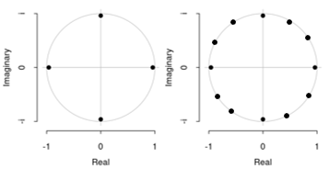

### Testing for Seasonal Unit Root

* Dickey Fuller test directly can only performed for AR(1) series
* Augmented Dickey Fuller test allows to deal with higher order AR series but not with seasonal series
* Dickey Hasza Fuller (DHF Test) – test is restricted to SAR(1) series
 $∆_{s}Y_{ts}=ρY_{\left(t-1\right)s}+ \sum_{j=1}^{k}{β_{j}∆_{s}Y\left(\left(t-j\right)s\right)}+e_{ts}$

 + H0: ρ = 0 i.e. presence of ‘s’ unit roots at every cycle
  + H1: ρ < 0 i.e. no unit root at all frequencies
  + Drawback – this test cannot be applied to intermediate scenarios e.g. having unit roots at some (not all) frequencies other than 0.
* HEGY Test relies on the shape of polynomial expansion of φs(L)
* Del Barrio Castro Osborn and Taylor – defined the DGP of a univariate seasonal series (Y) consisting of a deterministic part (μ) and a stochastic part (x) as –
* $Y_{ts}=μ_{ts}+x_{ts}$ i.e. series = deterministic + stochastic
* where, $μ_{ts}= α_{0}+βt+ ∑γ_{j}D_{j}=mean value constant+deterministic time trend+seasonal dummies$
* and, $ϕ_{s}\left(L\right)x_{ts}=u_{ts} (white nosie)$
* Lag Polynomial is given by –
  + $ϕ_{s}\left(L\right)=1- ϕ_{1}L- ϕ_{2}L^{2}…ϕ_{s}L^{s}$ can be expressed as –

$ϕ_{s}\left(L\right)=\left(1-ϕ_{0}L\right)\left(1-ϕ_{s\frac{1}{2}}L\right)Π_{j=1}^{\frac{S}{2}-1}\left[1-2\left\{β_{1j}\cos\left(\frac{2πj}{s}\right)-β_{2j}\sin\left(\frac{2πj}{s}\right)\right\}L+\left(β_{1j}^{2}+β_{2j}^{2}\right)L^{2}\right]$

This helps us to separate the non-seasonal and seasonal roots.

For Quarterly Data,

* + Where, ‘ $α_{0}$’ is the mean value associated with zero-frequency (j = 0) capturing non-seasonal unit root
  + ‘ $ϕ_{s\frac{1}{2}}$’ component for half seasonal duration associated with Nyquist frequency (π) (terminology of numerical analysis indicating mid-point).
  + ‘ $β_{1j} and β_{2j}$’ are associated with conjugate seasonal frequency 2π j/s and 2π – 2π j/s

### HEGY Steps

* Step 1 : Detrend the data

We start by estimating the deterministic part using OLS or GLS methods.

$μ_{ts}= α_{0}+βt+ ∑γ_{j}D_{j}=δ^{'}w_{ts}$

The deterministic part plays an important role in determining the distribution of seasonal unit root test.

|  |  |  |
| --- | --- | --- |
| j = 0 | H0,0: φ0 = 1 i.e. presence of non-seasonal unit root at zero-frequency | H1, 0: φ0 < 1 i.e. stationary in long-term |
| j = s / 2 | H0,s/2: φ s/2 = 1 i.e. presence of unit root at s/2 frequency | H1, s/2 : φ s/2 < 1 i.e. stationary at half-frequency |
| j = others | H0,k: β1k=1 and β2k=0 for k=1, 2 … s/2 – 1 i.e. presence of seasonal harmonic frequency | H1, k : β21k + β22k<1 for k=1, 2 … s/2 – 1 i.e. stationary at remaining cycles |

* Step 2

From step 2, we get ${\tilde{Y}}_{ts}=Y_{ts}-{\hat{δ}}^{'}w_{ts}$ i.e. detrended series. The regression equation used in HEGY Test in Augmented Form is –

$$∆_{s}{\tilde{Y}}_{ts}= π_{0}{\tilde{Y}}_{0,t}+ π_{s/2}{\tilde{Y}}_{\frac{s}{2},t}+ \sum_{i=1}^{\frac{s}{2}-1}{π_{1i}{\tilde{Y}}_{1i, t}+{π_{2i,t}\tilde{Y}}_{2i, t}}+\sum_{j=1}^{k-1}{τ_{j}∆_{s}{\tilde{Y}}_{\left(t-j\right)s}}+e_{ts}$$

Here, $\sum_{j=1}^{k-1}{τ_{j}∆_{s}{\tilde{Y}}_{\left(t-j\right)s}}$ implies that the original series was of order ‘k’. This is the augmented term to capture possible serial correlation due to possible presence of higher order autoregression.

Here,

* H0,0: π0 = 0
* H0,s/2: πs/2 = 0
* H0,*i* : π1,*i* = 0, π2,*i* = 0 for i = 1,2 … s/2-1

The first two tests are carried out by using the lower-tail of t-distribution (left tailed test) and the third test is carried out using the upper-tail of F-distribution (right tailed test).

## ARIMAX Model

ARIMAX is the extended form of ARIMA Model (at multivariate case), this is the integration of AR and MA parameters, this is univariate short term forecasting technique. It works well with small datasets.

In ARIMAX model, we consider an exogenous regression covariate.

E.g. of exogeneous covariate – in agriculture, production forecast can be based on factors like area of land, seed quality. We can also include factors like rainfall which is an exogeneous variables whose value will be determined by other factors like humidity, wind speed and other weather factors.

Model → $Y_{t}=βX_{t}+ϕ_{1}Y_{t-1}+…+ϕ_{p}Y_{t-p}- θ_{1}z_{t-1}-…- θ_{q}z_{t-q}+z_{t}$

Here, Yt is regresses on its past values and errors, along with Xt.

## ARCH-&-GARCH Models

### ARCH Model

**Eagle’s ARCH Model : $y_{t}=e_{t}+α\sqrt{e_{t}^{2}}$.** This model is heteroskedastic i.e. non-linear in variance but linear in mean. This model has several other variations, like GARCH, EGARCH etc.

**Auto Regressive Models with Conditional Heteroscedasticity**

* + 1. Financial assets often display the following behaviour.
    2. After a large change in the asset price there follows a period of high volatility, which can be in either direction.
    3. Following small changes there tend to be further small changes. In other words, the variance of the process is dependent upon the size of the previous value.
    4. This is the property of conditional heteroscedasticity.
    5. The words ‘homoscedastic’ and ‘heteroscedastic’ just mean having equal (i.e. constant) or different variances respectively.
    6. The class of autoregressive models with conditional heteroscedasticity of order p – the ARCH(p) – is defined by the relation

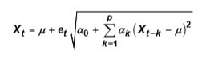 Where, e is a sequence of independent standard normal random variables.

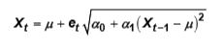ARCH (1) Model

The ARCH models have been used for modelling financial time series. If Zt is the price of an asset at the end of the tth trading day, it is found that the ARCH model can be used to model Xt = ln ( Zt/Zt-1), interpreted as the daily return on day t .

The ARCH family of models captures the feature frequently observed in asset price data that a significant change in the price of an asset is often followed by a period of high volatility.

**Exponential smoothing expected to outperform Box-Jekins?**

**–** When there is a slowly varying trend or multiplicative seasonal variations.

**Exponential smoothing preferred over Box-Jenkins technique?**

**–** When there is a slowly varying trend and there is multiplicative rather than additive, seasonal variation.

### GARCH Model

A further extension widely used in financial applications is the Generalised ARCH Model, denoted by GARCH(q, p) with has the ARCH(p) model as the special case GARCH(0, p).

A series et is GARCH(q, p) if $e_{t}=w_{t}\sqrt{h_{t}}$ where $h_{t}=α_{0}+\sum_{i=1}^{p}{α_{i}e_{t-i}^{2}}+ \sum_{j=1}^{q}{β_{j}h_{t-j}}$.

#### GARCH(1,1) Model

A GARCH(1,1) Model is given by $h_{t}^{2}=α_{0}+αe_{t-1}^{2}+βh_{t-1}^{2}$, where α0 >0, α >0, β >0.

* Here, the Squared Residuals follow ARMA(1,1) process. $e_{t}^{2}=α_{0}+\left(α+β\right)e_{t-1}^{2}+v_{t}-βv_{t-1}$, which is stable for 0< α +β < 1.
* **Unconditional Variance $V\left(e_{t}\right)=\frac{α_{0}}{1-α-β}$**
* **Kurtosis** also exists if $3α^{2}+2αβ+β^{2}<1$.

$K\left(e_{t}\right)=3+\frac{6α^{2}}{1-β^{2}-2αβ-3α^{2}}$. The Kurtosis is always above 3 (value for normal distribution) since α>0

Thus, GARCH(1,1) is used to model distributions with fat tails.

* If value of α → 0, then heteroskedasticity disappears and the value of kurtosis → 3. It depends more strongly on α than on β.
* **ACF of GARCH** → ACF values show no correlation but squared ACF are correlated.
* **ARCH(∞) Representation** → $h_{t}^{2}=\frac{α_{0}}{1-β}+α\sum_{j=1}^{∞}{β^{j-1}e_{t-j}^{2}}$. The larger β, the longer the effect of the shocks.

### Non-linear Extension of ARCH

A problem arises especially when estimating higher order ARCH models without restrictions: the estimated coefficients violate the non-negativity constraints. To avoid this, use multiplicative approach for conditional variance: $h_{t}^{2}=e^{α_{0}}e_{t-1}^{{2α}_{1}}e_{t-2}^{{2α}_{2}}…e_{t-q}^{{2α}_{q}}$ or $\log\left(h_{t}^{2}\right)=α_{0}+α_{1}\log\left(e_{t-1}^{2}\right)+α_{2}\log\left(e_{t-2}^{2}\right)…+α_{q}log⁡(e_{t-q}^{2})$. This expression is always positive regardless of whether the parameters are positive or negative.

Drawback → this says that positive and negative shocks exerts the same impact on the conditional variance as the signs disappear due to squaring. On the other hand, it is well known that reaction of volatility of share prices is different if the shocks are negative i.e. if they result from bad news, than if they are positive, i.e. if they result from good news. This leverage effect leads to higher volatility as a result of negative shocks as compared to positive ones.

### TGARCH aka Threshold GARCH Model

Here we assume different GARCH models for positive and negative shocks. Thus, the TGARCH(1,1) model can be written as $h_{t}^{2}=α_{0}+αe_{t-1}^{2}+γe_{t-1}^{2}d_{t-1}+βh_{t-1}^{2}$, with $d_{t}\left\{\begin{aligned}1 if e_{t}<0 \\ 0 otherwise\end{aligned}\right.$.

If γ >0, a leverage effect is observed as the impulse α + γ of negative shocks is larger than the impulse α of positive shocks.

### EGARCH aka Exponential GARCH Model

This model not only captures asymmetries but also ensures that the conditional variance is always positive. The EGARCH(1,1) model can be written as $\ln\left(h_{t}^{2}\right)=α_{0}+α\left|\frac{e_{t-1}}{h_{t-1}}\right|+γ\left|\frac{e_{t-1}}{h_{t-1}}\right|+βln⁡(h_{t-1}^{2})$.

Here, the standardised residuals e/h are used.

The ARCH effect is produced by the absolute value of standardised residuals and not by their squares. The asymmetry is also captured by the standardised residuals.

For $γ≠0$, we find an ARCH effect of α + γ for positive residuals and one for α – γ for negative residuals. If a leverage effect exists, we expect γ to be negative.

The main difference between EGARCH and TGARCH is that leverage effect is significant in the EGARCH model.

### ARCH-in-Mean Model

It is assumed that higher returns of a financial asset imply a higher risk. Therefore, mean and variance tend to go into the same direction. If we assume the risk premium to be time-dependent, this can be represented by applying the ARCH-in-mean (ARCH-M) approach. $Y_{t}=βX_{t}+δh_{t}^{2}+e_{t}$, where $e_{t}|I_{t-1}\sim N(0,\backslash h_{t}^{2})$, where the variance ht2 might be generated by an ARCH or GARCH process.

## Time Series Plots

### autoplot

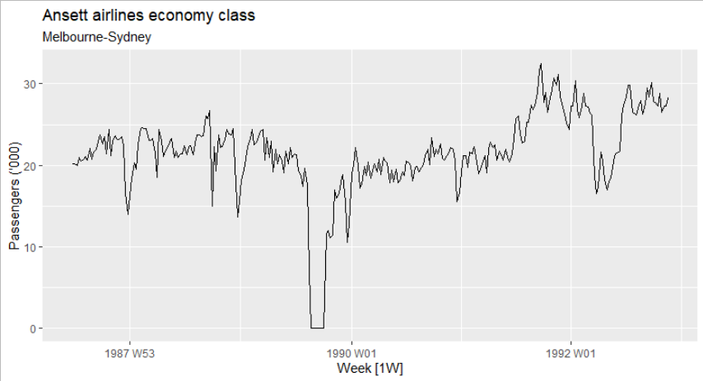

* + There was a period in 1989 when no passengers were carried — this was due to an industrial dispute.
  + There was a period of reduced load in 1992. This was due to a trial in which some economy class seats were replaced by business class seats.
  + A large increase in passenger load occurred in the second half of 1991.
  + There are some large dips in load around the start of each year. These are due to holiday effects.
  + There is a long-term fluctuation in the level of the series which increases during 1987, decreases in 1989, and increases again through 1990 and 1991.
  + There are some periods of missing observations.

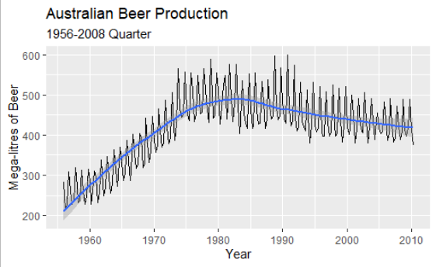 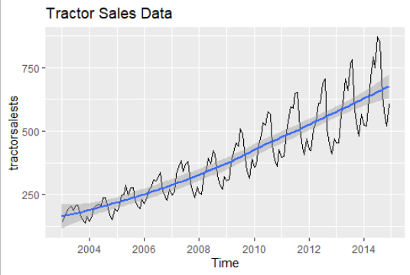

### ggtsdisplay

***Plot of PACF***

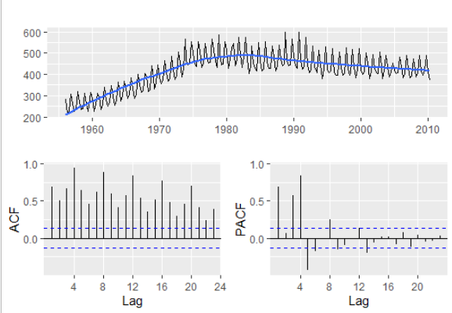 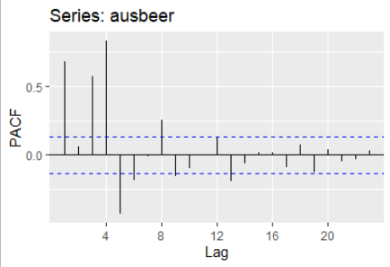

***Histogram***

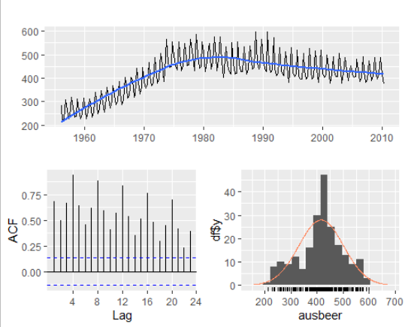 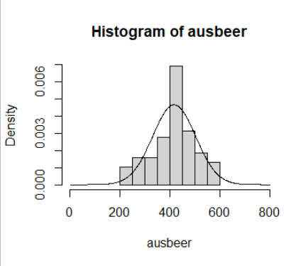

***Scatter***

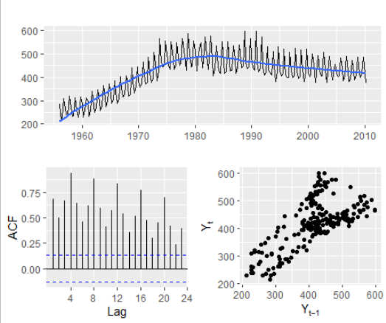 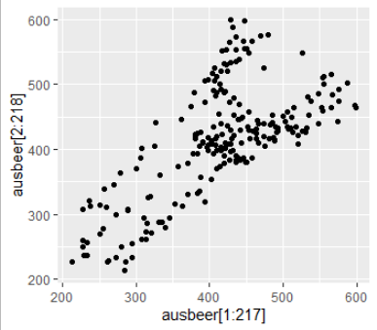

***Spectrum***

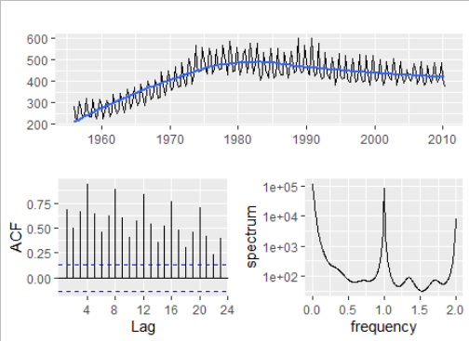 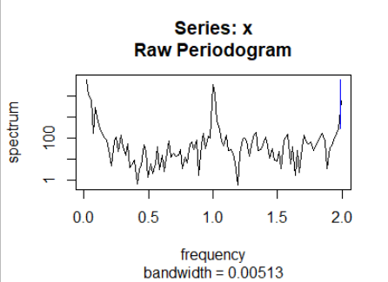

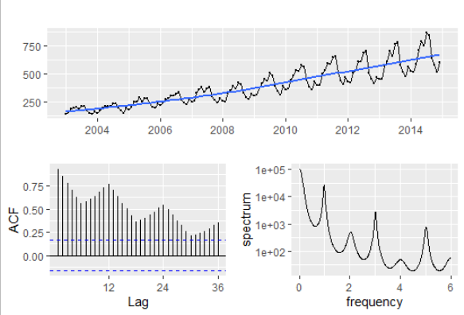 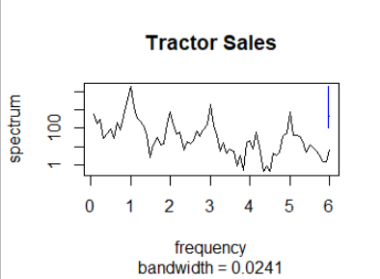

### gglag plot

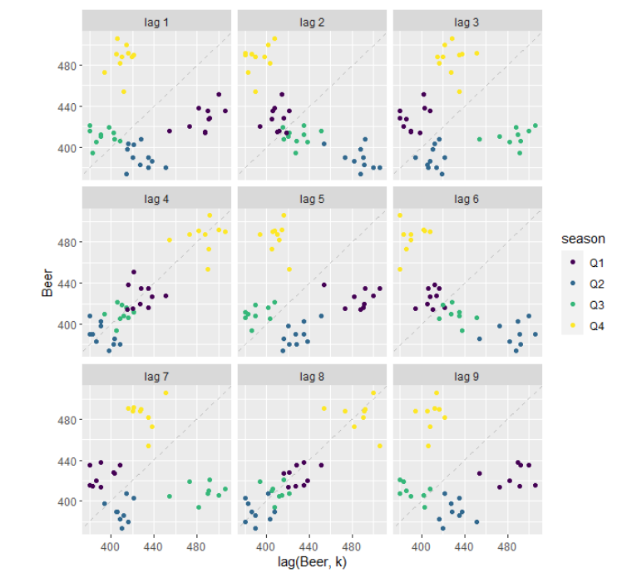

* Each graph shows plot of Yt plotted against Yt-k, where ‘k’ are different lags.
* Different colours indicate different lags
* Close to dotted line = strong relationship
* Here, at lags 4 and 8 there is strong positive relationship – indicating strong seasonality
* There is at lags 2 and 6 negative relationship

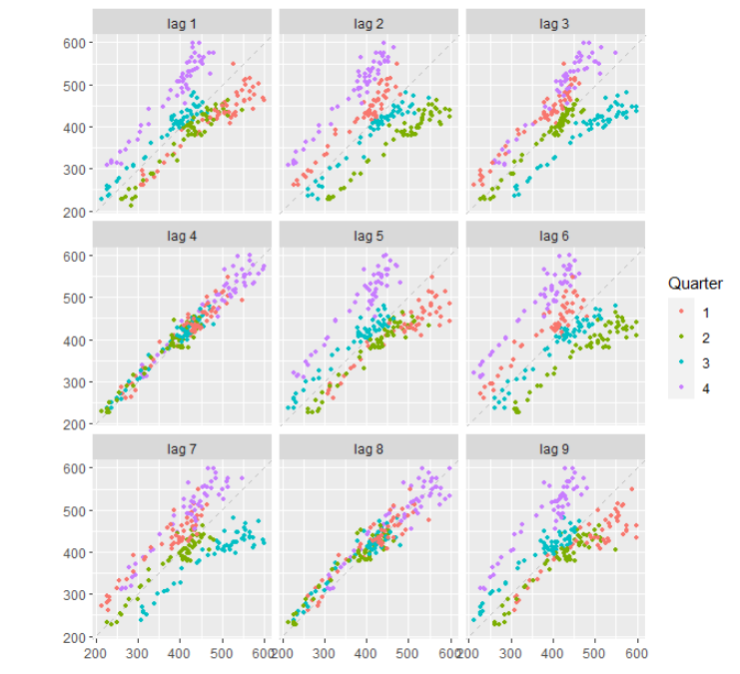

* Very strong positive relationship at lags 4 and 8 – strong seasonality, makes some sense because the data is quarterly.
* There is positive relationship at all lags.

### STL features

***Choosing between ‘STL’ and ‘decompose’***

* First plot original time series
* If there is no clear pattern in amplitude of seasonality or volatility is not increasing over time, we use an ‘additive’ model instead of ‘multiplicative’ model.
* If the dataset is monthly observations – not spanning over an integer number of years. We prefer ‘STL’ function.
* If data is additive, and does not span over integer time period, we use ‘STL’ function

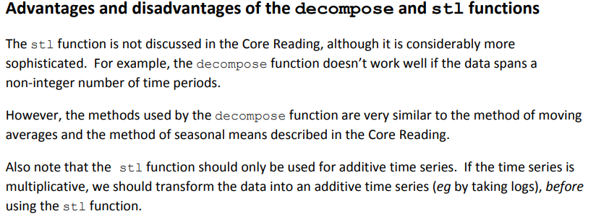

Time series decomposition can be used to measure the strength of trend and seasonality in a time series.

* Yt = Tt + St + Rt
* Where, T is smoothed trend component, S seasonal component and R random component.
* For strongly trended data, ***seasonally adjusted data*** should have much more variation than the remainder component. (seasonally adjusted data has 2 components, trend and random, if trend is strong it translates into variance of trend > variance of random). Thus, $\frac{V\left(R_{t}\right)}{V\left(R_{t}+T_{t}\right)}$ should be relatively small. But for data with little to no trend, the two variances should be approximately same.
* Thus, Strength of trend = Ft = $\max\left(0, 1-\frac{Var\left(R_{t}\right)}{Var\left(T_{t}+R_{t}\right)}\right)$

This gives us measure of strength of trend between 0 and 1.

Now, because the variance of the remainder V(Rt) might occasionally be even larger than the variance of the seasonally adjusted data, we set the minimal possible value of Ft equal to zero

* The strength of seasonality, of ***detrended data*** is given by –

$F_{s}=max⁡(0, 1-\frac{Var\left(R_{t}\right)}{Var\left(S_{t}+R_{t}\right)}$

$F_{s}$ close to zero = no seasonality, while Fs close to 1 = strong seasonality because Var(Rt) is much smaller than V(Rt + St)

* These measures can be useful when we have to find the series with the strongest trend or seasonality.

### Seasonal Plot

A seasonal plot allows the underlying seasonal pattern to be seen more clearly, and is especially useful in identifying years in which the pattern changes.

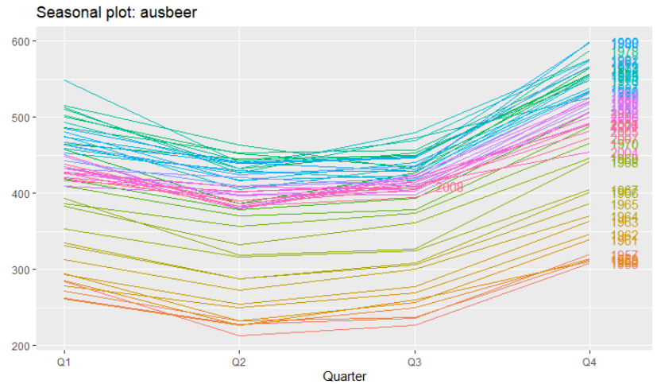

* Drop in quarter 2 and 3 followed by rise in quarter 4 and 1.
* This could be because the demand for beer be lower and same (approximately) throughout the middle part of the year (April to September) but rises when the year ends and a new one begins. (October to January)
* There is overall increase in consumption of beer over the years. For e.g. in the 1950-60s the range of production is 213 to 386 (first 40 values) and range of production over 2000s is 380 to 521. This is reflected in the above plot as well, as years increase, the production units increase as well
* 2008 has data only for 3 quarters, this the plot for 2008 ends there.

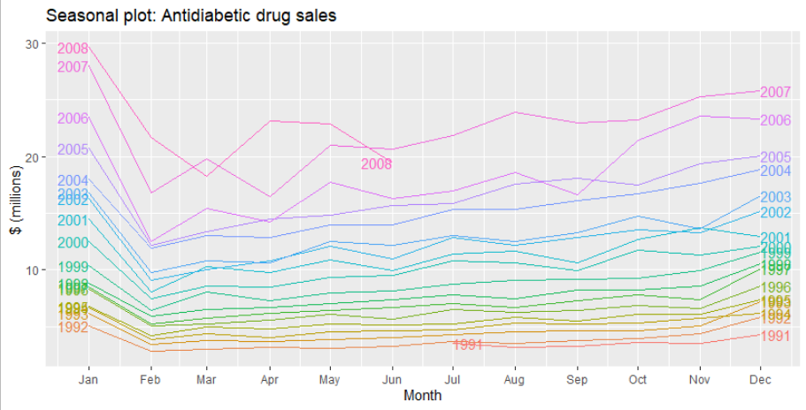

* Seasonal plot of Anti-Diabetic Drug Sales
* It is clear that there is a large jump in sales in January each year. Actually, these are probably sales in late December as customers stockpile before the end of the calendar year, but the sales are not registered with the government until a week or two later.
* This stockpiling translates into fall in purchases in February as the stock lasts.
* The purchases remain more of less similar during rest of the year. This conforms to the fact the medicines like anti diabetic drugs are ‘necessity goods’.
* As years increase, the magnitude of series increases due to increasing cost of medicines.
* The small number of sales in June 2008 is probably due to incomplete counting of sales at the time the data were collected.

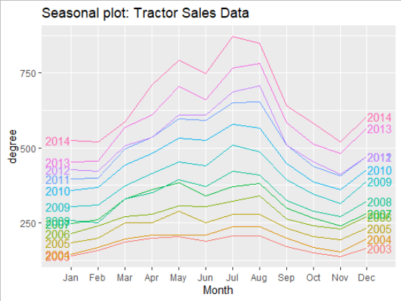

* Each year gets its own curve. As the years go by, sales increase.
* There is a common seasonality pattern, going from left to right, but it is not identical.
* There is a bump in sales in months of May and July-August
* There is a drop in November followed by an increase in December – indicating that people delay their purchases to year end when they expect prices to fall.

### Polar Plot

The idea of polar plot is to show small deviations, nearer to the centre and larger deviations moving farther from the centre. This uses the idea of a radius in order to show what the seasonality is. The radii are months/ quarters. So we if go a certain direction, we can see the variation for a particular month/ quarter.

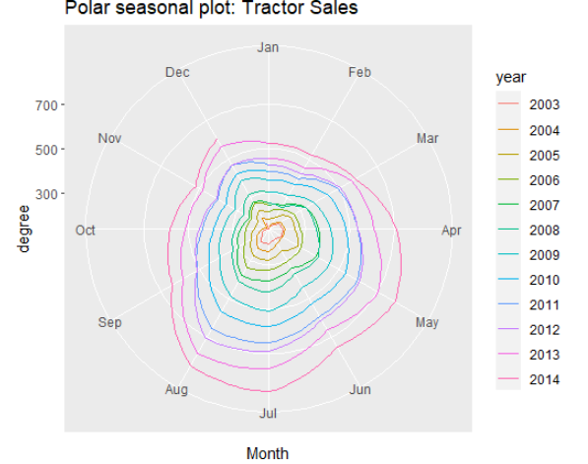

* From the centre, if look down south, we see the seasonal variation for the month of July. The deviations are far away from the centre indicating that the seasonality is strong in July. This was seen above as well.
* From the centre, if we look north, we see the seasonal variations for the month of Jan. the deviations are close to centre indicating that the seasonality is quite low.
* The drop see the month of Nov can also be seen here.
* The data set ends with 2014 December, thus the end point is plotted so.

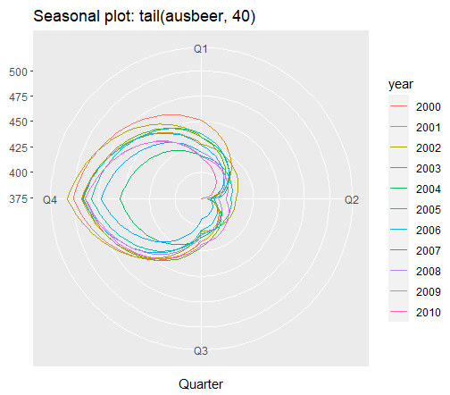

* If we look at the last 40 values (10 years), the plot is easier to interpret.
* For Quarter 4, the deviations are very large. While for quarter 2, there is a significant drop. Indicating strong seasonality.

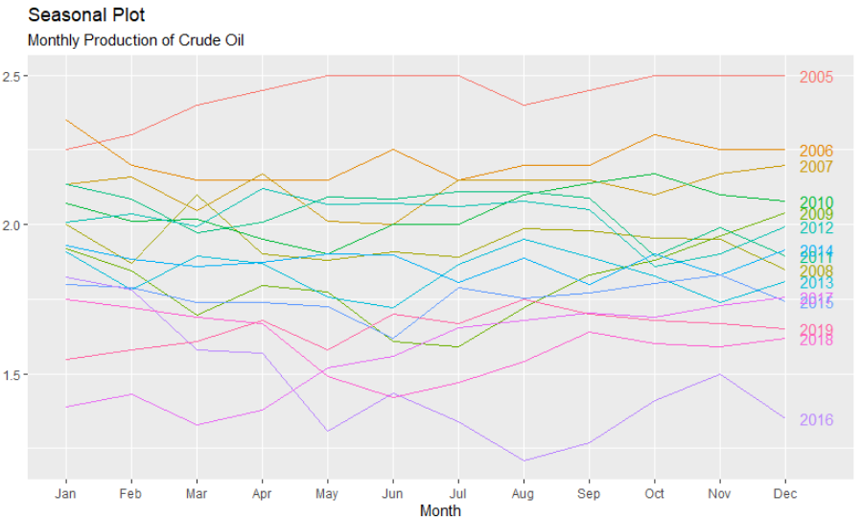

* There is no clear seasonal pattern because if some years show a drop in a particular month, other years show a rise in that particular month.
* But it is clear that the production is on a overall decline.

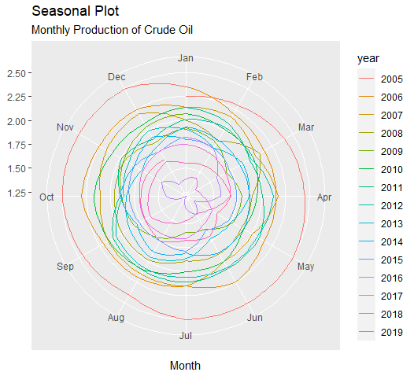

* For each year, the plot looks roughly circular.
* What happens if these variations look circular? It means there is no significant seasonality.
* If the circular patterns appearing are the same but with different centres, we can say that the seasonal component is same for different years, the circles shift in the same way for every year.

### Trend and Seasonality In ACF Plots

* When data have a trend, the autocorrelations for small lags tend to be large and positive because observations nearby in time are also nearby in value. So the ACF of a trended time series tends to have positive values that slowly decrease as the lags increase.
* When data are seasonal, the autocorrelations will be larger for the seasonal lags (at multiples of the seasonal period) than for other lags.
* When data are both trended and seasonal, you see a combination of these effects. The slow decrease in the ACF as the lags increase is due to the trend, while the “scalloped” shape is due to the seasonality.

## Spectrum Analysis

### Introduction

The basis for Spectral Analysis is that any function can be described as a sum of periodic functions of different wavelengths (in space) /period (in time).

Many time series show periodic behaviour. This periodic behaviour can be very complex. Spectral analysis is a technique that allows us to discover underlying periodicities. Spectral analysis is one of the most widely used methods for data analysis in geophysics, oceanography, atmospheric science, astronomy, engineering etc. The idea is to describe a time series into high and low frequency signals which can be interpreted in the context of the problem at hand. In a nutshell, we compare the time series with sine and cosine functions at different frequencies.

* When we describe Yt in terms of a sequence of innovations et where $y_{t}=μ+\sum_{j=0}^{∞}{ψ_{j}e_{t-j}}$, the focus has been on the implications of such representation for the covariance between Yt and Ys. This is known as analysing the properties of Yt in the ***time-domain***.
* When we describe Yt as a weighted sum of periodic functions of the form cos( ωt) and sin( ωt), where ω denotes a particular frequency: $y_{t}=μ+\int_{0}^{π}{α\left(ω\right).\cos\left(ωt\right)dω}+\int_{0}^{π}{δ\left(ω\right).\sin\left(ωt\right)dω}$. The goal will be to determine how important different frequencies are in accounting for the behaviour of Yt. This is known as ***frequency-domain*** or spectral analysis.

Imagine a unit circle with unit radius and centre at the origin, O, with the radius rotating at a rotational velocity ω radians per unit of time. Let ‘t’ be time. The angle, ω*t, in radius is measured as the distance around the circumference from the positive real axis, with the anti-clockwise rotation defined as positive. So if the radius sweeps out a full circle, it has been rotated through an angle of 2π radians. The time taken for this revolution or cycle is 2π/ω and is known as the *period*.

The sine function sin(ω*t) is the projection of the radius onto the vertical axis, and the cosine function, cos(ω*t) is the projection of radius onto the horizontal axis. In general, a sine wave of frequency ω, amplitude A and phase ψ is ***A*sin(ω*t + ψ)***. The positive phase shift ψ represents an advance of ψ/2π cycles. In spectral analysis it is convenient to refer to specific sine waves as ***harmonics***. Using basic trigonometry, we can express ***A*sin(ω*t + ψ) = A[cos(ψ)sin(ω*t) + sin(ψ)cos(ω*t)].***

This equation is the basis of spectral analysis because a sampled sine wave of any given amplitude and phase can be fitted by a linear regression model with the sine and cosine functions as predictor variables.

**Definition** → Spectral analysis is the decomposition of a stationary series into a linear combination of sinusoids with random and uncorrelated coefficients.

The spectral density can be estimated using an object known as periodogram, which is a squared correlation between our time series and sine-cosine waves at the different frequencies spanned by the series. For large ‘n’, the periodogram is approximately independent for distinct frequencies. This independence can be improved – as can the visual quality and interpretability of the plot - by smoothing the periodogram using a kernel smoother (some sort of weighted running average).

We calculate the series’ power spectrum to determine what frequencies dominate the variance. The function ‘spectrum’ is a wrapper for calculating the periodogram (i.e. an estimate of spectral density) from the time series.

There are a couple of issues to keep in mind –

* The spectrum will be far more interpretable if it is smoothed:
  + Use the argument ***spans***, which specifies the parameters for what is known as the ***Modified Daniell Kernel*** for smoothing the spectrum (essentially just a running average)
  + higher number of spans = more smooth + lower the peaks of the spectrum will be
* By default calculation of the spectrum is on a log-scale
  + Use the argument ***log="no"*** to change this default

The spectrum needs to be multiplied by 2 to make it actually equal to variance.

### Unit of Measurement of Frequency

The SI unit of frequency is Hertz which is one cycle per second and is equivalent to $2π$ radians per second. A frequency of ‘f’ cycles per second is equivalent to ω radians per second, where ω = $2πf$ Or, $f=\frac{ω}{2π}$.

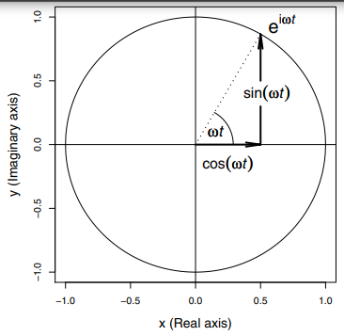**Angle ω*t is the length along the radius. The projection of radius onto the X (real number) and Y (imaginary number) axes is cos(ω*t) and sin(ω*t) respectively**.

### Spectrum

We consider functions → $\cos\left(2 π\frac{k}{n}t\right) and \sin\left(2 π\frac{k}{n}t\right)$.

* ‘t’ is time period
* ‘k’ number of cycles
* ‘n’ time span
* Frequency = cycles/time = ‘k/n’ (k < n)
  + If ‘k’ is small = sine time series has ***low*** frequency
  + If ‘k’ is large = sine time series has ***high*** frequency
* The amplitude of signal (i.e. maximum range of variation) is 1 (range is -1 to 1). We can change the amplitude (by multiplying with a constant), hence change the range of the signal.

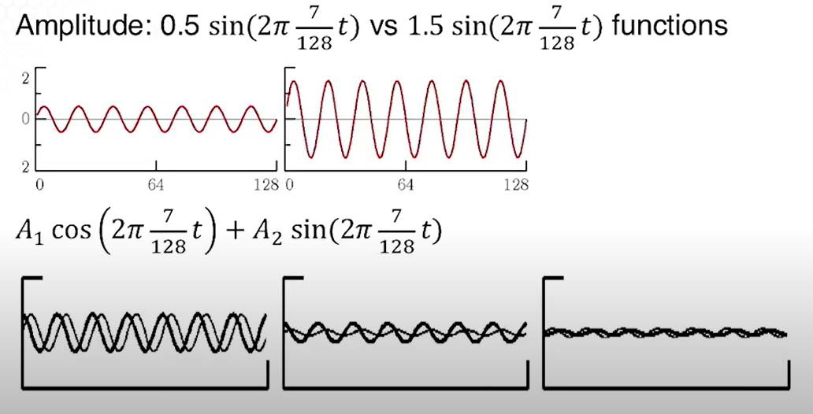This is an example of sine time series signal with 7 cycles over 128 time periods with different amplitudes of 0.5 and 1.5, the difference is clear from the plots.

* Say $X_{t}= A cos(2 π w t + φ )$…. (1)
  + Here, $t ∈(-∞ , ∞)$.
  + ‘w’ is a frequency index ( $w =\frac{k}{n}$)

For w = 0.5, the series makes one cycle every two time units

* ‘A’ is ***Amplitude*** of function
* ‘φ’ is ***Phase*** determining the starting point of the cosine function
* We can introduce Random Variation in this time series by allowing the amplitude and phase to vary randomly.

Using basic trigonometric we have,

* $X_{t} = Acos(φ)cos(2π w t) – Asin(φ)sin(2π w t) \left[where, w =\frac{k}{n}\right]$.
 $X_{t} = U_{1}cos(2 π w t) + U_{2}sin(2 π w t)$

 $U_{1}= A*cos(φ)$ + and $U_{2}= – A*sin(φ)$
  + Amplitude $‘A’ = \sqrt{U_{1}^{2}+ U_{2}^{2}}$
  + Phase $‘φ’ =\tan^{-1}\left(-\frac{U_{2}}{U_{1}}\right)$.

### Periodic Series With Multiple Frequencies And Amplitudes:

$X_{t}=\sum_{k=1}^{q}{\left[ U_{k1}\cos\left(2πω_{k}t\right)+U_{k2}\sin\left(2πω_{k}t\right) \right]}$ exhibits the process as a sum of uncorrelated components with variance σ2k for frequency wk.

Auto covariance is given by $γ\left(h\right)=\sum_{k=1}^{q}{σ_{k}^{2}cos⁡(2πω_{k}h)}$ i.e. the sum of periodic components with weights proportional to the variances σ2k.

Here, Xt is a zero-mean stationary process with $Var\left(X_{t}\right)= \sum_{k=1}^{q}{σ_{k}^{2}}$ exhibiting overall variance as a sum of variances of each of the component parts. Estimate of sample variance: **γ(0) = V(Xt) = $\sum_{k=1}^{q}{\left(a_{k}^{2}+b_{k}^{2}\right)}$.**

Example –

$x_{t1}=2\cos\left(2πt\frac{6}{100}\right)+3\sin\left(2πt\frac{6}{100}\right)$

* Amplitude of Xt1 .
* Hence, the max and min values that xt1 will attain are +/- √13 = +/- 3.61
$x_{t2}=4\cos\left(2πt\frac{10}{100}\right)+5\sin\left(2πt\frac{10}{100}\right)$

$x_{t3}=6\cos\left(2πt\frac{40}{100}\right)+7\sin\left(2πt\frac{40}{100}\right)$

* Xt = xt1 + xt2+ xt3

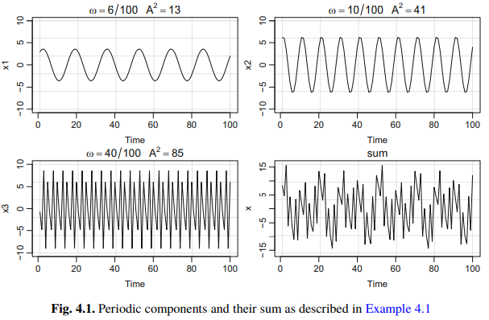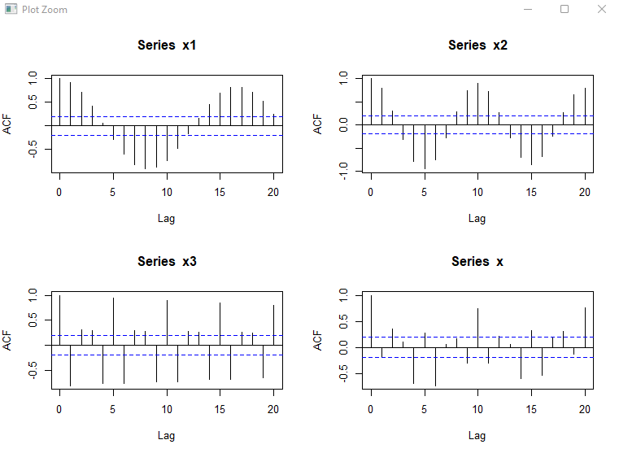

### Finite Fourier Series

Suppose we have a time series of length ‘n’ (‘n’ is even), we can fit a linear regression on Xt with sine-cosine regressors with coefficients ‘ai’ and ‘bi’.

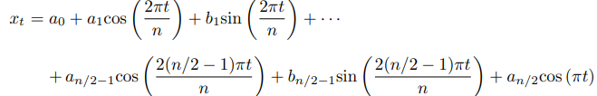

Where,

* Here, a0 is the intercept equal to x̅.
* + The ***lowest frequency*** (2π) i.e. ‘one cycle’ is represented by 2π/n radians per sampling interval.
  + The ***highest frequency*** (π) is ‘0.5 cycle’ is represented by π/n radians per sampling interval.
  + **To generalise**, we represent ‘k cycles’ as 2πk/n radians per sampling interval (where, k is integer between 1 and n/2). This frequency is called the ***folding frequency*** and defines the highest frequency that can be seen in discrete sampling.
  + This is observed as alternating between -1 and +1 at the sampling points.
  + This regression model is a ***Finite Fourier Series*** for a discrete time series.

We refer to the sine wave that makes ‘k’ cycles as the ‘k***th harmonic***’. The ‘first harmonic’ is commonly referred to as the ***Fundamental Frequency***.

* The amplitude of the mth harmonic is $A=\sqrt{a_{k}^{2}+b_{k}^{2}}$.

### Sample Spectrum

A plot of A2k as spikes against ‘k’ is a ***Fourier Line Spectrum***. The Raw-periodogram in R is obtained by joining the tips of the spikes in the Fourier line spectrum to give a continuous plot and scaling it so that the area equals the variance. The periodogram distributes the Variance over frequency.

The raw periodogram has 2 drawback – (1) the precise set of frequencies is arbitrary as in depends on the record length and (2) it does not become smoother as the length of time series increases, it just stakes more spikes closer together. Remedy → smooth the periodogram by taking a moving average of spikes before joining the tips. This is called as the ***Sample Spectrum***.

Sample spectrum of ***Xt*** is represented by ***Cxx()***.

Smoothing will reduce the height of peaks, and excessive smoothing will blue the features we are looking for. In R, we use ***spectrum()*** command, with argument ***span*** to specify the number of spikes in the moving average.

The time series should be mean-adjusted or a0 spike should be set to 0 before averaging spikes to avoid increasing the low-frequency contributions to the variance. In R, the spectrum function removes the linear trend before calculating the periodogram.

We define the scaled periodogram to be $P(j/n) = a_{j}^{2} + b_{j}^{2}$

A scaled periodogram helps identify which frequency components are large/small in magnitude. Thus the scaled periodogram is simply the sample variance (estimate of σ2j) at each frequency component corresponding to the sinusoid oscillating at a frequency of $w_{j}=\frac{j}{n}$. These particular frequencies are called ***Fourier Frequency*** or ***Fundamental Frequencies***.

* If P(j/n) is large → frequencies $w_{j}=\frac{j}{n}$ are predominant in the series
* If P(j/n) is small → noise.

### Nyquist Frequency

It is defined as the cut-off frequency associated with a given sampling rate and is one-half the sampling rate.

* Sampling rate = Δ
* Sampling frequency = 1/ Δ cycles per second
* A sine-wave with frequency 1/ Δ (radius rotates anti-clockwise) and frequency -1/ Δ (radius rotates clockwise).
* For a frequency ‘f’ in [-1/2Δ, +1/2Δ]. Any ‘f’ will be indistinguishable from any other frequency

$f±kΔ$ (k is integer).

* Example – a sin(2π t) wave Δ = 0.2 (i.e. sampled at 0.2s), and if k = -1, frequency = 1- 1/0.2 = -4 Hz.
* **Physically, a frequency of -4Hz and 4Hz are identical except for phase-difference of a half-cycle**. (reason :- $sin⁡(-\text{θ)}= -sin⁡(\text{θ)}=\sin\left(\text{π - θ}\right)$.
* To summarise, Nyquist Frequency $Q=\frac{1}{2Δ}$ where Q should be the higher than any frequency components in the continuous signal.
* The Nyquist Frequency determines the sampling interval Δ.

### Discrete Fourier Transform (DFT)

$d\left(\frac{j}{n}\right)=\frac{1}{√n} \sum_{t=1}^{n}{x_{t} e^{-2π*i*t*\frac{j}{n}}} =\frac{1}{√n} \left(\sum_{t=1}^{n}{x_{t}\cos\left(2πt\frac{j}{n}\right)}-i \sum_{t=0}^{n}{x_{t}\sin\left(2πt\frac{j}{n}\right)}\right)$

$\left[Using Euler^{'}s Formula, e^{i*α}=\cos\left(α\right)+i\sin\left(α\right)\right]$ where, j = 0, 1, 2 … n-1, j/n are fundamental frequencies.

The discrete Fourier transform has a lot of redundancies. Thus, we use FFT.

### Fast Fourier Transform (FFT)

$\left|d{\left(\frac{j}{n}\right)}^{2}\right|=\frac{1}{n}{\left(\sum_{t=1}^{n}{x_{t}\cos\left(2πt\frac{j}{n}\right)}\right)}^{2}+ \frac{1}{n}{\left(\sum_{t=1}^{n}{x_{t}\sin\left(2πt\frac{j}{n}\right)}\right)}^{2}$ this quantity is called the ***periodogram***. We may calculate the scaled periodogram as $P\left(\frac{j}{n}\right)=\frac{4}{n}\left|d{\left(\frac{j}{n}\right)}^{2}\right|$.

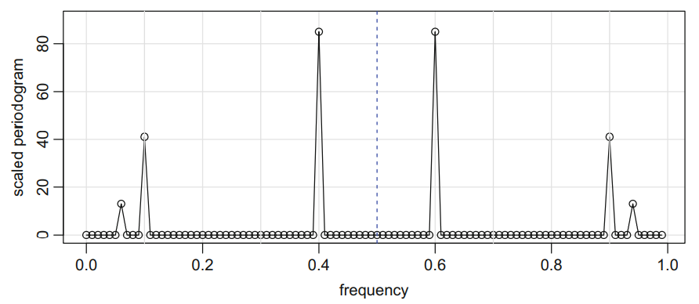

* Scaled periodogram of above example.
* Identifies three components x1, x2, x3 clearly.
* There is some mirroring effect at the ***folding frequency*** of 0.5. thus, the periodogram is not plotted for frequencies higher than folding frequency.
*  heights of the scaled periodogram = squared amplitudes of the components generated. And P(j/n) = 0 otherwise.

Let’s observe a signal-plus-noise xt = st + vt.

* st = cos(2π w*t) cos(2π d*t)
* where, 'd' is very small

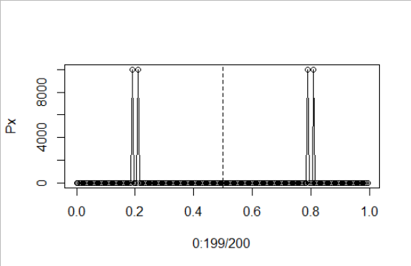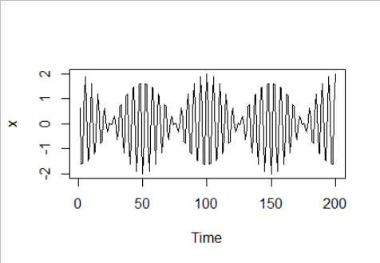

This process will oscillate at frequency 'w' but the amplitude will modulated by cos(2π d*t). Now, because 2cos(a)cos(b) = cos(a + b) + cos(a – b), the periodogram of data generated as xt will have 2 peaks close to each other at a +/- b.

### Spectral Density Function

Consider a periodic stationary process with fixed frequency w0 –

* 
* Where, U1 and U2 ~ N(0, σ2) and are uncorrelated.
* Number of periods to complete one-cycle = 1/w0.

Autocovariance function is given by –

* 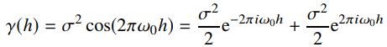

Now because Autocovariance function of a stationary process with a non-negative definite function, it can be expressed as the Riemann-Stieltjes Integral –

* 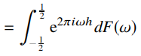
* Where, 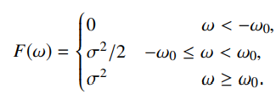
* F(w) behaves like a CDF of a random variable but F() = σ2 = Var(Xt) instead of 1.

Thus, F(w) is a CDF of variances rather than probabilities because F($∞$) is total variance of process Xt. Thus F(w) is called the ‘***spectral distribution function***’.

### Properties of Spectral Density

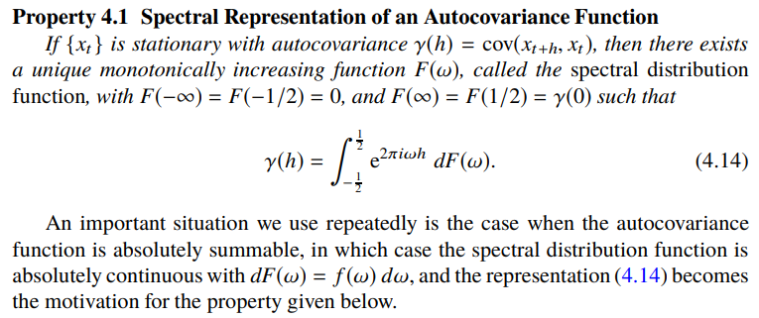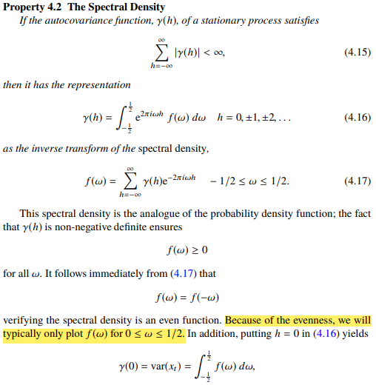

The Autocovariance function expresses information in terms of ‘lags’ whereas the spectral distribution expresses the same information in terms of ‘cycles’.

Spectral density *f* (w) and Autocovariance function γ (h) are called ***Fourier Transform Pairs*** which implies that if -

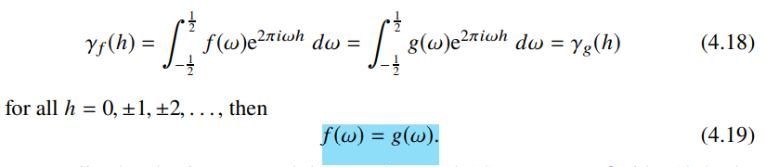

### Spectral Density of White Noise Wt

* Variance of Wt = σ2w
$Autocovariance=\left\{\begin{aligned}σ_{w}^{2} at h=0 \\ 0 otherwise\end{aligned}\right.$

* Spectral density $f_{w}\left(ω\right)= σ_{w}^{2} for-\frac{1}{2}≤w≤\frac{1}{2}$
* This implies that it contains all frequency in roughly equal mix.
* In fact, the name white noise comes from the analogy to white light, which contains all frequencies in the colour spectrum at the same level of intensity.
* Expressing in linear form :

$Y_{t}= \sum_{j=-∞}^{∞}{a_{j} X_{t-j}} where, \sum_{j=-∞}^{∞}{\left|a_{j}\right|}< ∞$

* This form is called *convolution*. The coefficients are collectively called *impulse response function*. The series Yt is called the *filtered output*.
* The Fourier transform is called *frequency response function* and is given by -

$A(ω)= \sum_{j=-∞}^{∞}{a_{j} e^{-2 π i ω j}}$

* Now if Xt has a spectral density fx(w), then we can express the spectral density of Yt as:

$$f_{y}\left(ω\right)={\left|A\left(ω\right)\right|}^{2} f_{x}\left(ω\right)$$

### Spectral density of ARMA

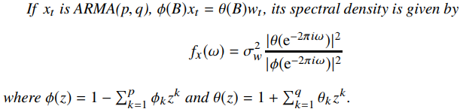

**Note - Harmonics** are needed to capture the non-sinusoidal behaviour of the signal.

## Prophet in R

<https://medium.com/future-vision/the-math-of-prophet-46864fa9c55a>

Prophet is a procedure for forecasting time series data based on an additive model where non-linear trends are fit with yearly, weekly, and daily seasonality, plus holiday effects.

It works best with time series that have strong seasonal effects and several seasons of historical data. Prophet is robust to missing data and shifts in the trend, and typically handles outliers well.

Any time series can be expressed as: $Y_{t}=g_{t}+s_{t}+h_{t}+e_{t}$

* ‘***gt***’ = trend component for non-periodic changes i.e. growth over time
* ***Saturating Growth Model*** – it is applicable in cases where there are constraints present. For e.g. cubed footage, processing power, number of people with internet access. Here we model non-linear saturating trends. $g\left(t\right)=\frac{C}{1+exp⁡(-k\left(t-m\right))}$ where, ‘C’ is carrying capacity, ‘k’ is growth rate, ‘m’ is offset parameter.
  + To allow for parameters ‘C’ and ‘k’ to change with time, we end up with a model

$g\left(t\right)=\frac{C_{t}}{1+exp⁡(-(k+a{\left(t\right)}^{T}δ)(t-(m+a{\left(t\right)}^{T}γ)))}$

Where, Ct is carrying capacity changing with time. To incorporate change in growth rate, we use turning points. The 𝛿j is the change in rate that occurs at time sj.

* + C(t) often represents expected capacities of the system at any point in time.
  + Code: growth = “logistic”
* ***Linear Trend with Changepoints*** – default model. It is applicable in cases without a market cap. Trend component is a simple piece-wise linear model with a constant rate of growth.

* + Where, k is growth rate, 𝛿 has rate adjustments, m is offset parameter.
  + R code: growth = “linear”
* ***Automatic Changepoint Selection*** – if known in advance changepoints ***sj*** can be specified by a user as dates of product launches and other growth-altering events, or by default, changepoints may be automatically selected given a set of candidates.
  + Automatic selection can be done quite naturally with the formulation in either model by putting a sparse prior on δ.
  + Often, it is advisable to specify a large number of changepoints (e.g. one per month for a several year history) and use the prior: $δ_{j}\sim Laplace(0, τ)$ where, τ directly controls the flexibility of the model in altering its rate.
* ‘***st***’ = seasonality component for periodic changes i.e. weekly, monthly, quarterly, yearly.

Business time series often have multi-period seasonality as a result of the human behaviours they represent. For e.g. a 5-day work week can produce effects on a time series that repeat each week, while vacation schedules and school breaks can produce effects that repeat each year.

Prophet relies on Fourier series to provide a malleable model of periodic effects.

$$s\left(t\right)= \sum_{n=1}^{N}{\left(a_{n}\cos\left(2πn\frac{t}{P}\right)+b_{n}\sin\left(2 πn\frac{t}{P}\right)\right)}$$

Where, ***P*** is regular period (like 365.25 for annual).

* ‘***ht***’ = holidays and events

Holidays and events are predictable events of the year including those on irregular schedules (e.g. Black Friday and Superbowl in USA).

To utilise this feature, the user needs to provide a custom list of events. Fusing the list of holidays into the model is made straightforward by assuming that the effects of holidays are independent.

* ‘***et***’ = random component

## Neural Networks

### Introduction

We know how important it is to estimate seasonality of our data, gauge the trend and ensure that the data is stationary. But in practise, the presence of trend and season variation can be hard to estimate and/or remove. It is often very difficult to define trend and seasonality satisfactorily. The main difficulty is that the underlying dynamics generating the time series is usually unknown and seems random. The traditional statistical time series tools requires considerable experience and skills to select appropriate parameters to capture this underlying dynamics of the data. The great thing about neural networks is that it does not require you to specify the exact nature of relationship (linear or non-linear, seasonality, trend) that exists between input and output.

The ***Task Of A Neuron*** is to performed a weighted sum of inputs and apply an activation function before passing the output to the next layer.

### Sigmoid Activation Function

Sigmoid is a ‘s-shaped’ differentiable activation function. It takes a real-valued number and ‘squashes’ it between 0 and 1 range. It is given by $f\left(u\right)=\frac{1}{1+\exp\left(-c u\right)}$.

Sigmoid function can be easily differentiated. This is helps us to reduce the computational cost during training. The derivative is used to learn which weights work best of the network to produce output with minimum mistake.

### Tan h Activation Function

Hyperbolic Tangent. It is a popular alternative to the sigmoid function. It takes the form $f\left(u\right)=\tanh\left(c u\right)$. It is also ‘s-shaped’ but it produces output between -1, +1 range. Tan h is symmetrical about zero.

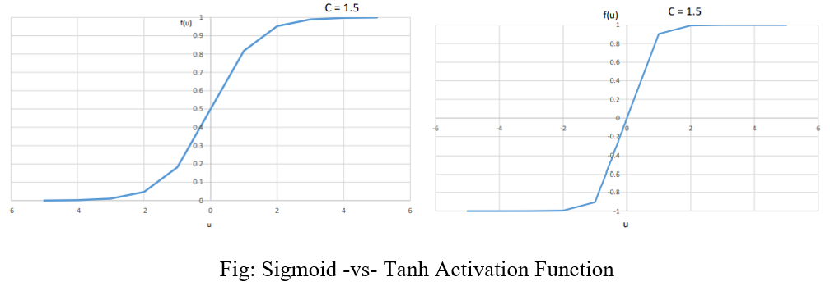

### Feed-Forward Neural Networks

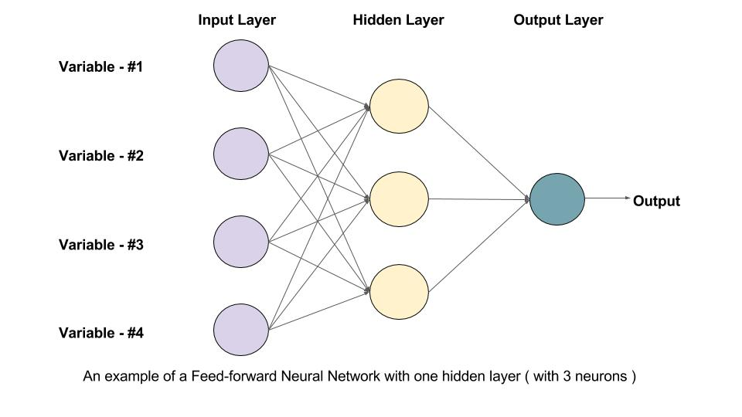

A feed forward neural network is constructed from a number of interconnect nodes called neurons. These are usually arranged into layers. A typical feed-forward network will have at a minimum an input layer, a hidden layer and a output layer.

* Input layers take in attributes / covariates we wish to feed the network.
* Output layer corresponds to the output we wish to predict or classify.
* Hidden layer nodes are generally used to perform non-linear transformation on the original input attributes.

### How a Neural Network Learns

For any input data and neural network weights, there is an associated magnitude of error, which is measured by a cost function. This is the measure of how the neural network performs. The goal is to find a set of weights that minimizes the mismatch between network outputs and actual values.

The typical neural network applies error propagation from output to inputs, gradually fine-tuning i.e. improving the weights by minimizing errors.

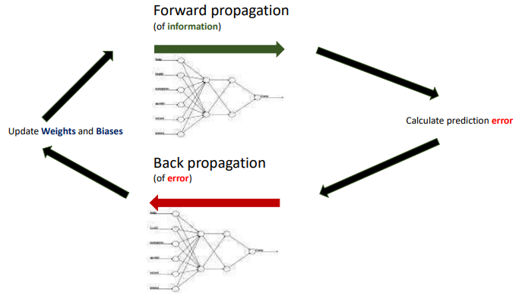

### Neural Network Architecture

A neural network can be thought of as a network of ‘neurons’ organised in layers. The predictors/ inputs form the bottom layer, and the forecast/ output form the top layer. There may be intermediate layers containing ‘hidden neurons’.

The basic objectives of ANNs was to construct a model for mimicking the intelligence of human brain into machine. ANNs try to recognise regularities and patterns in the input data, learn from experience and then provide generalized results based on their known previous knowledge.

* **ANNs are data-driven and self-adaptive in nature**. There is no need to specify a particular model form or to make any a priori assumption about the statistical distribution of the data; the desired model is adaptively formed based on the features presented from the data.
* **ANNs are inherently non-linear**, which makes them more practical and accurate in modelling complex data patterns, as opposed to various traditional linear approaches, such as ARIMA methods.
* **ANNs are universal functional approximators.** They have shown that a network can approximate any continuous function to any desired accuracy. ANNs use parallel processing of the information from the data to approximate a large class of functions with a high degree of accuracy. Further, they can deal with situation, where the input data are erroneous, incomplete or fuzzy.

The coefficients attached to these predictors are called ‘weights’. The forecasts are obtained by a linear combination of the inputs. The weights are selected in the neural network framework using a ‘learning algorithm’ that minimises a ‘cost function’ such as MSE.

Once we add an intermediate layer with hidden neurons, the neural network becomes non-linear.

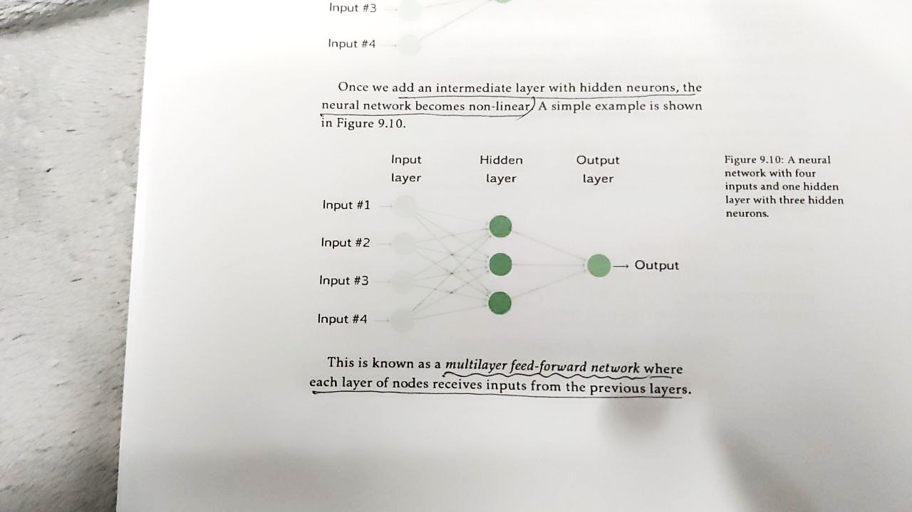 This is known as Multilayer Feed-Forward Network where each layer of nodes receive inputs from the previous layers. The outputs of nodes in one layer are inputs to the next layer. The inputs to each node are combined using a weighted linear combination. The result is then modified by a non-linear function before being output.

In the hidden layer, this is then modified using a non-linear function such as a sigmoid, to give the input for the next layer. This tends to reduce the effect of extreme input values, thus making the network somewhat robust to outliers.

The feed forward ANN model performs a non-linear functional mapping from past observations of the time series to the future value. To estimate the connection weights, non-linear least square produces are used, which are based on minimization of an error function. The optimization techniques used for minimizing the error function are referred as Learning Rules. The best-known learning rule in literature is the Backpropagation or Generalized Delta Rule.

### Neural Network Autoregression

Here we consider feed-forward networks with one hidden layer. NNAR( p, k) indicates that there are ‘p’ lagged values and ‘k’ nodes in the hidden layer. NNAR(p,0) corresponds to ARIMA(p,0,0) and NNAR(p,P,0)m corresponds to SARIMA(p,0,0)(P,0,0)m.

R code: nnetar().

The function fits NNAR(p, P, k)m model. If values of ‘p’ and ‘P’ are not specified, they are automatically selected. If ‘k’ is not specified, k = (p+ P +1)/2. We can perform log-transformation by specifying lambda=0.

Linear Regression → R code: avNNet().

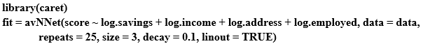

The function from caret package fits a feed-forward neural network with one hidden layer. The network specified here contains three nodes (size =3) in the hidden layer. The decay parameter has been set to 0.1. (the value of parameters are often restricted to prevent them becoming too large. The parameter that restricts weights is known as the ‘decay parameter’ and is often set to be equal to 0.1). The argument repeats = 25 indicates that 25 networks were trained and their predictions are to be averaged. The argument lineout = TRUE indicates that the output is obtained using a linear function.

### Time Lagged Neural Networks (TLNN)

In the TLNN, the input nodes are time series values at some particular lags. For e.g. a typical TNN for a time series, with seasonal period s = 12 can contain the input nodes as the lagged values at time t-1, t-2 and t-12. The value at time ‘t’ is to be forecasted using the values at lags 1, 2 and 12.

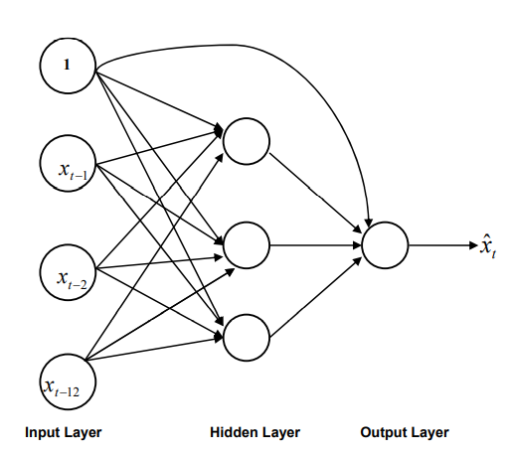In addition, there is a constant input term, which may be conveniently taken as ‘1’ and this is connected to every neuron in the hidden and output layer. The introduction of this constant input unit avoids the necessity of separately introducing a bias term.

### Seasonal Artificial Neural Network (SANN)

The SANN structure does not require any processing of raw data. It can learn seasonal pattern in the series, without removing them. In this model, the seasonal parameter ‘s’ is used to determine the number of inputs and output neurons. This consideration makes the model surprisingly simple for understanding and implementation. The ith and (i+1)th seasonal period observations are respectively used as the values of input and output neurons in this network structure. Each seasonal period is composed of a number of observations.

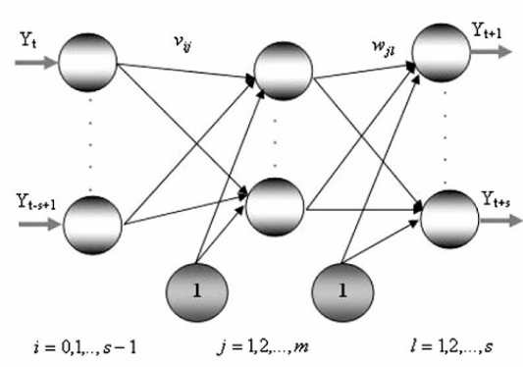 Thus while forecasting with SANN, the number of input and output neurons should be taken as 12 for monthly and 4 for quarterly time series. The appropriate number of hidden nodes can be determined by performing suitable experiments on the training data.

Some other types of neural networks are PNN (probabilistic neural network) for classification problem and GRNN (generalised regression neural network) for regression problem.

### Recurrent Neural Network (RNN)

RNNs contain hidden states which are distributed across time. This allows them to efficiently store a lot of information about the past.

Neural networks can be classified into dynamic and static. Static Neural networks calculate output directly from the input through feed-forward connections. For e.g. in a basic feed-forward neural network, the information flow in a single direction from input to output. Such neural networks have no feedback elements.

In a dynamic neutral network, the output depends on the current input to the network, and the previous inputs, outputs and/or hidden states of the network. Recurrent neural networks are an example of a dynamic network.

#### Visual Representation of RNNs

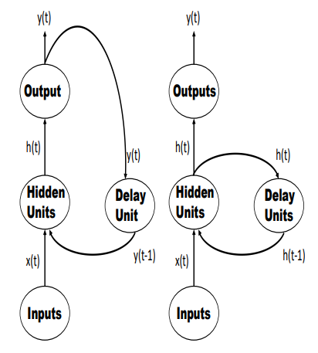the core idea is that recurrent connections allow memory of previous inputs to persist in the network’s internal state, and thereby influence the network’s output.

At each time step, the network processes :

* + The input attributes (Xt)
  + Updates its hidden state via activation function (ht)
  + And uses it to make a prediction of its output (yt).

The value held in the delay unit is fed back to the hidden units as additional input.

#### Role of the Delay Units

The delay unit enables the network to have short-term memory. This is because it stores the hidden layer activation values and/or output values of the previous time step. It releases these values back into the network at the subsequent time step. In other words, the RNN has a “memory” which captures information about what has been calculated by the hidden units at an earlier time step.

Time series data contains patterns ordered by time. Information about the underlying data generating mechanism is contained in these patterns. RNNs take advantage of this ordering because the delay units exhibit persistence. It is this “short term” memory feature that allows an RNN to learn and generalise across sequence of inputs.

### General Regression Neural Network (GRNN)

<https://cran.r-project.org/web/packages/tsfgrnn/vignettes/tsfgrnn.html>

A GRNN is a variant of an RBF (radial basis function) network characterized by a fast single-pass learning. A GRNN consists of a hidden layer with RBF neurons. Normally, the hidden layer has so many neurons as training examples. The centre of a neuron is its associated training example and so, its output gives a measure of the closeness of the input vector to the training example. Commonly, a neuron will use the multivariate Gaussian function:

$$G\left(x, x_{i}\right)=\exp\left(-\frac{{\left|\left|x-x_{i}\right|\right|}^{2}}{2σ^{2}}\right)$$

Where, xi and σ are the center and the smoothing parameter respectively and ‘x’ is the input vector.

Given a training set consisting of ‘n’ training patterns (vectors {x1, x2, … xn}) and their associated ‘n’ targets, normally scalars ({y1, y2, … yn}), the GRNN output for an input pattern ‘x’ is computed in two steps. First, the hidden layer produces a set of weights representing the closeness of ‘x’ to the training patterns: $w_{i}=\frac{\exp\left(-\frac{{\left|\left|x-x_{i}\right|\right|}^{2}}{2σ^{2}}\right)}{\sum_{j=1}^{n}{\exp\left(-\frac{{\left|\left|x-x_{j}\right|\right|}^{2}}{2σ^{2}}\right) }}$.

Note that the weights decay with distance to the training pattern. The weights sum to one and represent the contribution of every training pattern to the final result. The GRNN output layer computes the output as follows: $\hat{y}=\sum_{i=1}^{n}{w_{i}y_{i}}$

So a weighted average of the training targets is obtained, where the weights decay with distance to the training patterns. The smoothing parameter controls how many targets are important in the weighted average. When σ is very large the result is close to the mean of the training targets because all of them have a similar weight. When σ is small only the closest training targets to the input vector have significant weights.

## Fuzzy Time series

[A short tutorial on Fuzzy Time Series | by Petrônio Silva | Towards Data Science](https://towardsdatascience.com/a-short-tutorial-on-fuzzy-time-series-dcc6d4eb1b15)

[A short tutorial on Fuzzy Time Series — Part II | by Petrônio Silva | Towards Data Science](https://towardsdatascience.com/a-short-tutorial-on-fuzzy-time-series-part-ii-with-an-case-study-on-solar-energy-bda362ecca6d)

[A short tutorial on Fuzzy Time Series — Part III | by Petrônio Silva | Towards Data Science](https://towardsdatascience.com/a-short-tutorial-on-fuzzy-time-series-part-iii-69445dff83fb)

### Introduction

The Fuzzy Logic state a duality instead of a dichotomy: a certain element may belong and simultaneously do not belong to the same set at certain levels, such that the membership is a value in the interval [0,1]. The fuzzy sets have no strict boundaries and they are usually overlapping.

E.g. classifying people into categories based on weight {thin, slender, fat} or height {low, medium, high} or age = {child, adolescent, young, adult, elderly}. However, a person could be in a middle category between these two values. But classic/ rigid sets do not give us the flexibility. Fuzzy logic allows us to say that the person can be 90% medium and 10% high for example.

So, for a given numerical variable X we have its Universe of Discourse U which is the range of X ± some%.

We define a variable linguistic variable A which represents numerical variable X as a set of a few words.

For e.g. A̅ = {“very small”, “small”, “short”, “medium”, “tall”, “very tall”}. Here, we can say that we have divided U into 6 overlapping intervals. There are several types of membership functions to determine where each value of ‘X’ belongs. Let us consider the triangular membership function defined as $\max\left(\min\left(\frac{x-a}{b-a},\frac{c-x}{c-b}\right),0\right)$, where ‘a’, ‘b’ and ‘c’ draws a triangle. When a given input value ‘x’ is equal to ‘b’ we say that it is 100% inside the fuzzy set. On other hand, the membership increases linearly from 0 to 1 on interval [a, b] and linearly decrease from 1 to 0 on interval [b, c]. If ‘x’ is smaller than ‘a’ or greater than ‘c’, we say that ‘x’ is completely outside of the fuzzy set.

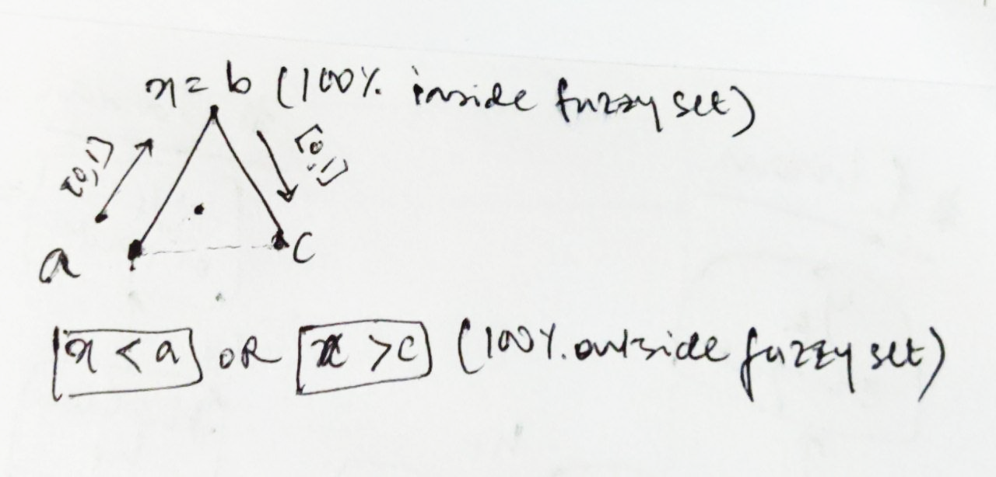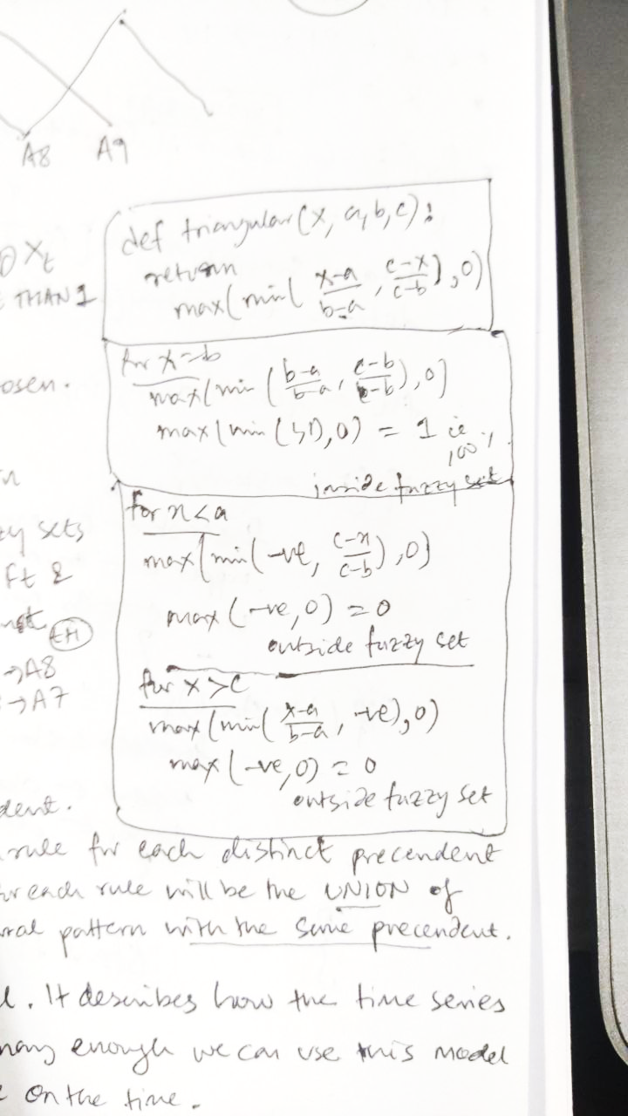

### What Are Fuzzy Time Series?

The idea is to divide the Universe of Discourse from time series in intervals/ partitions (called fuzzy sets) and learn how each area behaves (extracting rules through the time series patterns). The rules of these models tell how the partitions related with themselves over time, as values jump from one place to another. In other words: let’s create a linguistic variable to represent the numerical time series and these areas will be the linguistic terms of our variable.

### Training Procedure

Data set containing enrolments of Alabama University.

 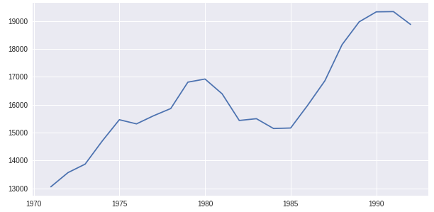

#### Definition of Universe of Discourse ‘U’

First we define U = {min(Xt), max(Xt) ± 20% security margin}.

#### Create the Linguistic Variable A

Now we split U on several overlapping intervals and create a fuzzy set for each of them. The number of intervals is one of the important features determining accuracy. Also, the way we split U has a great impact on accuracy as well. For e.g. the simplest method is called Grid Partitioning where all partitions have same length and format. For our data, we divide it into 10 categories A = {A1, A2, … A10}.

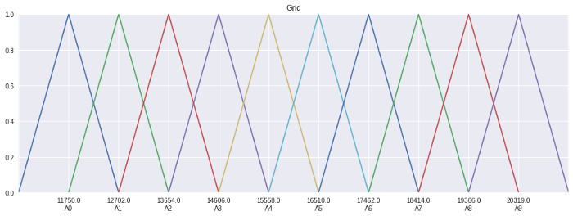

#### Fuzzyfication

Now we need to convert numerical values Xt into fuzzy values giving rise to fuzzy time series Ft. Remember fuzzy sets are overlapping, so a single value in Xt can belong to more than one fuzzy set.

Chen’s method → a value in Xt belongs to that fuzzy set with which it has maximum membership.

Other methods consider all fuzzyfied value.

#### Creating Temporal Patterns

A temporal pattern indicates two fuzzy sets that appear sequentially on fuzzy time series Ft and have the format Precedent → Consequent where the precedent indicates a fuzzy set on time ‘t’ and the consequent represents the fuzzy set appearing next on ‘t+1’.

e.g. A1→ A2, A2→A2 … A8→A8, A8→A7.

#### Creating the Rules

Our model rules also the format precedent → consequent. Given the previously generated temporal patterns, we group them by its precedents. Our model will contain a rule for each distinct precedent found and the consequent of each rule will be the union of all consequent of each temporal pattern with the same precedent.

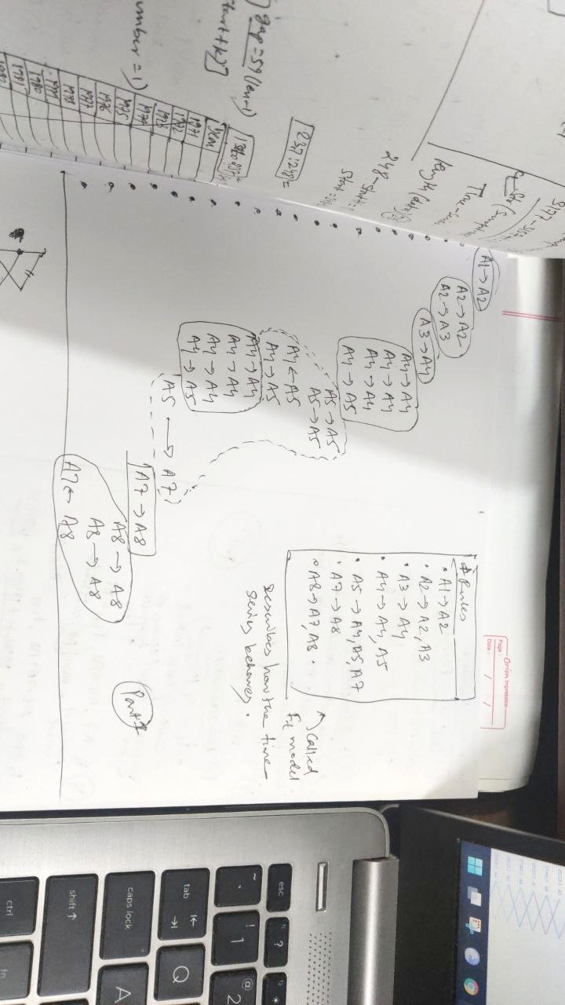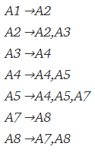Rules

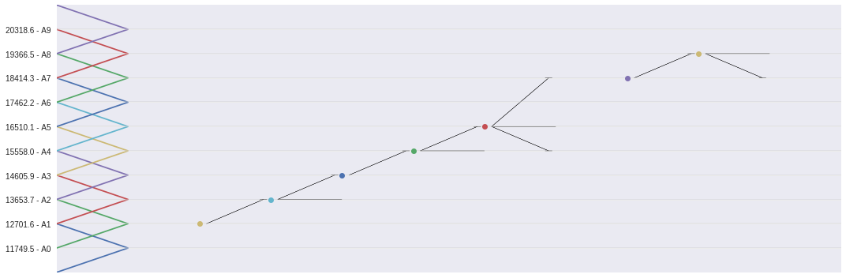

The rule set is our FTS model because it describes how the time series behaves. If it was stationary enough, we can use this model to forecast the next values on time.

### Advantages

* Simple and readable
* Very easy to parallelize/distribute what makes it very attractive for big data
* Very easy to update what makes it very attractive for frequently changing data

### Forecasting Procedure

#### Input value fuzzyfication

The numerical input Xt will be converted into fuzzy values of linguistic variables A, generating the value Ft. This is achieved under training.

For e.g. for t = 1992, the values Xt = 18876. Fuzzifying Xt the set of most pertinent is A7, so Ft = A7.

#### Find compatible rules

Here we find the rule whose precedent is equal to F7. The consequent of the rule will be the fuzzy forecast.

e.g. Ft = A7 then rule: A7 →A8 and Ft+1 = A8.

#### De-fuzzyfication

Here we convert the fuzzy value Ft back to numerical value. This can be done via Center of Mass Method where, Numerical Value = mean( center of fuzzy-sets of Ft+1).

* E.g. Ft = A7, rule A7→ A8, Ft+1 = A8. Thus, Numerical value = mean(A8-center) = 19366.46
* E.g. Ft = A8, rule A8→A7, A8, Ft+1 = A8 or A7.

Thus, Numerical value = $\frac{19355.46+18414.3}{2}=18890.38$

### Conclusion

This model is very simple but is a good guide to understand how fuzzy time series work. The most accurate methods now use more lags (here, we used only 1-lag), weights in the rules, optimizers to find the best number of sets and lags etc.

### FTS Parameters

#### Partitioning

* 1. Number of partitions

This is simply the most influential parameter in model accuracy. Number of partition ↑ Accuracy↑. And there is a trap that lies right here –

* Too few → underfitting (due to signal over simplification).
* Too many → overfitting (making model to start learning noise on data).

In a differenced time series 10 partitions or 35 is a good number to start.

* 1. Type of partition
* Grid partitioning
* Entropy-based
* Cluster-based
  1. Membership function

This is a parameter than has little real influence on model accuracy, but depending on the case you may have a good reason for using a Gaussian or Trapezoidal function instead of the triangular function, which is the default. One of the justifications may be the number of parameters (the Gaussian uses 2, the triangular 3 and the trapezoidal 4), the legibility of the model or even other issues related to the nature of the process and the data.

#### Number of Lags

It is the 2nd most important parameter, since it represents the autoregressive models to be used. The order parameter is the memory size of the model, or how much past information is needed to describe future events. To decide this parameter it is important to be familiar with the concept of ACF.

The question here is how many lags do i need for the model to learn the temporal pattern, cycles and seasonality. For this we look at the ACF plot.

However there is a trap here. Higher the number of lags, more complex the model is, and slower the learning and inference.

#### Type of Method

* 1. Weightage

The weights increase the model accuracy balancing which sets in the rules of the model are more influential for the forecast. They slightly lessen the readability of the model. Weighted models are generally more preferable. E.g. HOFTS-vs-WHOFTS and PWFTS. HOFTS stands for Higher Order FTS (p >1) and PWFTS stands for Probabilistic Weighted FTS (where probabilistic weights are on the precedent and consequent of each rule).

* 1. Univariate -vs- Multivariate model

Some Univariate FTS models are mentioned above.

Some Multivariate Models are MVFTS (Multivariate FTS for order p=1), WMVFTS and Granular WMVFTS (for higher order ‘p’).

## Generalised Poisson Regression

<https://12ft.io/proxy?q=https%3A%2F%2Ftowardsdatascience.com%2Fgeneralized-poisson-regression-for-real-world-datasets-d1ff32607d79>

In Count-based data, the dependent variable Y represents number of occurrence of some event. We can model such data using standard Poisson distribution. But there is a problem – the Poisson distribution has mean = variance. This is called Equi-dispersion. But many real-life datasets are not equi-dispersed. When variance > mean there is over-dispersion and variance < mean there is under-dispersion.

So, if we use the standard Poisson model, we are unable to capture the variability in data and we end up making poor predictions. Solution – we can assume that Variance is some function of mean.

E.g. Variance = mean + α (mean)p where, p = 0, 1, 2 … and ‘α’ is called the dispersion parameter. It represents the additional variability not explained by the regression model.

* For α = 0, we have a standard Poisson regression.
* For α $≠$ 0 and p = 1 or 2, we have Negative Binomial Regression.

Here, the observed count Y is modelled as $Y|λ\sim Poi\left(λ\right) and λ\sim Gamma$. This is often referred to as Poisson-Gamma Mix.

**CONSUL Generalized Poisson Regression (GP1 Model)**

$$P\left(Y=k\right)=\frac{e^{-\left(λ+αk\right)}{\left(λ+αk\right)}^{k-1}}{k!}, where E\left(Y\right)=\frac{λ}{1-α}, V\left(Y\right)=\frac{λ}{{\left(1-α\right)}^{3}}$$

**FAMOYE’s Generalized Poisson Regression (GP1 Model)**

$$P\left(Y=k\right)=\left(\frac{λ}{1+αλ}\right)\left(\frac{{\left(λ+αk\right)}^{k-1}}{k!}\right)e^{\left(\frac{-λ(1+αλ)}{1+αλ}\right)}, where E\left(Y\right)=λ and V\left(Y\right)=λ{\left(1+αλ\right)}^{2}$$

**Estimation of Dispersion parameter ‘α’**

$$α=\frac{\sum_{i=1}^{N}{\left(\frac{\left|Y_{i}-\hat{Y_{i}}\right|}{\sqrt{Y_{i}}}-1\right){\left(\hat{Y_{i}}\right)}^{1-p}}}{N-k-1}$$

* N is training sample size
* k is regression variables
* Yi is ith observed value
* $\hat{Y_{i}}$ is predicted Poisson rate λi corresponding to ith training sample.

$p= \left\{\begin{aligned}1 for GP1 \\ 2 for GP2\end{aligned}\right.$

## Negative Binominal Regression

<https://12ft.io/proxy?ref=&q=https://towardsdatascience.com/negative-binomial-regression-f99031bb25b4>

We define the following variables

* Yi = Count data on time ‘i’
* X = Predictor Variable
* λi = rate of observation in unit time on day ‘i’

Unlike under Poisson where mean = variance. Here we model variance in terms of mean

* Variance = Mean + α (Mean)p.
* [NB1] For p =1, Variance = (1+p)*Mean
* [NB2] For p =2, Variance = Mean + α(Mean)2.

#Correct Value of α

* For this we use an Auxiliary OLS regression without a constant
* For NB2, 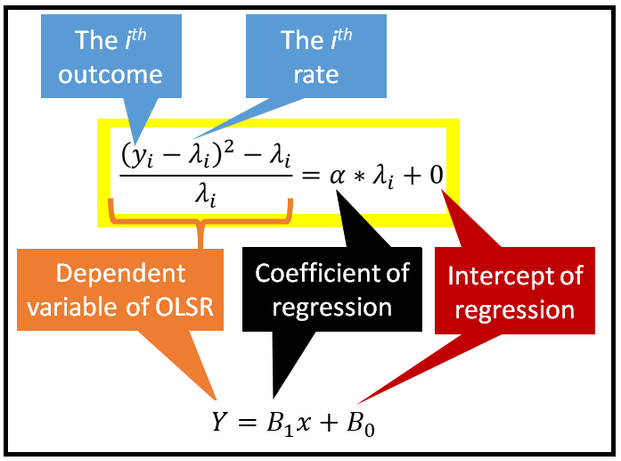
* For NB1, $\frac{{\left(Y_{i}-λ_{i}\right)}^{2}-λ_{i}}{λ_{i}}=α+0$

#Value of λ → we fit a Poisson Regression Model

To summarise the Process

* + 1. Poisson Regression Model → $\hat{λ}$
    2. Fit Auxiliary Regression Model → α
    3. Using fitted α, we fit NB2 regression
    4. Using fitted NB2, make prediction
    5. Goodness of fit Test

## Hidden Markov Model

<https://towardsdatascience.com/a-math-lovers-guide-to-hidden-markov-models-ad718df9fde8>

Any phenomenon/ process can be divided into two portions → Unobserved and Observed.

|  |  |
| --- | --- |
| **Observed (Yt)** | **Unobserved (St)** |
| Yt can be directly seen/observed | St’s effect on this can be FELT on Yt. |
| It is called Visible Process | It is called Hidden Process |
| Modelled via suitable ARIMA, Integer Poisson models … | Modelled via Hidden Markov Process |

* St changes regimes/states – impact of this change can be felt on Yt but we don’t know the timing of change in St. Thus, it is called **Hidden**!
* A change in St impacts the Mean and Variance of Yt. This is the Primary idea behind the Hidden Markov Model.

### # Defining St

Say St obeys 2-state markov process, State Space = {1, 2}.

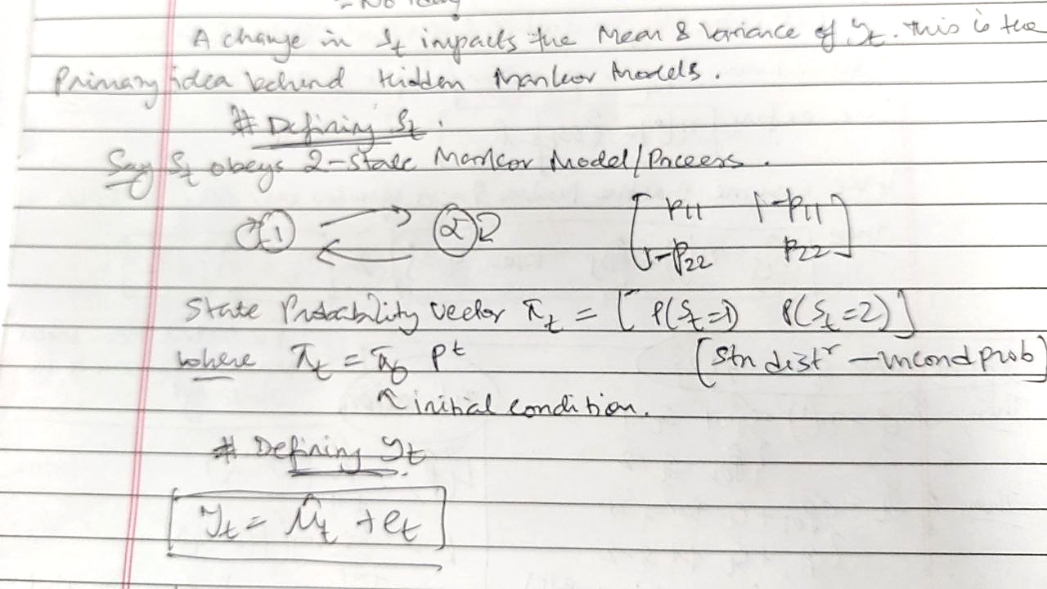

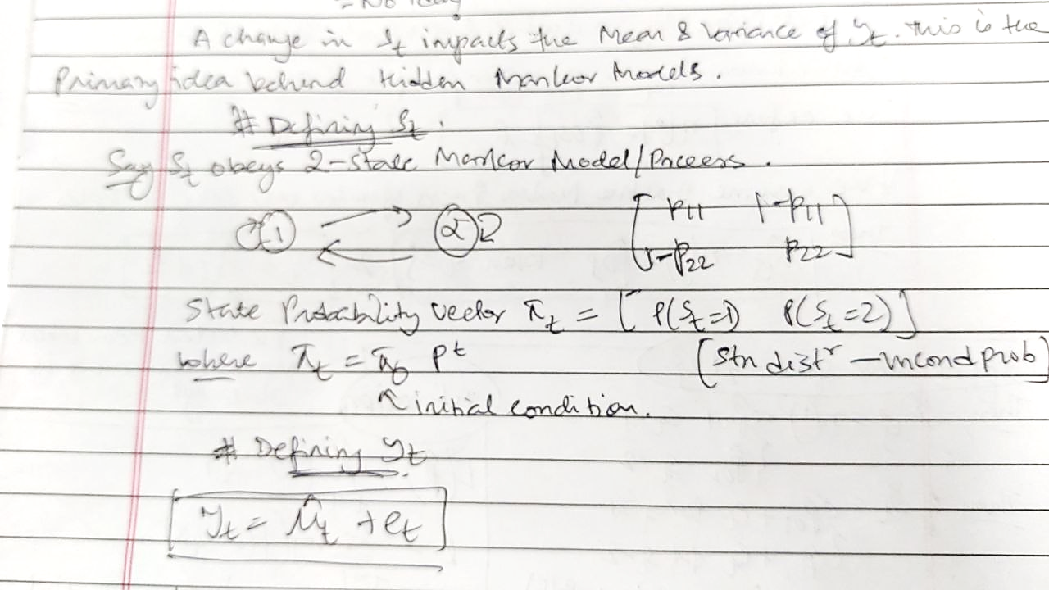

### # Defining Yt

Where, $e_{t}$ is the residual error such that $e_{t}\sim N\left(0, σ^{2}\right)$ i.e. errors are homoscedastic.

Where, $\hat{μ_{t}}$ is the modelled/ predicted mean. It is predicted by some regression function given by .

* + If $η\left(.\right)=0$, then we have a white noise process where $Y_{t}=e_{t}$
  + If $η\left(.\right)=\overline{Y}$, then we have a mean-model where $Y_{t}=\overline{Y}$
  + If $η(\hat{β}, X_{t})$ is linear, then we have a linear regression model.
  + If $η(\hat{β}, X_{t})$ is exponential, then we have a Poisson or Non-linear least square regression model.

We assume $Y_{t}\sim N(\hat{μ_{t}}, σ^{2})$. Thus, the conditional PDF of Yt is given by

$f\left(Y=Y_{t} | X=X_{t}, \hat{β}\right)=\frac{1}{σ\sqrt{2π}}\exp\left(-\frac{1}{2σ^{2}}{\left(Y_{t}-\hat{μ_{t}}\right)}^{2}\right)$

### # Mixing St and Yt

Key concept – St influences $\hat{μ_{t}} and σ^{2}$. There are 2 ways → MSDR and MSAR.

### MSDR – Markov Switching Dynamic Regression

$Y_{t}=\hat{μ_{t S_{t}}}+e_{t}$

Here, the predicted mean $\hat{μ_{t S_{t}}}$ is dependent on which state St is in. we know predicted mean is the output of some link function η(.). Here, we define, $η\left(.\right)={\hat{β}}_{0 S_{t}}={\hat{μ}}_{t S_{t}}$.

#### Let us assume that the Markov Process operates over 2 states S = {1, 2}.

Then, ${\hat{μ}}_{t_{j}}=η\left(.\right)= \left\{\begin{aligned}{\hat{β}}_{01} for S_{t}=1 \\ {\hat{β}}_{02} for S_{t}=2\end{aligned}\right.$.

Then, $Y_{t}= \left\{\begin{aligned}{\hat{β}}_{01}+e_{t} for S_{t}=1 \\ {\hat{β}}_{02}+e_{t} for S_{t}=2\end{aligned}\right.$.

The corresponding Conditional pdf is given by

$$f\left(Y=Y_{t} | X_{t}=1, \hat{β}={\hat{β}}_{01}, S_{t}=1\right)=\frac{1}{σ\sqrt{2π}}\exp\left(-\frac{1}{2σ^{2}}{\left(Y_{t}-\hat{β_{01}}\right)}^{2}\right)=pdf_{1}$$

$$f\left(Y=Y_{t} | X_{t}=1, \hat{β}={\hat{β}}_{02}, S_{t}=2\right)=\frac{1}{σ\sqrt{2π}}\exp\left(-\frac{1}{2σ^{2}}{\left(Y_{t}-\hat{β_{02}}\right)}^{2}\right)=pdf_{2}$$

The Un-Conditional pdf is given by

$f\left(Y=Y_{t}\right)=pdf_{1}*P\left(S_{t}=1\right)+pdf_{2}*P(S_{t}=2)$.

Where, $P\left(S_{t}=1\right) and P(S_{t}=2)$ are state probability of the Markov Process.

Estimation →

* + Then, take partial derivative with respect to $p_{11}, p_{22}, {\hat{β}}_{01}, {\hat{β}}_{02},σ^{2}$.

#### Let us extend to ‘k’ state S = {1, 2, … k}

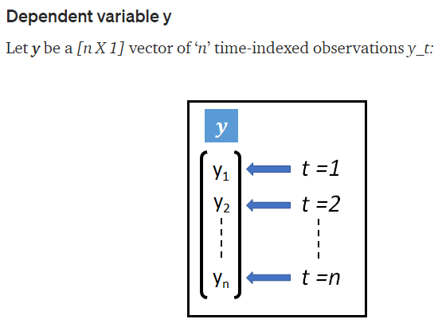 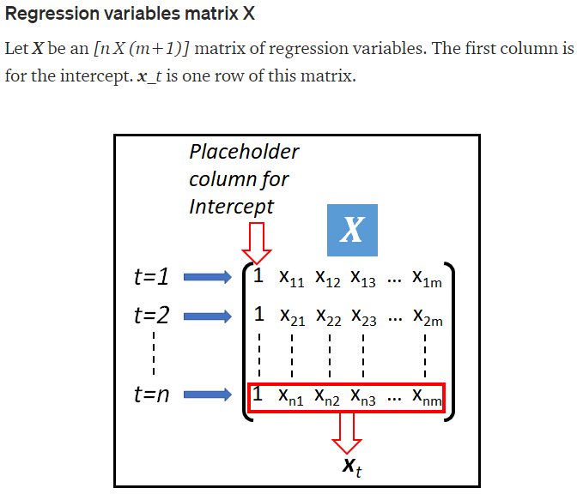 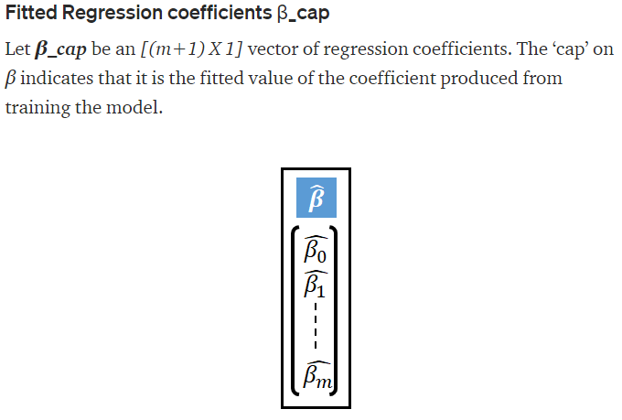

$$Y_{t}={\hat{μ}}_{tj}+e_{t} when S_{t}=j$$

Where, ${\hat{μ}}_{tj}=η\left(X_{t}, β_{j}\right) where, j ∈\{1,2, …k\}$

Basically, $β$ represents Regression Coefficients which SWITCHES based on the “state” in which the Markov Process is in now. $\hat{β}= \left[\begin{matrix}{\hat{β}}_{01} & ⋯ & {\hat{β}}_{0k} \\ ⋮ & ⋱ & ⋮ \\ {\hat{β}}_{m1} & ⋯ & {\hat{β}}_{mk}\end{matrix}\right]$.

The *k-state* Markov Process is governed by TPM $P= \left[\begin{matrix}p_{11} & ⋯ & p_{1k} \\ ⋮ & ⋱ & ⋮ \\ p_{k1} & ⋯ & p_{kk}\end{matrix}\right]$.

Here, ${\hat{μ}}_{tj}=η\left(X_{t}, β_{j}\right)={\hat{β}}_{0j}+{\hat{β}}_{1j}x_{1t}+…+{\hat{β}}_{pj}Y_{t-1}+…+{\hat{β}}_{\left(p+q-1\right)j}Y_{t-q}+{\hat{β}}_{mj}X_{mt}$

We include lagged values of Yt to avoid residual correlation.

This yields Normally distributed Yt where Un-Conditional pdf is given by

$$f\left(Y=Y_{t} | {\hat{β}}_{s}, P\right)=\sum_{j=1}^{k}{\left[\frac{1}{σ\sqrt{2π}}\exp\left(-\frac{1}{2σ^{2}}{\left(Y_{t}-μ_{tj}\right)}^{2}\right)*P(S_{t}=j)\right]}$$

Yt can also follow Poisson Distribution

$P\left(Y=Y_{t} | {\hat{β}}_{s}, P\right)=\sum_{j=1}^{k}{\left[\frac{e^{μ_{tj}}μ_{tj}^{Y_{tj}}}{Y_{t}!}*P(S_{t}=j)\right]} where, {\hat{μ}}_{tj}=η\left(X_{t}, {\hat{β}}_{j}\right)=e^{X_{t}{\hat{β}}_{j}}$ (Exponential Link Function).

Estimation is same as under the case of 2-state.

### MSAR – Markov Switching Auto Regression

Consider, $Y_{t}={\hat{μ}}_{t S_{t}}+\hat{ϕ}\left(Y_{t-1 }-{\hat{μ}}_{\left(t-1\right)S_{t}}\right)+e_{t}$

Here we say that, Yt fluctuates around ${\hat{μ}}_{t S_{t}}$ (i.e. estimated state-specific mean value) caused by $\hat{ϕ}\left(Y_{t-1 }-{\hat{μ}}_{\left(t-1\right)S_{t}}\right)$ (i.e. fraction of deviation observed at previous time step). This resembles AR(1) and can be easily extended to AR(p).

## Poisson Hidden Markov Model for Time Series Regression

<https://towardsdatascience.com/the-poisson-hidden-markov-model-for-time-series-regression-236c269914dd>

A Poisson hidden markov model uses a mixture of 2 random processes – a Poisson process and a discrete markov process, to represent counts based time series data.

Counts based time series data contains only whole numbered values such as 0, 1, 2… E.g. daily number of hits on an eCommerce website, the number of bars of soap purchased each day at a department store and so on.

Such data cannot be adequately represented using models such as the Linear model or the ARIMA model because in those models, the dependent variables Y is assumed to be real valued with both positive and negative values. Count based time series data required the use of models which assume that the dependent variables is (1) discrete and (2) non-negative i.e. Whole Numbered.

The Poisson or Poisson-like models such as the Generalised Poisson and the Negative binomial models often work well for modelling whole numbered datasets.

Unfortunately, the Poisson family of models do not explicitly account for, and therefore are unable to adequately capture the auto-correlation in the data, which happens to be a hallmark of time series datasets.

Over the years, researchers have devised models like Poisson Auto-Regressive model and Poisson Integer ARIMA Model in which the Poisson conditional mean is expressed as a linear combination of not only the regression variables X but also lagged copies of the dependent variable Y.

The Poisson Hidden Markov Model goes one step further by mixing in a discrete k-state Markov Model that is “hidden” in that at each time step in the time series, one does not know for sure which markov regime the markov process is in. Instead, at each time step, one estimates the effect of the possible existence of each regime on the mean value that is predicted by the Poisson model. This makes the Poisson process mean a random variable whose expected value is a function of the probability that the underlying markov model is in a particular state.

### Poisson HHM Specification

#Defining the Visible Process

$Y_{t}=\hat{μ_{t}}+e_{t}$

Where, $e_{t}\sim N\left(0, σ^{2}\right)$

We assume that Y follows Poisson Process such that $Y_{t}\sim Poi(μ_{t})$ for $t∈\{1,2, …n\}$.

$P\left(Y=Y_{t}\right| μ_{t})=\frac{e^{-μ_{t}} μ_{t}^{Y_{t}}}{Y_{t}!}$

Here we have an exponential link function where $\hat{μ_{t}}=\exp\left(X_{t}\hat{β}\right)$.

Where, $X_{t}\hat{β}= β_{0}*1+ \hat{β_{1}}X_{1t}+ \hat{β_{2}}X_{2t}+…\hat{β_{m}}X_{mt}$.

  

#Combining with the Hidden Process

Our aim is to Mix the discrete markov model with Poisson regression. Suppose we have ‘k-states’ of the markov process. Here, we define $Y_{t}={\hat{μ}}_{tj}+e_{t} when S_{t}=j$ where $j∈\{1,2, …k\}$ because the hidden process St affects the mean of Yt.

Now, $\hat{μ_{tj}}=\exp\left(X_{t}\hat{β_{j}}\right)$. Where, $β_{tj}= \left[\begin{matrix}{\hat{β}}_{01} & ⋯ & {\hat{β}}_{0k} \\ ⋮ & ⋱ & ⋮ \\ {\hat{β}}_{m1} & ⋯ & {\hat{β}}_{mk}\end{matrix}\right]$ which is an (m+1) *x* k matrix, where each column represents different states.

The hidden markov model is governed by $P= \left[\begin{matrix}p_{11} & ⋯ & p_{1k} \\ ⋮ & ⋱ & ⋮ \\ p_{k1} & ⋯ & p_{kk}\end{matrix}\right]$. We can write the unconditional state probability vector $π_{t}=\left[P\left(S_{t}=1\right) P\left(S_{t}=2\right)… P(S_{t}=k)\right]$ where, $π_{t}= π_{0}P^{t}$.

Let’s circle back to the Poisson mean: $\hat{μ_{tj}}=\exp\left(X_{t}\hat{β_{j}}\right)$ is the predicted mean of Poisson regression model at time ‘t’ assuming the underlying Markov Process is in state ‘j’.

Since we don’t know which state/regime the Markov Process is in a time ‘t’, we have to work with ‘k’ such predicted means as follows: $\hat{μ_{t}}=\left[{\hat{μ}}_{t1} {\hat{μ}}_{t2} … {\hat{μ}}_{tk}\right]$. It would be absurd to generate ‘k’ predictions for Yt for all $t∈\{1,2, …n\}$.

The trick to deal with this lies in realizing that μ̂ is a random variable with ‘k’ possible values and associated probabilities (given by $π_{tj}=π_{0}*TPM^{t}$).

Thus, $\hat{μ_{t}}=E\left(\hat{μ_{t}}\right)=\sum_{j=1}^{k}{\hat{μ_{tj}}*π_{tj}}$.

**Parameter Estimation →**

$likelihood=Π_{t=1}^{n}P(Y=Y_{t})$

* $log-likelihood= \sum_{t=1}^{n}{\ln\left( P\left(Y=Y_{t}\right) \right)}$.
* Partially differentiate with respect to each transition probability, each regression coefficient βj and set it to zero.
* We solve the resulting system of $( k^{2}+\left(m+1\right)*k )$ equations corresponding to k2 markov transition probabilities, (m+1)*k regression coefficients in β̂s using optimization algorithm such as Newton-Raphson, Nelder-Mead or Powell’s.
* The above optimization is subject to constraint 0≤ pij ≤ 1 for all i, j and $p_{i}=\sum_{j=1}^{k}{p_{ij}}=1$. (TPM properties).

## Poisson Integer ARIMA Model

<https://timeseriesreasoning.com/contents/the-poisson-inar1-regression-model/>

<https://citeseerx.ist.psu.edu/viewdoc/download?doi=10.1.1.914.8707&rep=rep1&type=pdf>

Use → to model whole number count data like number of clicks on an ecommerce website. The count data posses challenges of Autocorrelation and being whole numbers which classical ARIMA model cannot deal with.

**#Structure of Poisson INAR(1)**

$Y_{t}=ρ⊙Y_{t-1}+e_{t}$

* Here we assume that et ~ Poi(μt)
* For a covariate X and regression coefficient β given by

$\left[\begin{matrix}x_{11} & ⋯ & x_{1m} \\ ⋮ & ⋱ & ⋮ \\ x_{n1} & ⋯ & x_{nm}\end{matrix}\right] and \left[\begin{matrix}β_{1} \\ … \\ β_{m}\end{matrix}\right]$. We define $μ_{t}=e^{X_{t}β}$

* ‘ $⊙$’ operation → represents binomially thinned value of process at previous time step
* $ρ⊙Y_{t-1}$ → number of visits on a website Yt = 1000 can be looked at as an independent, identical random variable which follows Bernoulli distribution with success probability ‘ρ’. Thus, E(Yt) = ρYt
* The process closely resembles the familiar Gaussian AR(1) process but is non-linear due to the ‘ $⊙$’ operation replacing the usual scalar multiplication in continuous models. The purpose of this operation is to ensure the integer discreetness of the process. It will be called the binomial thinning or simply thinning operator defined as → 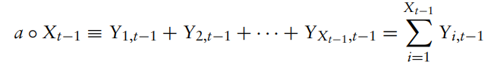
* The conditional probability of observing Yt events

$$P\left(Y_{t} | Y_{t-1}\right)=\sum_{j=0}^{\min\left(Y_{t}, Y_{t-1}\right)}{(^{Y_{t-1}}C_{j}})ρ^{j}{\left(1-ρ\right)}^{Y_{t-1}-j}*\frac{e^{-μ_{t}}μ_{t}^{Y_{t-j}}}{Y_{t-j} !}$$

The first term is the binomial probability of ‘j’ success in (Yt -j) trials and the second term is the Poisson probability of observing (Yt-j) events where ‘j’ lies {0, min(Yt, Yt-1)}

## Rank your time series

<https://towardsdatascience.com/how-ranking-timeseries-data-can-identify-abnormal-behaviour-475c7fd21fb5>

Say there are 20 generators working to produce goods. We have measurements of temperature of each generator and production of these generators. We rank on the basis on production. Say generator A (production rank 1 and highest temperature) and generator B (production rank 11 and coldest temperature). We see the changes in rankings over the years. In 2021, Generator A (ranked lowest producer and 2nd hottest) while generator B (ranked 7th hottest and production unchanged). This is an anomaly behaviour. We need to look into why such changes have occurred so that we can spot a disaster in the making and cut our losses.

## Feature Engineering in Time Series

In time series, feature engineering works in different way because it is sequential data and it gets formed using the changes in any values according to time. Since under time series, the input and the output are the same variable, ‘time’ is the feature we use for featuring engineering. For e.g. we may require engineering dates from the year where we are finding the value of our sales is increasing. Time series data gets created using the independent variable where time is the most common variable. Features like max, minimum, average, median, number of temporary peaks.

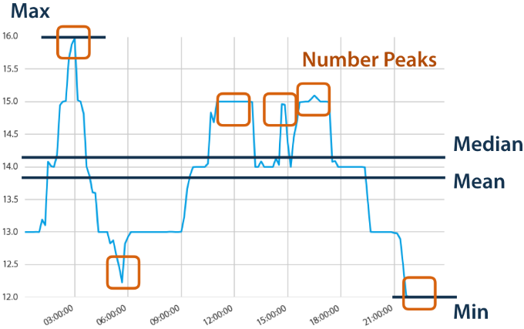

### ‘tsfeatures’ package in R

* **Arch stat**

arch_stat Computes a statistic based on the Lagrange Multiplier (LM) test of Engle ([1982](https://cran.r-project.org/web/packages/tsfeatures/vignettes/tsfeatures.html#ref)) for autoregressive conditional heteroscedasticity (ARCH). The statistic returned is the R2 value of an autoregressive model of order specified as lags applied to x2.

* **Crossing points**

crossing points are defined as the number of times a time series crosses the median line.

* **Entropy**

The spectral entropy is the Shannon entropy

$$-\int_{-π}^{π}{\hat{f}\left(λ\right)\log{\hat{f}\left(λ\right) dλ}}$$

where $\hat{f}(λ)$  is an estimate of the spectral density of the data. This measures the “forecastability” of a time series, where low values indicate a high signal-to-noise ratio, and large values occur when a series is difficult to forecast.

* **Flat spots**

flat_spots are computed by dividing the sample space of a time series into ten equal-sized intervals, and computing the maximum run length within any single interval.

* **Heterogeneity**

The heterogeneity features measure the heterogeneity of the time series. First, we pre-whiten the time series to remove the mean, trend, and autoregressive (AR) information (Barbour & Parker [2014](https://cran.r-project.org/web/packages/tsfeatures/vignettes/tsfeatures.html#ref)). Then we fit a GARCH(1,1) model to the pre-whitened time series, xt, to measure for autoregressive conditional heteroskedasticity (ARCH) effects. The residuals from this model, zt, are also measured for ARCH effects using a second GARCH(1,1) model.

* arch_acf is the sum of squares of the first 12 autocorrelations of {x2t}.
* garch_acf is the sum of squares of the first 12 autocorrelations of {z2t}.
* arch_r2 is the R2 value of an AR model applied to {x2t}.
* garch_r2 is the R2 value of an AR model applied to {z2t}.

The statistics obtained from {x2t} are the ARCH effects, while those from {z2t} are the GARCH effects. Note that the two R2 values are used in the Lagrange-multiplier test of Engle ([1982](https://cran.r-project.org/web/packages/tsfeatures/vignettes/tsfeatures.html#ref)), and the sum of squared autocorrelations are used in the Ljung-Box test proposed by Ljung & Box ([1978](https://cran.r-project.org/web/packages/tsfeatures/vignettes/tsfeatures.html#ref)).

* **Hurst**

We use a measure of the long-term memory of a time series (hurst), computed as 0.5 plus the maximum likelihood estimate of the fractional differencing order d given by Haslett & Raftery ([1989](https://cran.r-project.org/web/packages/tsfeatures/vignettes/tsfeatures.html#ref)). We add 0.5 to make it consistent with the Hurst coefficient. Note that the fractal dimension can be estimated as D=2−hurst.

* **Lumpiness and stability**

Stability and lumpiness are two time series features based on tiled (non-overlapping) windows. Means or variances are produced for all tiled windows. Then stability is the variance of the means, while lumpiness is the variance of the variances.

* **Max kl shift, Max level shift, Max var shift**

These three features compute features of a time series based on sliding, (overlapping) windows.

max_level_shift finds the largest mean shift between two consecutive windows.

max_var-shift finds the largest variance shift between two consecutive windows.

max_kl_shift finds the largest shift in Kulback-Leibler divergence between two consecutive windows. Each feature returns a vector of 2 values: the size of the shift, and the time index of the shift.

* **STL Features: command *slt_features()***
  + Nperiods **–** number of seasonal periods in the data determined by the frequency of observation ( for non-seasonal, Nperiods = 1)
  + The size and location of the peaks and troughs in the seasonal component are used to compute strength of peaks (**peak**) and strength of trough (**trough**).
  + Strength of trend = $1-\frac{Var\left(e_{t}\right)}{Var\left(f_{t}+e_{t}\right)}$ and seasonal strength = $1-\frac{Var\left(e_{t}\right)}{Var\left(s_{i,t}+e_{t}\right)}$

Where, time series $X_{t}=f_{t}+s_{1,t}+…+s_{m,t}+e_{t}$ (where, ft is the smoothed trend component, si,t is the ith seasonal component)

If their value is greater than 1, they are set to 1. If below zero, set to 0.

* + Spike – measures the spikiness of a time series and is computed as the variance of the leave-one-out variances of the remainder component et
  + Linearity and curvature – measures the linearity and curvature of time series calculated based on coefficients of an orthogonal quadratic regression.
  + e_acf1 and e_acf10 – contains the 1st autocorrelation coefficient and the sum of the 1st 10 squared autocorrelation coefficients.
* **Nonlinearity**

The nonlinearity coefficient is computed using a modification of the statistic used in Teräsvirta’s nonlinearity test.

Teräsvirta’s test uses a statistic $X^{2}=Tlog\left(\frac{SSE1}{SSE0}\right)$  where SSE1 and SSE0 are the sum of squared residuals from a nonlinear and linear autoregression respectively. This is non-ergodic, so instead, we define it as $\frac{10X^{2}}{T}$ which will converge to a value indicating the extent of nonlinearity as T→∞. This takes large values when the series is nonlinear, and values around 0 when the series is linear.

* **Compengine**

compengine calculate the features that have been used in the [CompEngine](https://www.comp-engine.org/) database, using a method introduced in package kctsa.

The features involved can be grouped as autocorrelation, prediction, stationarity, distribution, and scaling, which can be computed using autocorr_features, pred_features, station_features, dist_features, and scal_features.

* **Binarize_mean**

binarize_mean converts an input vector into a binarized version. Time-series values above its mean are given 1, and those below the mean are 0.

* **Embed2_incircle**

embed2_incircle gives proportion of points inside a given circular boundary in a 2-d embedding space.

* **fluctanal_prop_r1**

fluctanal_prop_r1 implements fluctuation analysis. It fits a polynomial of order 1 and then returns the range. The order of fluctuations is 2, corresponding to root mean square fluctuations.

* **histogram_mode**

histogram_mode measures the mode of the data vector using histograms with a given number of bins (default to 10) as suggestion.

* **localsimple_taures**

Simple predictors using the past trainLength values of the time series to predict its next value. localsimple_taures returns the first zero crossing of the autocorrelation function of the residuals from this Simple local time-series forecasting.

* **Motiftwo_entro3**

Local motifs in a binary symbolization of the time series. Coarse-graining is performed. Time-series values above its mean are given 1, and those below the mean are 0. motiftwo_entro3 returns the entropy of words in the binary alphabet of length 3.

* **outlierinclude_mdrmd**

outlierinclude_mdrmd measures the median as more and more outliers are included in the calculation according to a specified rule, of outliers being furthest from the mean. The threshold for including time-series data points in the analysis increases from zero to the maximum deviation, in increments of 0.01*sigma (by default), where sigma is the standard deviation of the time series. At each threshold, proportion of time series points included and median are calculated, and outputs from the algorithm measure how these statistical quantities change as more extreme points are included in the calculation. outlierinclude_mdrmd essentially returns the median of the median of range indices.

* **Sampenc, sampan_first**

sampen_first returns the first Sample Entropy of a time series where the embedding dimension is set to 5 and the threshold is set to 0.3. sampenc is the underlying function to calculate the first sample entropy with optional dimension and threshold settings.

* **Spreadrandomlocal_meantaul**

100 time-series segments of length l are selected at random from the time series and the mean of the first zero-crossings of the autocorrelation function in each segment is calculated using spreadrandomlocal_meantaul.

* **Std1st_der**

std1st_der returns the standard deviation of the first derivative of the time series.

* **Trev num**

trev_num returns the numerator of the trev function of a time series, a normalized nonlinear autocorrelation. The time lag is set to 1.

* **walker_propcross**

Simulates a hypothetical walker moving through the time domain. The hypothetical particle (or ‘walker’) moves in response to values of the time series at each point. The walker narrows the gap between its value and that of the time series by 10. walker_propcross returns the fraction of time series length that walker crosses time series.

## Functional Time Series (FDA Analysis)

<https://towardsdatascience.com/functional-time-series-83b717cca12> (left when read L2 Integrability)

<https://www.r-bloggers.com/2018/12/using-ggplot2-for-functional-time-series/> (explore)

As storing data becomes cheaper, it allows us to record data more frequently. It is not clear however, how to model time series that are recorded with a very high frequency, especially when multiple seasonality is involved. For e.g. Intraday stock process – we observed for every day the price as a ‘function of time of day’. Such functional data arises naturally in different settings such as medicine (EEG data), finance (stock prices) or meteorology (temperature).

Let’s take the example of time series data of temperature recorded per day from 2013 to 2017. So observations belong to year ‘t’ and day ‘i’. let ‘d’ be the number of days i.e. 365 and ‘n’ be the number of years i.e. 5.

Different approaches –

* Take the entire data as a univariate time series Yt = Xj,i (jth year, ith day). Problem – seasonality makes the analysis difficult.
* Model as a multivariate time series Yt = {Xj,1, Xj,2, … Xj, d} i.e. 365 series for each day. Problem – seasonality does not have to be accounted now, but the dimension is very high.
* Reduce frequency of observation to reduce dimension? But we lose out on critical data and how do we choose the frequency weekly or monthly?
* Final approach – consider the data as a functional time series Y(t, x) where we have a function Y(.,x) for every year ‘t’ with Y(t, i/d) = X(t, i). in this case, the yearly temperature is viewed as a function in time and every observation corresponds to a function, which describes the yearly temperature.

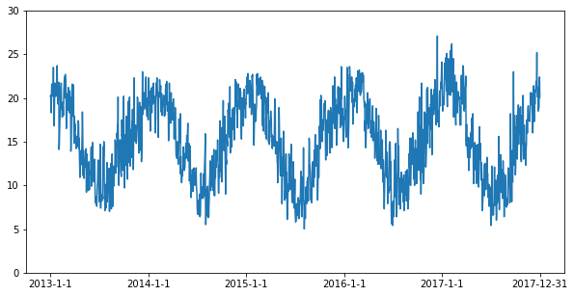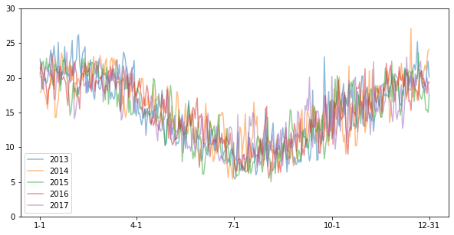

The difference in the 2 graphs is that now the X-axis does not measure time in years but it measures time in days (1 to 365). So we went from a univariate series with frequency = day to multivariate series (5 series for each year) with frequency = days.

* Important benefits →
  + Mean temperature is not constant. But mean temp in summer > winter. So, a non-stationary univariate time series might be stationary when modelled as a functional time series, because we compare data that is reasonable to compare (i.e. comparing temp in Jan 2016 with temp in 2017 instead of July 2016).
  + Further, modelling the data as a functional time series is often more natural than using a high-dimensional time series because it adds an additional structure. For example, if we observe continuous functions, such as temperature or stock prices, the values for two close time instants are similar, whereas such a structure is not given for arbitrary multivariate time series.
  + This is **Similar in spirit to Convolutional Neural Networks**. Due to their specific architecture, the use of CNNs is more restricted to a specific set of problems, yet for this set of problems, they work very well.

## Fasster : forecasting multiple seasonality with state-switching

<https://youtu.be/6YlboftSalY>

Time series data is changing. We have more data and it is collected more often and at regular intervals. This presents a few problems – complicated patterns emerge, multiple seasonality, missing values, lots of data, additional noise.

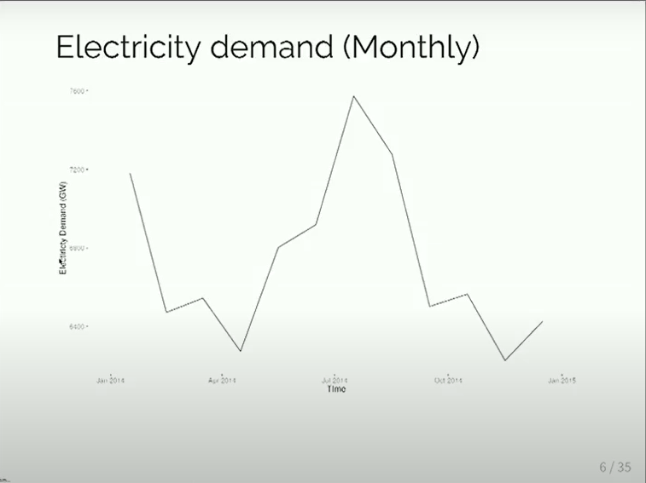 → 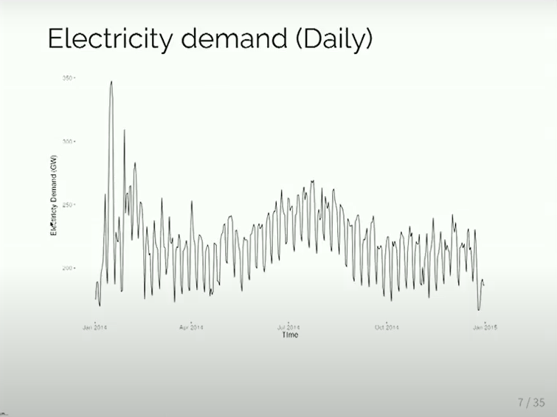 → 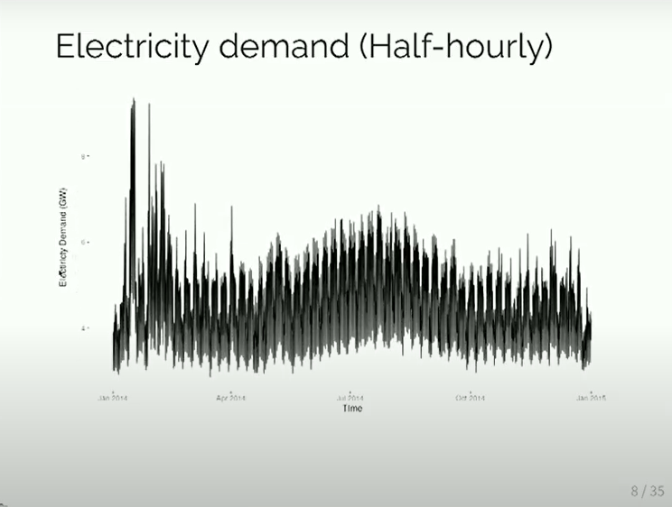

When we look at the monthly data, we see that there is annual seasonality reflecting the pattern associated with temperature. When we switch to daily data, the patterns become more complicated. We start to observe multiple seasonal patterns. We still observe the annual seasonality, high for June-July. However, for each week we have up-down patterns associated with working and non-working days.

When we switch to half-hourly data, we can hardly see what’s going on. So lets take a deeper look.

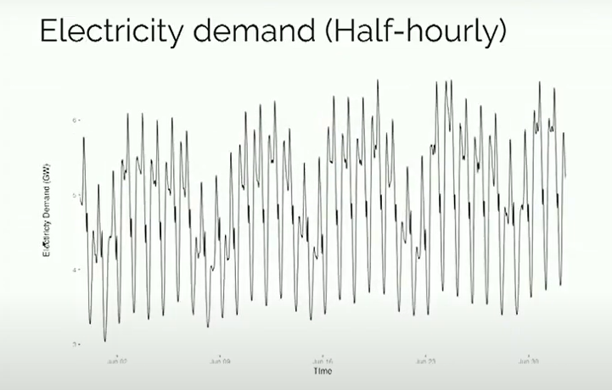 we zoom in on July.

We can see that there is a pattern within each day as well. So as people are awake, they move around, go to work and are asleep, the electricity used changes accordingly.

So we have 3 types of seasonality → Annual seasonality (reflecting changing seasons and temperature), working and non-working day seasonality (reflecting human-behaviour) and the half-hourly pattern.

**What is Fasster?**

FASSTER = Forecasting With Additive Switching Of Seasonality, Trend And Exogenous Regressors.

So it is a state-space model that is Flexible and Fast. It supports Missing values and Exogenous Regressors.

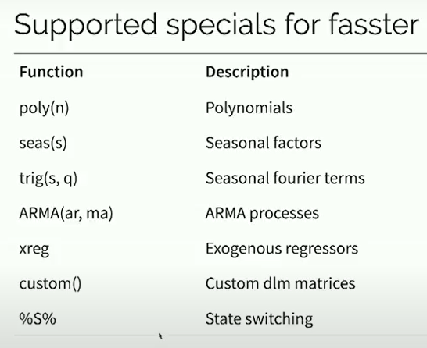 Data → 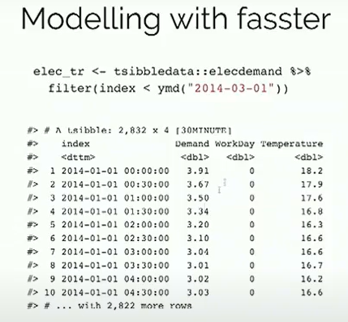

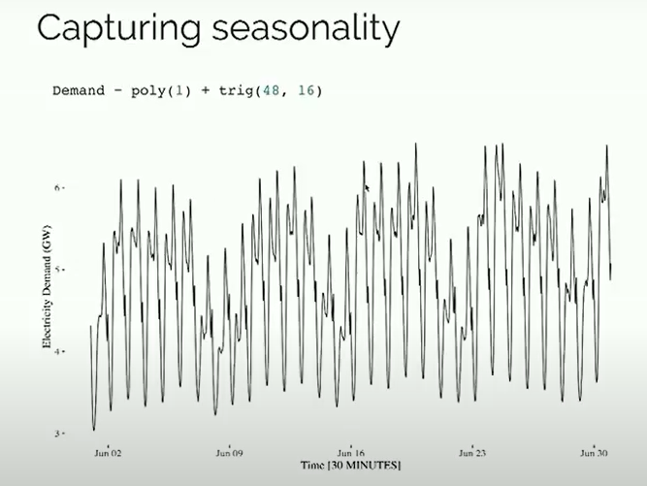 there are 48 ‘half-hours’ in a day so we need 48 daily seasonal frequency. We reduce the model complexity by using Fourier terms with 16 harmonics. Because the seasonal terms are centred around zero, and our data is not, we include a polynomial of degree 1 (a level term), to help center our seasonality.

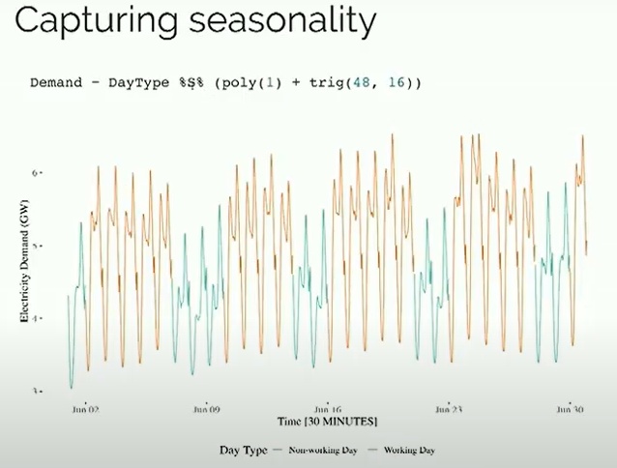 however, we have switching seasonality between working and non-working days. So that where the %S% operator comes into play. This allows us to swap between different day types. So we end up with different set of equations for weekends and weekdays.

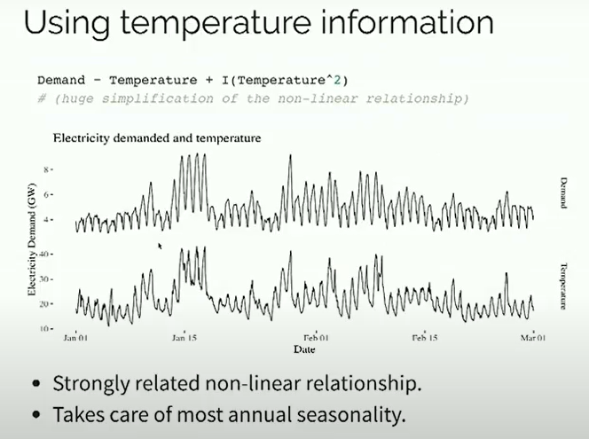 to capture annual seasonality we can use temperature as our regressor. For example we can used a quadratic relationship.

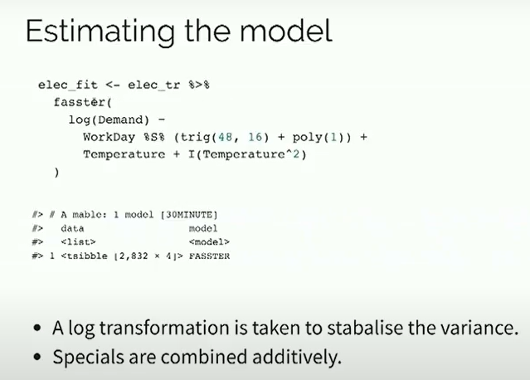 combining it all → we additively combine our special terms – we take log transformation of demand which is modelled using switching seasonality + temperature quadratic eqn. the log-transformation helps stabilise the variance.

## Deep Learning for Time series

<https://towardsdatascience.com/the-best-deep-learning-models-for-time-series-forecasting-690767bc63f0>

## Explore Topics

* **DeepAR**
* MQRNN
* Seq2seq
* ConvTrans
* DeepSSM
* Transformer – based model
* Attention based layer
* Temporal Fusion Transformer
* **lightGBM**
* **N-BEATS**
* Deep Space State Model (DSSM)
* Spacetimeformer